DEATH CAB FOR CUTIE REACHES #1 AT ALTERNATIVE RADIO WITH
“HERE TO FOREVER”

ASCENDS TO TOP SPOT AS SINGLE CAPS RECORD 9-WEEK #1 RUN AT AAA

NEW ROUND OF US + CANADIAN DATES ADDED TO ASPHALT MEADOWS HEADLINE TOUR

ADDITIONAL LEG KICKS OFF MAY 31, 2023; CULMINATES JUNE 17 IN BEND, OREGON

PRESALES BEGIN WEDNESDAY, OCTOBER 19 @ 10 AM LOCAL TIME
GENERAL ON-SALE HERE BEGINS FRIDAY, OCTOBER 21 @ 10 AM LOCAL TIME

CRITICALLY ACCLAIMED TENTH STUDIO ALBUM ASPHALT MEADOWS OUT NOW
BUY/STREAM HERE

“Twenty-five years into its career, the band brings its incisive, anguished writing to a particularly 2022 brand of existential angst on its 10th album, ‘Asphalt Meadows’… an expansive album…” – THE NEW YORK TIMES

“If you haven’t heard yet, Death Cab for Cutie is back back… [their] best album in over a decade...” – VULTURE

“…a late-career masterwork…” – PITCHFORK

“Gibbard’s openness to possibility is on full display throughout Asphalt Meadows, the surprising new album from Death Cab for Cutie (and their tenth since 1998) that finds the indie mainstays navigating a terrain of exciting new sounds.” – STEREOGUM

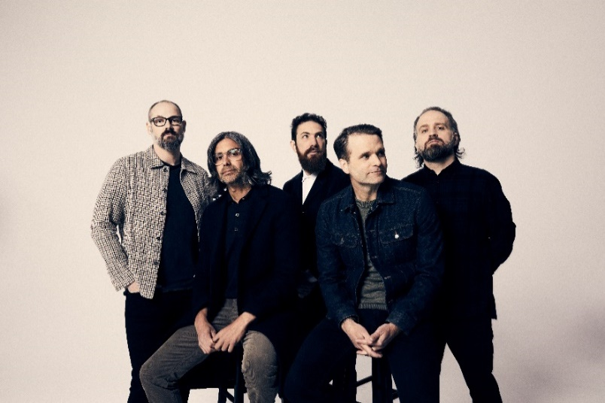
(download hi-res press photo; credit: Jimmy Fontaine)

As of this week, 8x GRAMMY® Award-nominated rock band Death Cab for Cutie has officially reached #1 at Alternative radio with current single “Here to Forever.” The track has swiftly ascended the charts since its mid-summer release, having just capped off a tremendous 9-week #1 run at AAA – the longest such run this year for any song at the format.

Today, the indie veterans have also announced new dates for their Asphalt Meadows headline tour, by way of a show in Knoxville added for February 2023, plus an additional run of US and Canadian dates set for next May/June. These spring dates kick off May 31 in Indianapolis and include stops in Cleveland, Vancouver, and Toronto, before culminating in Bend, Oregon on June 17 (full routing enclosed).

Presales for this run begin tomorrow, Wednesday, October 19 at 10am (local), and general on-sale begins Friday, October 21 at 10am (local) – tickets + additional information available here.

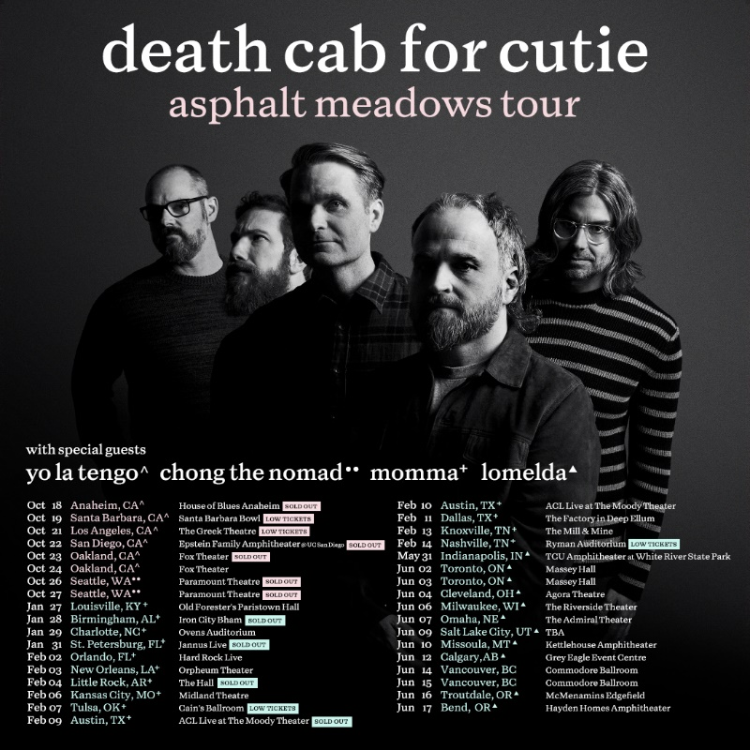
(download hi-res admat)

Death Cab for Cutie’s highly-anticipated tenth studio album Asphalt Meadows – out now on Atlantic Records – was released to widespread critical acclaim on September 16. Produced by GRAMMY® Award-winner John Congleton (St. Vincent, Sharon Van Etten, Wallows), the LP has earned tremendous praise from outlets including The New York Times, Los Angeles Times, Vulture, SPIN, Stereogum, and Pitchfork, who in their album review lauded Asphalt Meadows as “...a restoration of their creative momentum when a mere 'return to form' would have sufficed.”

“…their best album in years… In Asphalt Meadows, there are elements of the band’s early work… while also feeling fresh — thrashier and livelier than ever before — with some of Gibbard’s sturdiest songwriting...”
– SPIN –

“10 albums and 25 years into their career, the Washington indie veterans come back mature and assured but loaded with that early melodic magic.”
– NME –

“…Asphalt Meadows, an album that feels exactly like what Death Cab should ideally sound like 25 years since their formation: At once familiar and like nothing they’ve done before… some of Gibbard’s most introspective lyrics in years.”
– CONSEQUENCE OF SOUND –

“…some of the most compelling work of the band’s career… one that succeeds in highlighting the best Death Cab components and stretching them farther than ever before…”
– FLOOD –

“For 10 band albums now… the sonic muralist Gibbard has sketched gorgeous pneumatic panoramas that contain more truth in their tiny brushstroke details than is initially apparent on first inspection… [his] indie-rock songs are the best kind… growers that reveal the depths of their brilliance after consecutive listens. The idyllic new Asphalt Meadows – which sets up a paradoxical conundrum in its title alone – follows intellectual, multi-layered suit.”
– PASTE –

Death Cab for Cutie is currently celebrating their 10th studio album on the Fall 2022 leg of their Asphalt Meadows headline tour. This Friday, October 21, the band will make their much-anticipated return to LA’s Greek Theatre. The tour has included stops in Chicago, Boston, and at New York’s Forest Hills Stadium, and will culminate with a sold-out, two-night hometown finale at Seattle, WA’s Paramount Theatre on October 26 and 27.

###

DEATH CAB FOR CUTIE | ASPHALT MEADOWS TOUR

OCTOBER
18 – Anaheim, CA – House of Blues Anaheim # – SOLD OUT
19 – Santa Barbara, CA – Santa Barbara Bowl # – LOW TICKETS
21 – Los Angeles, CA – The Greek Theatre # – LOW TICKETS
22 – San Diego, CA – Epstein Family Amphitheater @ UC San Diego # – SOLD OUT
23 – Oakland, CA – Fox Theater # – SOLD OUT
24 – Oakland, CA – Fox Theater #
26 – Seattle, WA – Paramount Theatre % – SOLD OUT
27 – Seattle, WA – Paramount Theatre % – SOLD OUT

JANUARY 2023
27 – Louisville, KY – Old Forester’s Paristown Hall &
28 – Birmingham, AL – Iron City Bham & – SOLD OUT
29 – Charlotte, NC – Ovens Auditorium &
31 – St. Petersburg, FL – Jannus Live & – SOLD OUT

FEBRUARY 2023
2 – Orlando, FL – Hard Rock Live &
3 – New Orleans, LA – Orpheum Theater &
4 – Little Rock, AR – The Hall & – SOLD OUT
6 – Kansas City, MO – Midland Theatre &
7 – Tulsa, OK – Cain’s Ballroom & – LOW TICKETS
9 – Austin, TX – ACL Live at The Moody Theater & – SOLD OUT
10 – Austin, TX – ACL Live at The Moody Theater &
11 – Dallas, TX – The Factory in Deep Ellum &
13 – Knoxville, TN – The Mill & Mine &
14 – Nashville, TN – Ryman Auditorium & – LOW TICKETS

MARCH 2023
1 – Milan, Italy – Fabrique *
2 – Zurich, Switzerland – X-Tra *
3 – Munich, Germany – TonHalle *
5 – Copenhagen, Denmark – Den Grå Hal *
6 – Stockholm, Sweden – Filadelfia *
7 – Oslo, Norway – Sentrum Scene *
9 – Berlin, Germany – Columbiahalle *
10 – Tilburg, Netherlands – 013 *
11 – Amsterdam, Netherlands – Paradiso *
12 – Cologne, Germany – E-Werk *
14 – Antwerp, Belgium – De Roma *
15 – Luxembourg, Luxembourg – Atelier *
16 – Paris, France – Salle Pleyel *
18 – Nottingham, United Kingdom – Rock City *
19 – Dublin, Ireland – Bord Gais Energy Theatre *
21 – Birmingham, United Kingdom – 02 Institute *
22 – Edinburgh, United Kingdom – Usher Hall *
23 – Glasgow, United Kingdom – Barrowland *
25 – Manchester, United Kingdom – O2 Apollo *
27 – Brighton, United Kingdom – Dome *
28 – London, UK – Roundhouse *
29 – London, United Kingdom – Royal Albert Hall * – LOW TICKETS

MAY 2023
31 – Indianapolis, IN – TCU Amphitheater at White River State Park ^

JUNE 2023
2 – Toronto, ON – Massey Hall ^
3 – Toronto, ON – Massey Hall ^
4 – Cleveland, OH – Agora Theatre ^
6 – Milwaukee, WI – The Riverside Theater ^
7 – Omaha, NE – The Admiral Theater ^
9 – Salt Lake City, UT – Venue TBA ^
10 – Missoula, MT – Kettlehouse Amphitheater ^
12 – Calgary, AB – Grey Eagle Event Centre ^
14 – Vancouver, BC – Commodore Ballroom
15 – Vancouver, BC – Commodore Ballroom
16 – Troutdale, OR – McMenamins Edgefield ^
17 – Bend, OR – Hayden Homes Amphitheater ^

# w/ Special Guest Yo La Tengo
% w/ Special Guest Chong the Nomad
& w/ Special Guest Momma
* w/ Special Guest Slow Pulp
^ w/ Special Guest Lomelda

# # #

