TBR September 19 at 10am EST

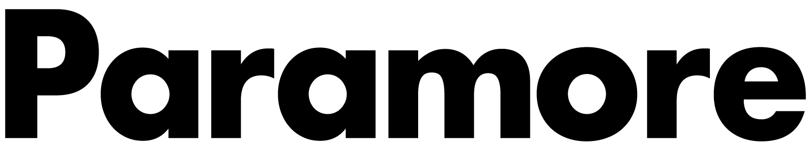PARAMORE ANNOUNCE INTIMATE NEW YORK CITY SHOW
REGISTER FOR TICKETS HERE

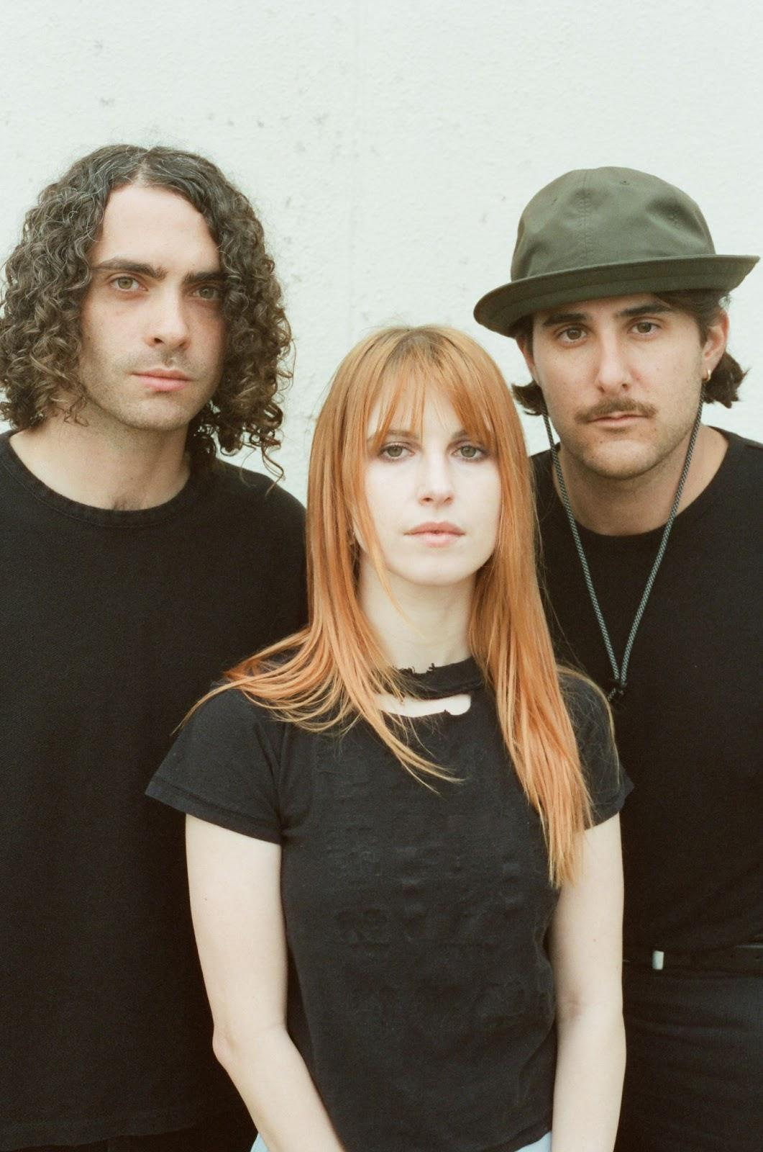

Paramore have added a New York City date to their run of intimate performances across the U.S. The band will be playing at the Beacon Theatre on November 13. Tickets will be sold through Ticketmaster’s Verified Fan platform. Fans can register now HERE through Tuesday, September 20 at 10pm ET for the Verified Fan presale. Registered fans who receive a code will have access to purchase tickets starting Friday, September 23 at 10am ET. Only fans that have received a unique code will have the chance to purchase tickets for this performance on a first come, first served basis. Tickets will be shown at all-in price, which includes face value and all fees.

Per current New York state law, ticket transfer cannot be restricted in any way. This means our show in New York cannot offer tickets through the face value fan-to-fan exchange, and resellers can set any resale price they choose. If you purchase a resale ticket, New York state law requires resellers to list the original purchase price of the ticket as well as all-in price including fees.

A portion of each ticket sold will be donated to Support + Feed in partnership with City National Bank.

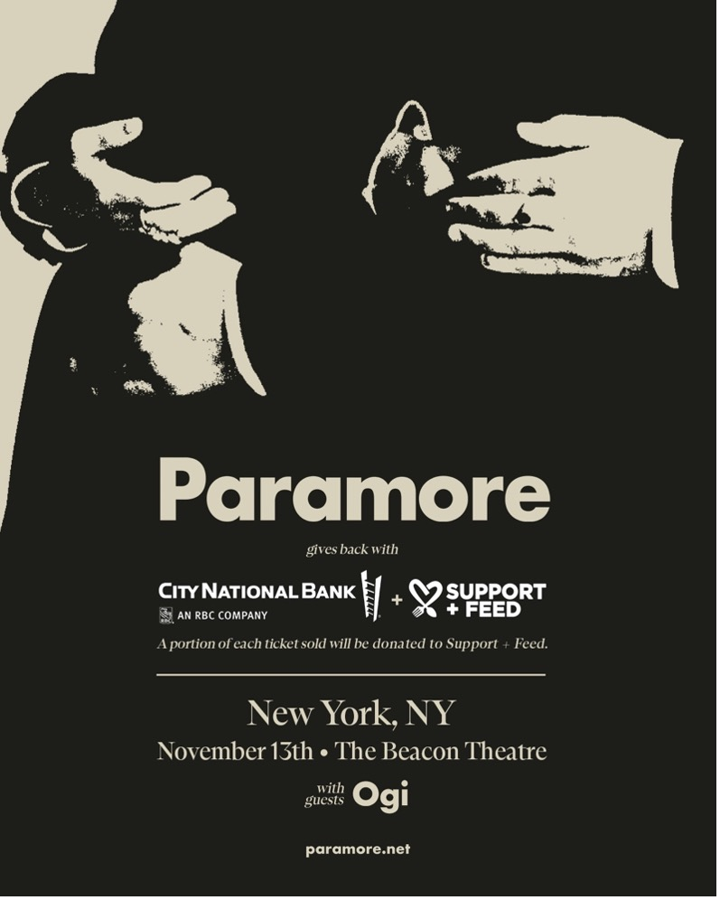

Singer-songwriter Claud will accompany Paramore on their first slew of shows in Bakersfield, Magna, Omaha, Oklahoma City and Chesterfield. Young the Giant, Japanese Breakfast and Claud will join the band for a very special show in Bonner Springs. Ogi will be supporting for the remainder of the dates after the Los Angeles shows with Faux Real and Elke.

PARAMORE SHOW DATES
October 2, 2022 - Bakersfield, CA - Mechanics Bank Theater #
October 4, 2022 - Magna, UT - The Great SaltAir #
October 6, 2022 - Omaha, NE - Orpheum Theater Omaha #
October 8, 2022 - Oklahoma City, OK - The Criterion #
October 9, 2022 - Austin, TX - Austin City Limits
October 11, 2022 - Chesterfield, MO - The Factory #
October 14, 2022 - Bonner Springs, KS - Azura Amphitheater* &
October 16, 2022 - Austin, TX - Austin City Limits^
October 20, 2022 - Los Angeles, CA - The Wiltern ~
October 22, 2022 - Las Vegas, NV - When We Were Young Festival^
October 23, 2022 - Las Vegas, NV - When We Were Young Festival^
October 27, 2022 - Los Angeles, CA - The Belasco %
October 29, 2022 - Las Vegas, NV - When We Were Young Festival^
November 7, 2022 - Toronto, ON - HISTORY =
November 9, 2022 - Chicago, IL - The Chicago Theatre =
November 11, 2022 - Cincinnati, OH - The Andrew J Brady Music Center =
November 13, 2022 - New York City, NY - Beacon Theatre =
November 15, 2022 - Atlanta, GA - Tabernacle =
November 16, 2022 - St. Augustine, FL - The St. Augustine Amphitheatre =
November 19, 2022 - Mexico City, MX - Corona Capital Festival^

*Not a Live Nation Date
^Festival Date - Ticketmaster Verified Fan Presale Not Applicable
# with Claud
= with Ogi
& with Japanese Breakfast + Young the Giant
~ with Faux Real
% with Elke

KEEP UP WITH PARAMORE:
Twitter / Instagram / Facebook / Web

About Live Nation Entertainment
Live Nation Entertainment (NYSE: LYV) is the world’s leading live entertainment company comprised of global market leaders: Ticketmaster, Live Nation Concerts, and Live Nation Sponsorship. For additional information, visit www.livenationentertainment.com.

For more information on Paramore:
Chloe Walsh @ The Oriel Co / Anna Ross @ The Oriel Co

chloe@theoriel.co
anna@theoriel.co

For more information on Live Nation Entertainment:
Monique Sowinski
moniquesowinski@livenation.com

