TBR JULY 15 @ 10AM EST

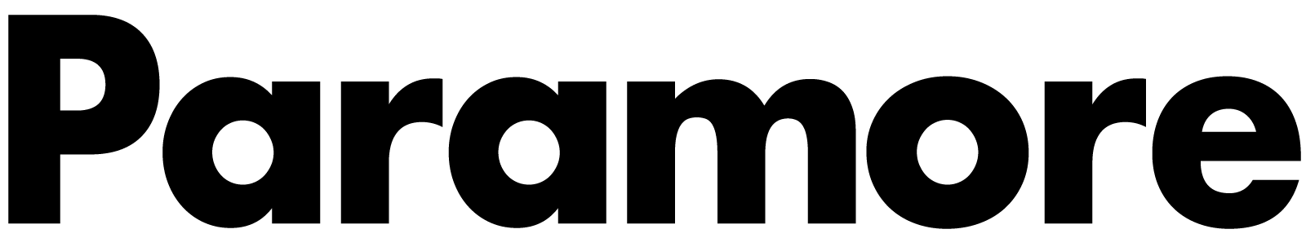

PARAMORE ANNOUNCE EXCLUSIVE 12-SHOW RUN THIS FALL

Ticketmaster Verified Fan Registration Open Now HERE

Public On Sale Begins Friday, July 22nd at 10AM Local

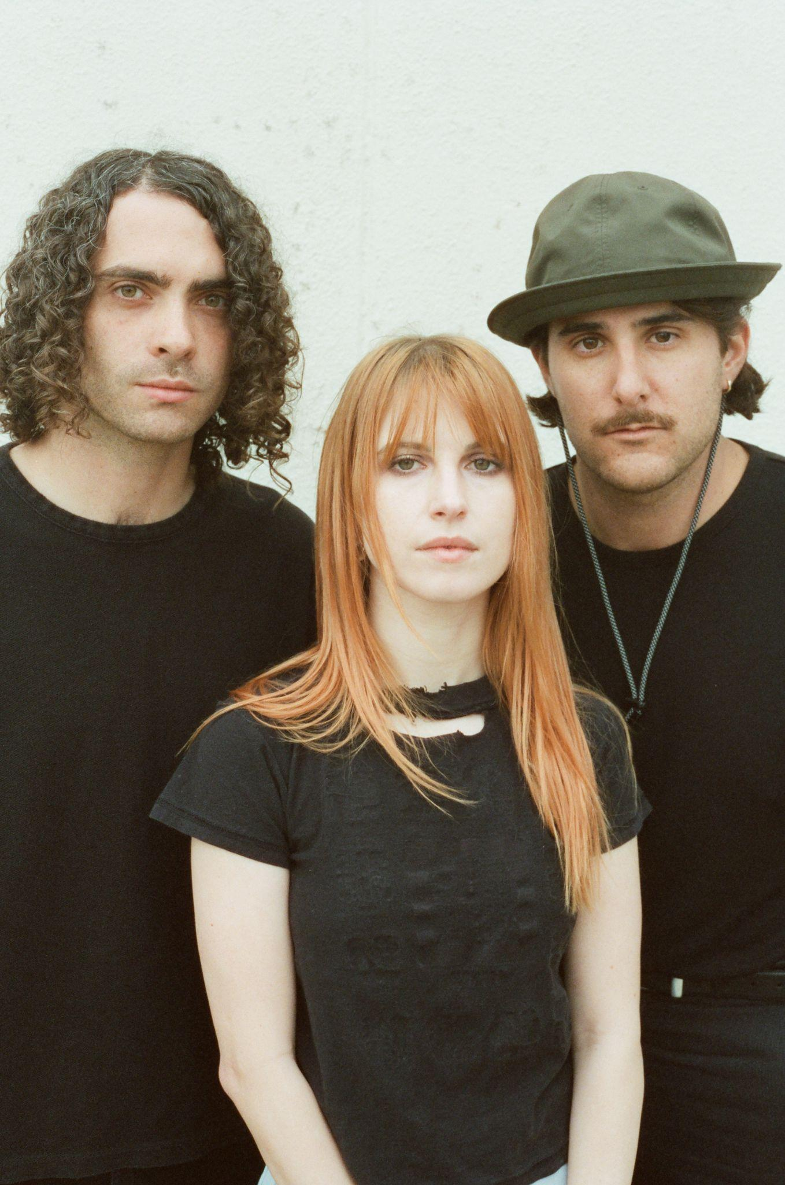

Paramore has announced their return to the road with 12 special performances throughout North America this fall. Produced by Live Nation, the band’s first outing since 2018 kicks off in Bakersfield on October 2nd and makes stops across theaters in Omaha, Chicago, Toronto, and Atlanta as well as festival appearances at Austin City Limits, When We Were Young and Corona Capital Festival before wrapping up in St. Augustine on November 16th. These select shows offer fans a once in a lifetime opportunity to see Paramore in a range of intimate venues.

To ensure tickets get into the hands of fans, Paramore has partnered with Ticketmaster’s Verified Fan platform. Fans can register now HERE through Sunday, July 17 at 10pm PT for the Verified Fan presale. Registered fans who receive a code will have access to purchase tickets before the general public on Wednesday, July 20 at 10am local time through Thursday, July 21 at 10pm local time. Only fans that have received a unique code will have the chance to purchase tickets for performances on a first come, first served basis. Public on sale begins Friday, July 22nd at 10am local time on paramore.net.

PARAMORE SHOW DATES
October 2, 2022 - Bakersfield, CA - Mechanics Bank Theater
October 4, 2022 - Magna, UT - The Great SaltAir
October 6, 2022 - Omaha, NE - Orpheum Theater Omaha
October 8, 2022 - Oklahoma City, OK - The Criterion
October 9, 2022 - Austin, TX - Austin City Limits^
October 11, 2022 - Chesterfield, MO - The Factory
October 14, 2022 - Bonner Springs, KS - Azura Amphitheater*
October 16, 2022 - Austin, TX - Austin City Limits^
October 22, 2022 - Las Vegas, NV - When We Were Young Festival^
October 23, 2022 - Las Vegas, NV - When We Were Young Festival^
October 29, 2022 - Las Vegas, NV - When We Were Young Festival^
November 7, 2022 - Toronto, ON - HISTORY
November 9, 2022 - Chicago, IL - The Chicago Theatre
November 11, 2022 - Cincinnati, OH - The Andrew J Brady Music Center
November 15, 2022 - Atlanta, GA - Tabernacle
November 16, 2022 - St. Augustine, FL - The St. Augustine Amphitheatre
November 19, 2022 - Mexico City, MX - Corona Capital Festival^

*Not a Live Nation Date
^Festival Date - Ticketmaster Verified Fan Presale Not Applicable

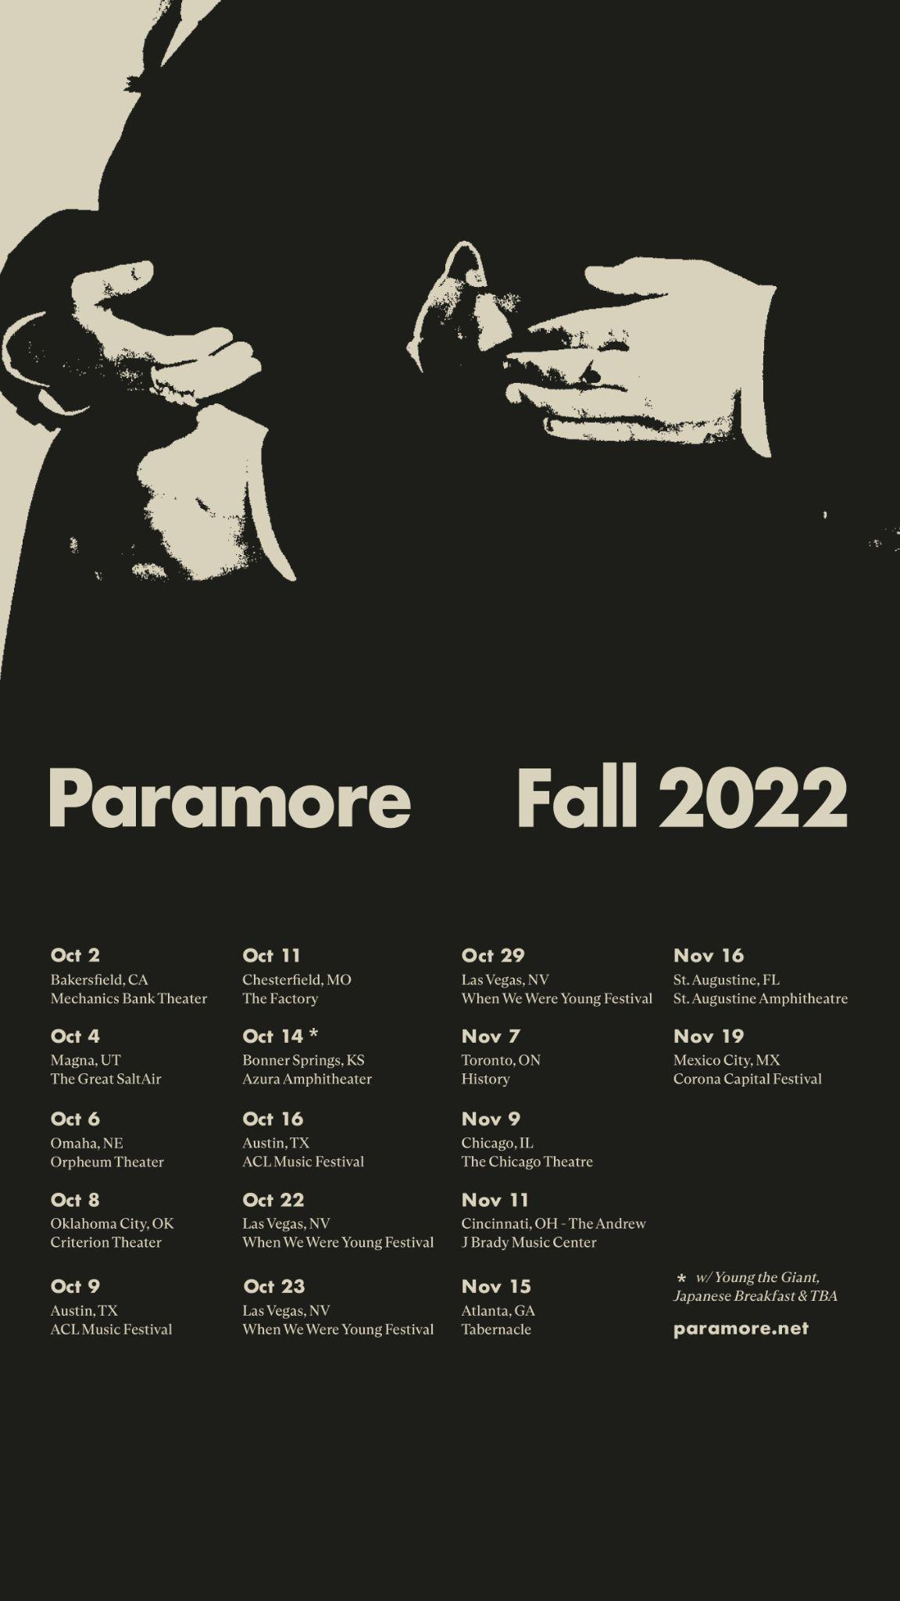

KEEP UP WITH PARAMORE:
Twitter / Instagram / Facebook / Web

About Live Nation Entertainment
Live Nation Entertainment (NYSE: LYV) is the world’s leading live entertainment company comprised of global market leaders: Ticketmaster, Live Nation Concerts, and Live Nation Sponsorship. For additional information, visit www.livenationentertainment.com.

For more information on Paramore:
Chloe Walsh @ The Oriel Co / Anna Ross @ The Oriel Co

chloe@theoriel.co
anna@theoriel.co

For more information on Live Nation Entertainment:
Monique Sowinski
moniquesowinski@livenation.com

