FOR IMMEDIATE RELEASE

OCTOBER 7, 2022

**Forest Blakk releases new track “I Remember”**

**ACCLAIMED SINGER/SONGWRITER’S FORTHCOMING *EVERY LITTLE DETAIL* EP**

**ARRIVES OCTOBER 28TH VIA ATLANTIC RECORDS**

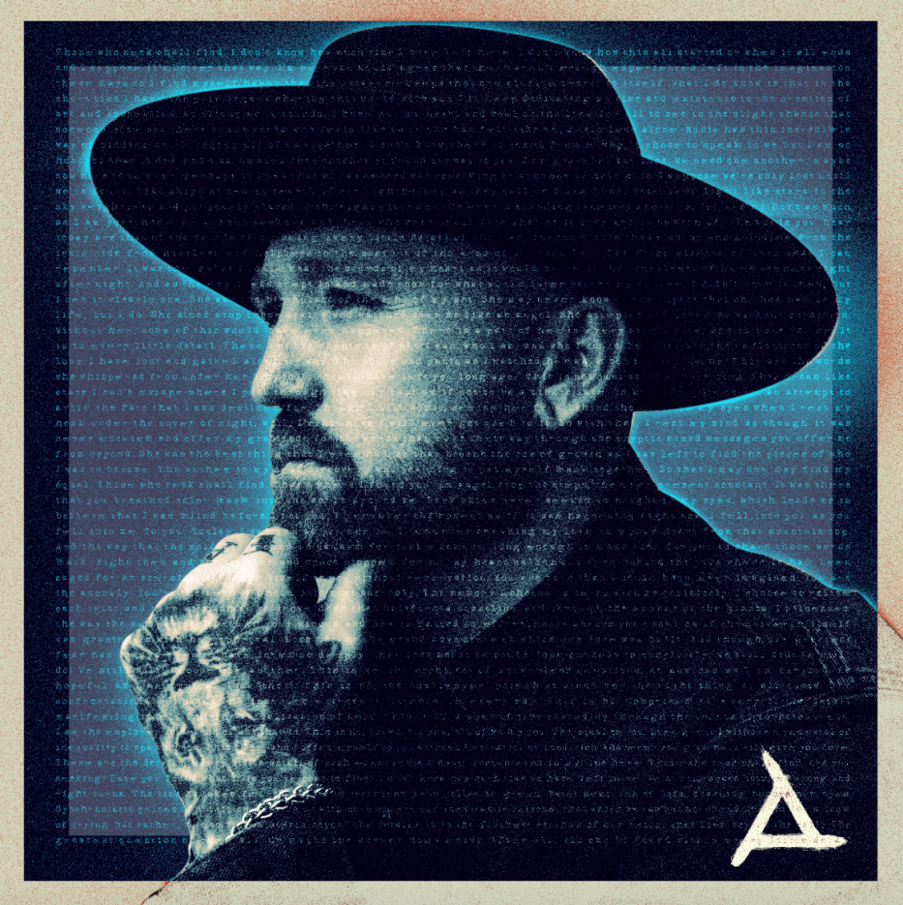

[DOWNLOAD HIGH-RES ARTWORK HERE](http://press.atlanticrecords.com/forest-blakk/)

**STREAM/BUY “I REMEMBER”:** [LINK](https://forestblakk.lnk.to/ELD)

**PRE-SAVE/ORDER *EVERY LITTLE DETAIL* EP:** [LINK](https://forestblakk.lnk.to/ELD)

Acclaimed singer/songwriter **Forest Blakk** has shared new track “**I Remember**” off his forthcoming ***Every Little Detail*** EP – arriving October 28th via **Atlantic** **Records**. Written alongside **Jamie N Commons (Lewis Capaldi, X Ambassadors)** and **Josh Zegan**, the poignantsong further affirms Blakk’s talent for sentimental storytelling, following in the footsteps of last months’ fiery new single “[**Another Love Song**](https://forestblakk.lnk.to/anotherlovesong).”

In addition to “**I Remember**” & “**Another Love Song**,” ***Every Little Detail***will feature Blakk’s 2021 smash single **“**[**If You Love Her**](https://www.youtube.com/watch?v=wDaiiluanQc).” Having amassed over 290 million total global streams to date and certified Gold in the United States (along with Platinum in his native Canada), “**If You Love Her**” earned Blakk his official US chart debut on **Billboard**’s **Emerging Artists** chart, his national US TV debut on **ABC**’s **Live with Kelly & Ryan,** top 30 placement on the Hot AC radio chart & saw the singer/songwriter collaborate with **Meghan** **Trainor** on a stunning duet version. Meanwhile follow-up singles “[**Give You Love**](https://www.youtube.com/watch?v=kuoo4ipaXsk)” and “[**Fall Into Me**](https://www.youtube.com/watch?v=NCUI2ziMzgw)” (co-written alongside **Matchbox Twenty** front man **Rob Thomas**) have amassed over 77 million streams with the latter also reaching top 30 on the Hot AC radio chart and currently being featured in an ad campaign for **Kay Jewelers**.

Highlighted as one of **PEOPLE Magazine**’s *“talented emerging artists making their mark on the musical landscape”* and deemed an *“artist on the rise”* by **Billboard**, Blakk made his debut with his 2018 EP ***Minutes*** and follow-up 2020 sophomore EP ***Sideways*** – the latter of which saw Blakk collaborate with the likes of **Will** **IDAP** (**Train**, **Florida** **Georgia** **Line**), **Nick Long** (**King Princess**), **Carl Ryden** (**Ricky Martin**, **David Guetta**), **Ollie** **Green** (**Freya** **Ridings**, **Gavin** **James**) & more to tell a love story through an incredibly realistic and candid lens. The 6-track collection featured singles “**I Wish I Knew**” (deemed an *“introspective look at love and love lost”* by **American Songwriter**) and uplifting anthem of resilience “**Put Your Hands Up**,” which debuted on an episode of **ABC**’s ***Grey’s Anatomy***. A compelling live performer, Blakk has toured extensively supporting **NEEDTOBREATHE**, **Gavin James** & most recently this past summer throughout North America with **Dean Lewis**.

***Every Little Detail* EP tracklist:**

1. Another Love Song

2. Give You Love

3. I Remember

4. I Hope You Know

5. Me

6. If You Love Her

7. Fall Into Me

8. Every Little Detail

CREDIT: JIMMY FONTAINE – [DOWNLOAD HIGH-RES HERE](http://press.atlanticrecords.com/forest-blakk/)

**CONNECT WITH FOREST BLAKK:**

[TIKTOK](https://www.tiktok.com/@forestblakk?lang=en) | [TWITTER](https://twitter.com/forestblakk) | [FACEBOOK](https://www.facebook.com/forestblakk) | [INSTAGRAM](https://www.instagram.com/forestblakk) | [YOUTUBE](https://www.youtube.com/channel/UC9vKX9Hz5dGVrhD5v3-UnAQ) | [FORESTBLAKK.COM](http://forestblakk.com/)

**CONTACT:**

[ted.sullivan@atlanticrecords.com](mailto:ted.sullivan@atlanticrecords.com)