FOR IMMEDIATE RELEASE
OCTOBER 17, 2022

FRED AGAIN.. SHARES BRAND NEW TRACK
‘DELILAH (PULL ME OUT OF THIS)’
LISTEN HERE

NEW STUDIO ALBUM ACTUAL LIFE 3 (JANUARY 1 - SEPTEMBER 9 2022)
DUE FOR RELEASE OCTOBER 28 2022 VIA ATLANTIC RECORDS
PRE-ORDER HERE

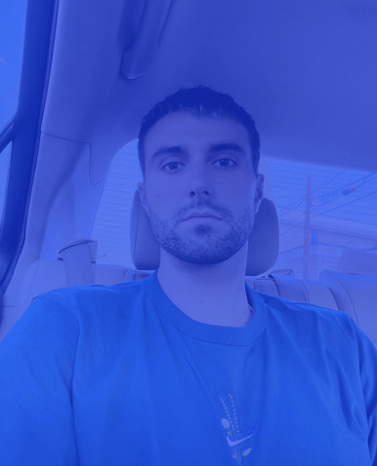
DOWNLOAD PRESS PHOTO HERE

Groundbreaking artist and producer Fred again.. today shares ‘Delilah (pull me out of this)’, the latest taste of his forthcoming album Actual Life 3 (January 1 - September 9 2022), featuring a sample of close friend Delilah singing her own track ‘Lost Keys’ on Instagram. Fred debuted the track live during his viral Boiler Room set earlier this summer which has now surpassed a record breaking 7M streams. Actual Life 3 is set to be released on October 28th via Atlantic Records and is available to pre-order here: https://fredagain.lnk.to/ActualLife3

Building on the template already laid down with his debut LP, Actual Life (February 2nd - July 19th) and its companion follow up Actual Life 2 (February 2 - October 15 2021), Actual Life 3 sees Fred again.. resume his diary-esque approach to production. His intimate use of voice notes from friends, videos found whilst scrolling on instagram and samples from important records in his life serves as a personal record of his life experiences, offering insight into his world over the past year. Actual Life 3 is a continuation of an autobiographical body of work that both references and pushes forwards the heritage of UK electronic music while standing as testament to the power of music in facilitating catharsis, healing and celebrating the realities of friendship, love and life.

Fred again.. has released a trio of tracks ‘Danielle (smile on my face)’, Bleu (better with time) and Kammy (like i do) in advance of the album release later this month. They follow a run of acclaimed club-ready singles under his ‘USB’ album series earlier this year including a collaboration with Swedish House Mafia and Future ‘Turn On The Lights again..’ (his highest charting single to date), June’s thunderous ‘Jungle’, January’s ‘Lights Out’ in collaboration with HAAi and Romy and March’s ‘Admit It (U Don’t Want 2)’ with I. Jordan. Armed with an arsenal of new music, the tracks are now fixtures in DJ sets around the world, as well as Fred’s own live performances - a stunningly honed show that takes crowds through material from the achingly beautiful moments of his Actual Life album series and unifying, standout tracks of last summer ‘Marea (We’ve Lost Dancing)’ and ‘Billie (Loving Arms)’. One of the places where this was experienced in all its glory was for the Coachella festival in California - where Forbes noted, “Fred Again.. caught quite the Coachella buzz, and for good reason. The aesthetic of his vibrant set somehow perfectly encapsulated our collective nervous breakdown of the past two years and then set us all free.”

So far in his short career, the prolific London artist has released two acclaimed, deeply personal albums from his Actual Life series which were beloved by fans and critics alike. Last year also saw Fred again.. become one of the year's most talked about live acts as he transformed his Actual Life records into an immersive, communal real-life experience for the first time. With shows selling out across the UK and USA, he was named one of Mixmag's "Top 10 Live Acts Of 2021". Fred continued his upwards trajectory with the viral success release of his Boiler Room set back in August, which has to date surpassed over 7 million streams, overtaking the numbers seen by artists such as Disclosure, Richie Hawtin, Skream & Fatboy Slim in only 4 weeks.

Fred again..: Actual Life 3 (January 1 - September 9 2022)

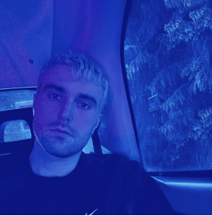

Tracklist:
1. January 1st 2022
2. Eyelar (shutters)
3. Delilah (pull me out of this)
4. Kammy (like i do)
5. Berwyn (all that i got is you)
6. Danielle (smile on my face)
7. Nathan (still breathing)
8. Bleu (better with time)
9. Kelly (end of a nightmare)
10. Clara (the night is dark)
11. Mustafa (time to move you)
12. Winnie (end of me)
13. September 9th 2022

Follow Fred again..
OFFICIAL SITE / INSTAGRAM / TIKTOK

Contact:
Kelly McWilliam / Atlantic Records
Kelly.McWilliam@AtlanticRecords.com

