FOR IMMEDIATE RELEASE
OCTOBER 19, 2021

ATLANTIC RECORDS AND ANDREW WATT’S GOLD TOOTH RECORDS ANNOUNCE EXCLUSIVE PARTNERSHIP

LEGENDARY GODFATHER OF PUNK, IGGY POP, IS FIRST ARTIST SIGNED
TO THE JOINT VENTURE

IGGY SET TO MAKE LABEL DEBUT WITH ELECTRIFYING SINGLE
“FRENZY” DUE OUT OCTOBER 28

“FRENZY” IS EXECUTIVE-PRODUCED BY GRAMMY AWARD-WINNING PRODUCER AND
GOLD TOOTH FOUNDER ANDREW WATT

PRE-SAVE “FRENZY” HERE

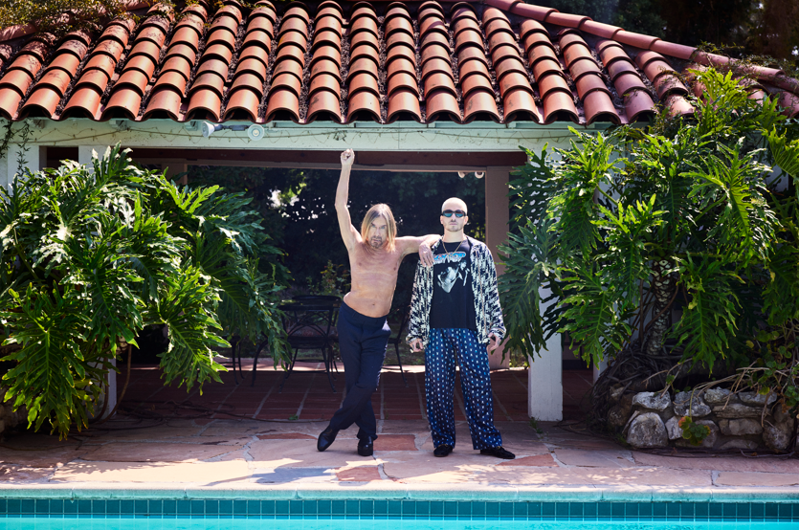

DOWNLOAD PRESS PHOTO HERE / CREDIT: DANNY CLINCH

Today, Atlantic Records has announced an exclusive partnership with Gold Tooth Records, founded by GRAMMY® Award-winning and multi-platinum producer Andrew Watt. In addition, the one and only Iggy Pop is the first artist signed to this joint venture. The GRAMMY® Lifetime Achievement Award honoree and Godfather of Punk shared he will make his label debut on October 28 with “Frenzy,” the first single off Iggy’s forthcoming album – pre-save the single HERE.

“I'm the guy with no shirt who rocks. Andrew and Gold Tooth get that, and we made a record together the old-fashioned way. The players are guys I've known since they were kids and the music will beat the shit out of you. Have a great day,” says Iggy Pop.

“Iggy Pop is a fucking icon. A true original. The guy invented the stage dive..I still can’t believe he let me make a record with him. I am honored. It doesn’t get cooler. This album was created to be played as loud as your stereo will go…turn it up and hold on…” says Andrew Watt.

“We’re incredibly excited to welcome Andrew and Gold Tooth into the Atlantic family. As a brilliant producer and stellar musician, Andrew has the gift of elevating every project into a work of art. And, of course, we’re over the moon to have the legendary and phenomenal Iggy Pop as our first joint signing. Iggy’s groundbreaking work forever changed the rock landscape, and he continues to make boundary-crashing music. This also marks his return to the Warner family, more than 50 years after he made his recording debut with the Stooges on our sister label Elektra. Iggy’s never stopped evolving, and he’s made a fantastic album that we can’t wait for the world to hear,” says Craig Kallman, Chairman & CEO, Atlantic Records.

Widely acknowledged as one of the most influential artists and dynamic live performers of all time, Iggy Pop is a singer, songwriter, musician, author, record producer, DJ, and actor whose epic body of work has earned him both worldwide critical acclaim and fanatic cult success. Beginning in 1967 with his era-defining group The Stooges, Pop merged primal rock, blues, and free jazz into something altogether dangerous and new, paving the way for punk, post-punk, hard rock, and grunge. His landmark solo career – which kicked off with 1977’s David Bowie-produced The Idiot and Lust For Life – has seen Pop traverse a stunning span of musical genres, inspiring generation after generation of rock ‘n rollers with his iconoclastic songcraft, uncompromising performance style, and one-of-a-kind charisma. Perhaps the greatest living embodiment of rock & roll, Pop has never slowed down, pushing the art form forward for more than half a century, including his most recent full length recording, 2019’s contemplative, critically acclaimed Free.

Andrew Watt’s diverse array of credits includes work with Justin Bieber, Post Malone, Elton John, Ed Sheeran, Miley Cyrus, Dua Lipa, Ozzy Osbourne and more. In 2021 he was honored with the GRAMMY® Award for Producer of the Year, Non-Classical, and recently produced Ozzy Osbourne’s #1 Billboard Chart-topping album Patient Number 9, as well as the single “Hold Me Closer,” the highly anticipated hit collaboration by Britney Spears and Elton John. At the top of 2022, Watt produced the entirety of Eddie Vedder’s critically acclaimed solo release Earthling, and in February, he landed two genre-bending hits on the Hot 100 in The Kid LAROI’s “Thousand Miles” and Ed Sheeran and Lil Baby’s “2step.” Beyond his producing and songwriting, Watt had the honor of joining Eddie Vedder on tour as part of his all-star side project, The Earthlings.

ABOUT IGGY POP
Emerging from the wilds of Michigan with the primal scream that was the first Stooges album, Iggy Pop has forged a singular path in musical history since 1969. His artistic output has been unrelenting and uniformly intense, from indelible Stooges staples Fun House and Raw Power, to solo classics including the brilliant 1977 double shot of his solo debut The Idiot and the timeless Lust For Life, New Values, Blah-Blah-Blah, Brick by Brick, Skull Ring, Post Pop Depression and most recently 2019’s Free. A member of the Rock & Roll Hall of Fame since his 2010 induction with The Stooges, Iggy has in recent years been the recipient of a Grammy Lifetime Achievement Award, as well as such prestigious international honors as France’s Commander of the Ordre des Arts et des Lettres and Sweden’s Polar Music Prize.

ABOUT ANDREW WATT
Andrew Watt is a Grammy winning music producer, having collaborated with a wide variety of A-list acts including Justin Bieber, Elton John, Miley Cyrus, Mick Jagger, Selena Gomez, Smokey Robinson, Bruno Mars, Sam Smith, Juice Wrld, Halsey, Nile Rodgers, Ellie Goulding, Khalid, Slash, The Chainsmokers, Blink 182, Bebe Rexha, Tom Morello, Florida Georgia Line, Duff McKagan, 5 Seconds of Summer, Taylor Hawkins and Chad Smith to name a few. Also an accomplished multi-instrumentalist, some of Watt’s production credits include Cardi B.’s groundbreaking 2019 album, Invasion of Privacy, which took home the Best Rap Album Grammy Award in 2019, Shawn Mendes and Camila Cabello’s smash global hit “Senorita,” as well as Lana Del Rey’s “Doin Time” which topped the Billboard charts at #1. In 2021, Watt took home his first Grammy Award for “Producer of the Year” at the 63rd annual Grammy Awards, for his work on Ozzy Osbourne’s Ordinary Man, Miley Cyrus’ Plastic Hearts, both of which he executive-produced, Dua Lipa’s Future Nostalgia, which took home the Grammy that year for Best Pop Vocal Album, and Post Malone’s Hollywood’s Bleeding, which was nominated for Album of the Year. His genre-transcending talent as a producer entices artists of all kinds but it is his laid-back charm that keeps them coming back – as friends, and as collaborators. His versatility as a songwriter, producer and all-around musician has made him a bona-fide hit-maker reminiscent of legends beyond his time.

ABOUT ATLANTIC RECORDS
Atlantic Records celebrated its 70th anniversary in 2018. Founded in New York City, the label literally grew from a one-room operation into one of the world’s preeminent music companies. Atlantic has released a string of recordings that have had a profound impact on the course of modern music, its rich history including such musical icons as Ray Charles, Aretha Franklin, John Coltrane, and Led Zeppelin. The Atlantic Records Group roster today includes many of the world’s most popular recording artists, among them Kelly Clarkson, Bruno Mars, Ed Sheeran, Cardi B, Sia, Roddy Rich, Coldplay, Lizzo, Jack Harlow, Tiesto, Ava Max, Charlie Puth, Charli XCX, Janelle Monáe, Lil Uzi Vert, Melanie Martinez, Skrillex, and many more.

CONNECT WITH IGGY POP
IGGYPOP.COM | FACEBOOK | INSTAGRAM | TWITTER | YOUTUBE

CONTACT FOR IGGY POP
Steve Martin & Michele Hug / Nasty Little Man
steve@nastylittleman.com / michele@nastylittleman.com

CONTACT FOR ANDREW WATT
Bianca Bianconi & Greg Cortez / 42West
Bianca.Bianconi@42West.net / Greg.Cortez@42West.net

CONTACT FOR ATLANTIC RECORDS
Kelly McWilliam / Atlantic Records
Kelly.McWilliam@AtlanticRecords.com

