FOR IMMEDIATE RELEASE
OCTOBER 26, 2022

MUSIC THE LABEL/ATLANTIC RECORDS SIGNEE JEVEN RELIFORD RELEASES HIS LONG-ANTICIPATED SINGLE “SAY DAT THEN (FEAT. ANN MARIE)
ACCOMPANIED BY SULTRY VISUAL STREAMING NOW
TRACK IS THE FOLLOW-UP TO HIS DEBUT SINGLE “BUTTERFLIES”
STREAM/DOWNLOAD “SAY DAT THEN”
WATCH/SHARE “SAY DAT THEN”

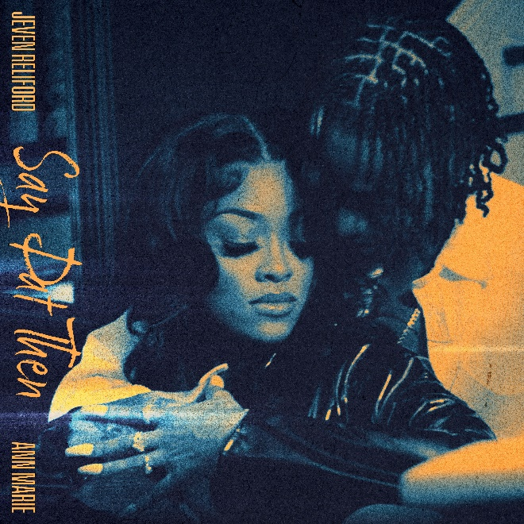
DOWNLOAD HI-RES ARTWORK

Today, Music The Label/Atlantic Records signee, Jeven Reliford, released his long anticipated single, “Say Dat Then (Feat. Ann Marie)” available for streaming on all DSPs. Emboldened by towering range, unassuming charisma, and relatable spirit, Jeven Reliford--the Atlanta, GA -born singer, and songwriter, is serving a fresh dose of much-needed pop + soulful sound. The single is accompanied by a sultry and seductive visual that pans back and forth between the pair. “Say Dat Then” comes on the heels of his Music The Label/Atlantic Records debut single “Butterflies.” Jeven’s debut single ‘Butterflies’ floats over a throwback towards a confessional chorus while his fluttering falsetto immediately takes flight.

“It’s about my partner and I really meaning what we say to each other. You have to mean what you say. If you say you really love me, you have to show me. It’s where I was coming from in the moment.”

After a long hiatus due to the COVID-19 pandemic, Jeven returns with a vision of maturing his sound and creating music that captures where he is with his art. This vision crystallizes on his single “Say Dat Then” (Feat. Ann Marie) produced by the SupaFriendz. On the track, elegant piano glistens through airy 808 claps. Jeven flexes his dynamic range as he urges, “If you’re really down, you better say dat then.” Meanwhile, Ann Marie responds with an equally emotional and endearing cameo. Jeven is truly an artist on the rise and if this single is any indication of what new heights await him, you don’t want to miss his ascension.

When Jeven Reliford sings, you’ll instantly recognize him. He projects his vocals in alternating bursts of emotion and power, dipping into grooves and taking flight on the hooks. He ultimately infuses his music with personality, bringing no shortage of charisma, clarity, and confidence to R&B. It’s why he’s quietly generated hundreds of millions of views. It’s why he’s attracted a fervent audience of millions of followers. It’s why he’s tipped for a breakthrough. The Georgia native recognized his voice as a kid. Mom and dad often heard him humming from his car seat. Listening to the likes of Chris Brown, Bruno Mars, and Justin Bieber, he often practiced their songs until he could replicate the high notes. Simultaneously, he excelled as an athlete, studying Brazilian jiu-jitsu, wrestling, and running track at a D1 level. He also quietly honed his vocals, showing off in the car until a friend encouraged him to post on TikTok. He reluctantly uploaded a 12-second cover of “Goodbyes” by Post Malone and Young Thug. It caught fire on the platform, inspiring him to continue to post. By his twelfth video, he had eclipsed a quarter-of-a-billion views and 37 million “likes” with labels flying him to meetings across the country. He eventually went on to catch the attention of Anthony “T.A.” Tate. After a number of meetings, he signed to Music The Label in partnership with Atlantic Records in 2020. He spent the next two years not only shaping his sound with tracks such as “Butterflies,” but also growing up. Now, there’s no mistaking him for anybody else on a series of 2022 singles and his forthcoming debut for Music The Label/Atlantic Records.

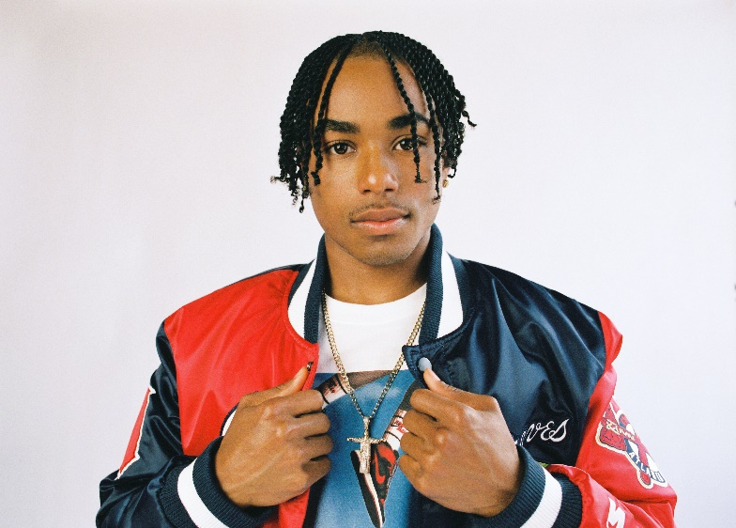
DOWNLOAD HI-RES PRESS PHOTOS

FOR PRESS INQUIRIES CONTACT:
SYDNEY MARGETSON
SYDNEY.MARGETSON@ATLANTICRECORDS.COM

CONNECT WITH JEVEN:
INSTAGRAM | TWITTER | FACEBOOK | TIK TOK

