For Immediate Release
OCTOBER 14, 2022

Jax’s “Victoria’s Secret” is a smash

Hit single charting top 40 on Billboard Hot 100 + Top 20 on Pop & Hot AC radio

Multi-talented singer/songwriter joins 2022 iHeartRadio Jingle Ball line-up,
performing at NYC’s Madison Square Garden & more

Viral Version featuring 10-year-old Metal virtuoso Harper out today

DOWNLOAD HIGH-RES ART/IMAGES

STREAM “VICTORIA’S SECRET”: LINK
STREAM “VICTORIA’S SECRET” [The Metal Version]: LINK

Multi-talented singer-songwriter Jax continues her meteoric rise with “Victoria’s Secret” (out now via Atlantic Records). The explosive single has proved an incredible viral sensation, garnering over 4 million weekly streams in the US alone for the past 12 weeks with overall global streams exceeding 125 million in just 3 months. The single earned Jax her debut entry on the Billboard Hot 100, jumping 14 spots to a new peak of #38 this week (the single’s 10th the chart). The anthem also continues to reign supreme at radio, currently ascending to the #18 spot on the Top 40 chart and #10 at Hot AC.

Originally shared on TikTok as part of her viral “The Kid I Babysit” series, Jax wrote “Victoria’s Secret” as an ode to body positivity and anti-bullying. Her personal take and blunt honesty quickly resonated with her followers and beyond, sparking a movement that ultimately garnered a response from the company itself. She’s since performed the song live on The TODAY Show, The Drew Barrymore Show and at the 2022 iHeartRadio Music Festival in Las Vegas, in addition to joining the line-up for iHeartRadio’s 2022 Jingle Ball tour (including stops at Madison Square Garden in New York City and The Kia Forum in Los Angeles).

Today, Jax teams up with 10-year-old Metal virtuoso Harper for “Victoria’s Secret” [The Metal Version] – released by demand after the duo’s unexpected interpretation went viral on TikTok (watch here). The hard-hitting re-imagined version only further proves the song’s relatability, connecting with listeners of all ages and musical genres.

The rise of “Victoria’s Secret” adds to what has already been an exciting year for Jax, kicking off with the release of her swooning single “To All The Boys I’ve Loved Before” which was deemed “a viral hit” by Billboard and followed by “u love u” featuring GRAMMY®-nominated producer/singer-songwriter JVKE. 2022 also saw Jax take home the iHeartRadio Music Award for TikTok Songwriter of the Year, thanks to her incredibly creative TikTok songs that have featured cameos from the likes of Leslie Jordan, John Stamos, Natasha Bedingfield and more.

Raised in New Jersey by way of New York, Jax got her start by performing a wide variety of genres and in bands growing up. At the age of 18, she developed cancer above her vocal cords, which returned following a couple months of remission right as she relocated to Los Angeles in pursuit of her music. Left unable to sing herself, Jax turned to songwriting for others and found industry success behind-the-scenes.

As her ability to perform returned, Jax needed to pivot yet again when the COVID-19 pandemic struck. This time she turned to TikTok, posting a hilarious response to the pop gem “Stacy’s Mom” from “Stacy’s Mom’s Perspective” which exploded with nearly 9 million views in just a few months and follow-ups including “Update from Avril Lavigne & Sk8er Boi 18 years later.” She continued to go viral a dozen or more times over, having now amassed over 12 million followers on the platform and over 195 million “likes” to date. With a massive online audience under her belt, Jax began sharing her own original music in late 2020 to an overwhelmingly positive response – ultimately leading to her signing with Atlantic Records for her forthcoming debut full-length.

“Victoria’s Secret” marks the latest in a catalog of fan-favorite singles from Jax – including her heartwarming ballad “Like My Father” which has amassed over 180 million streams and was crowned amongst “the best father-daughter dance songs of all time” by The Knot. Meanwhile, her nostalgia-fueled anthem “90s Kids” received over 1 million weekly streams for 21 consecutive weeks and label-debut single “Ring Pop” yielded high-profile appearances on The Ellen DeGeneres Show, Access Hollywood & more.

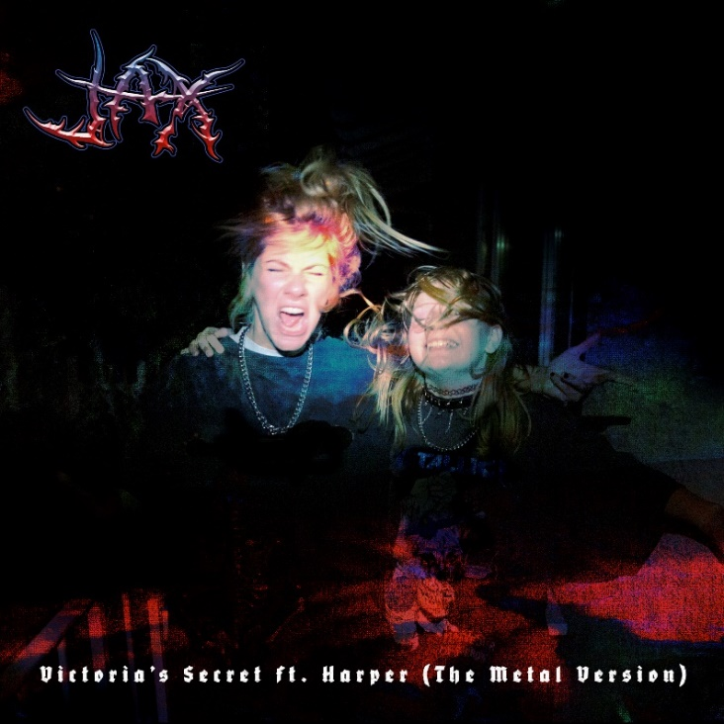
DOWNLOAD HIGH-RES ART/IMAGES

CONNECT WITH JAX:
TikTok | YouTube | Instagram | Twitter | Facebook | Press Assets

CONTACT:
Ted Sullivan | ted.sullivan@atlanticrecords.com

