FOR IMMEDIATE RELEASE
OCTOBER 5, 2022

KALI RETURNS WITH HER LATEST SINGLE “BOUT U”
ACCOMPANIED BY VISUAL STREAMING NOW
FOLLOW UP TO PREVIOUSLY RELEASED “WET” VISUAL
TOXIC CHOCOLATE EP RELEASED EARLIER THIS YEAR AVAILABLE FOR STREAMING
LISTEN/DOWNLOAD “BOUT U”
WATCH/SHARE “BOUT U”
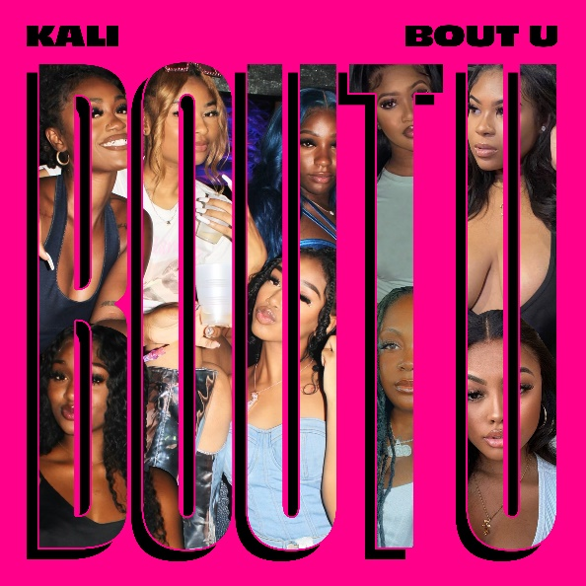
DOWNLOAD HI-RES ARTWORK

Rising Atlanta, GA rap star Kali is back with her latest single “Bout U” available for streaming now on all DSPs. Single is also accompanied by a visual streaming now via YouTube. When it comes to those she loves, Kali doesn’t hold anything back and delivers daggers in the form of her lyrics. The energetic and fierce single has been teased by Kali via TikTok and Instagram with thousands of responses, making the single a highly anticipated release. Produced by Mack Got The Heat, 44 Preme, and Reloaded Jo, “Bout U” also comes on the heels of the fun, sexy visual for previously released “Wet.”

Kali’s been having a landmark year. After the release of her highly acclaimed EP Toxic Chocolate, Kali was admitted into the XXL 2022 Freshman Class. This momentous, career-defining feat was supported by her thrilling freestyle and cypher performances streaming now. She continued her run with the release of the singles “FNF (Freestyle)” and “Wet” with each visual at over a combined 1M views via YouTube.

# # #

Toxic Chocolate – available now at all DSPs and streaming services – arrived earlier this year amidst both popular and critical acclaim, with Hot New Hip Hop simply declaring her “Rap's Next ‘It’ Girl.” The EP is highlighted by the incendiary singles, “UonU (Feat. Yung Bleu)“ and “Standards,” the latter of which had its exclusive premiere – alongside Kali’s debut interview – on Apple Music’s New Music Daily Radio with Zane Lowe. Kali then increased the power of Toxic Chocolate with the surprise addition of the fan favorite “Chainzzz (Feat. Muni Long)” as well as a revised sequence.

The arrival of Toxic Chocolate was further joined by an electrifying performance of the EP standout, “New Day,” filmed exclusively for UPROXX Sessions and streaming now HERE. UPROXX further praised Kali for “her gift for wordplay and her spicy relationship sensibilities,” adding, “(Kali) turns the tables on the f*ckboys of hip-hop, using their manipulative tactics to even the odds and give them a taste of their own medicine.”
# # #

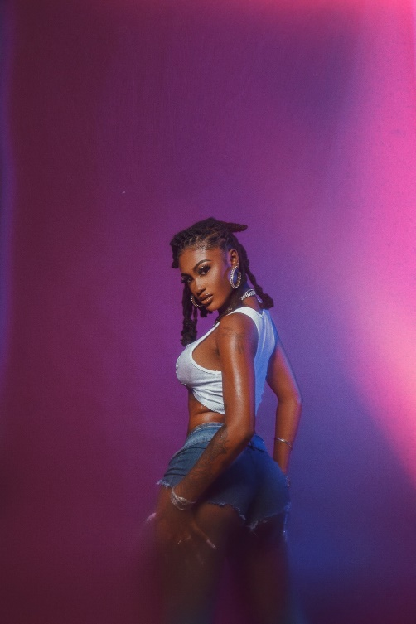

CONNECT WITH KALI
TIKTOK | TWITTER | INSTAGRAM | FACEBOOK | YOUTUBE

PRESS CONTACT
Ariana White | Ariana.White@AtlanticRecords.com

