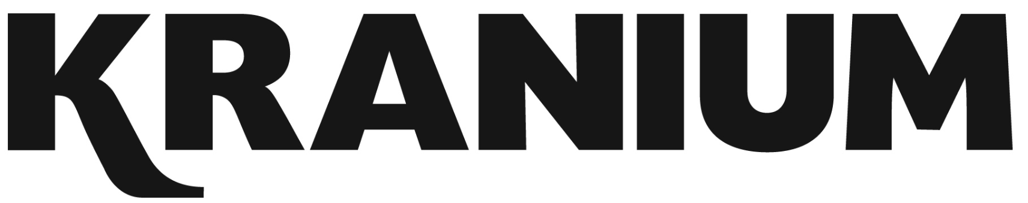

Over the span of his career, Kranium has established himself as one of the hottest international dancehall artists in the world. In 2019, Kranium unveiled his debut album, Midnight Sparks to the world. The album saw Kranium continuing to craft a simmering sonic cocktail of reggae, R&B, hip-hop, and soul, including superstar features from the likes of AJ Tracey, Mahalia, Burna Boy, and longtime collaborator Ty Dolla $ign. The album showcased fiery singles as “So Me Move,” “Just The Style (Feat. Alkaline),” “Talkin’ (Feat. PJ),” and “In Charge.” Kranium’s sparkling debut was followed in 2020 with the release of “Gal Policy,” a fan-favorite with a lyric video that accumulated over 14 million views in six months of its release. In addition, Kranium also unveiled “Through The Window,” afterwards closing out the year with a fiery collaboration “Block Traffic (feat. Rytikal).” In 2021, Kranium released his EP, Toxic, and followed up with the “Wi Deh Yah” single earlier this year. A true “set the tone” record that showcases Kranium’s clever lyricism, gift for melodies, and the perfect balance of vocals, “Wi Deh Yah,” displayed the smoothness he’s known for but with a bit of street Dancehall flare. Kranium supported the single with his “Wi Deh Yah” Tour and followed up with an appearance and performance at the 2022 Essence Music Festival. Recently, he released a sexy new single “Without You (Feat. Queen Naija)” and spoke with Billboard about his upcoming EP. With his sites set on 2023, Kranium will embark on his “Wi Deh Yah” UK Tour.

