KSI RELEASES HARD-HITTING NEW SINGLE
“NOT OVER YET” FEATURING TOM GRENNAN

LISTEN HERE | WATCH HERE

MARKS KSI’S FIRST RELEASE ON ATLANTIC RECORDS

CONTINUES MOMENTUM TOWARDS HIS HIGHLY ANTICIPATED BOXING RETURN
AT THE O2 ON AUGUST 27

TICKETS ON SALE NOW AT TICKETMASTER.COM & AXS.COM

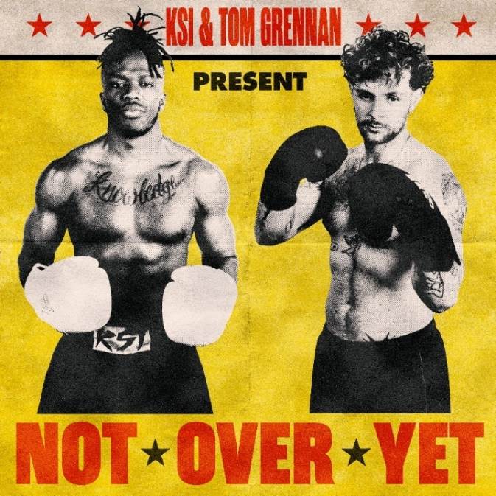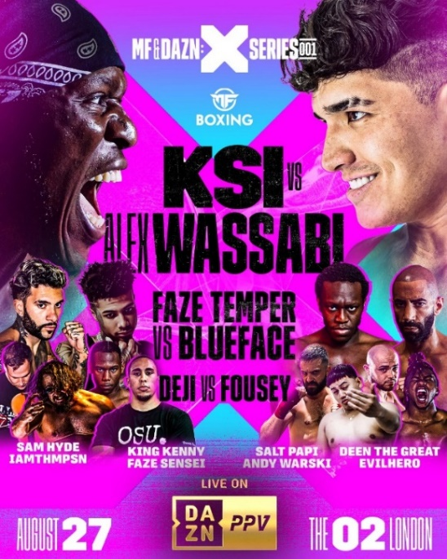
DL art here

Today, 3x BRIT nominated KSI marks the dawn of a new era with the release of striking new single “Not Over Yet”, an Atlantic Records debut featuring BRIT and Ivor Novello-nominated star Tom Grennan. Underpinned by heartbreak, KSI is not giving up on love as the song begins as an acoustic symphony before exploding into a fiery d’n’b beat with a soaring singalong chorus which perfectly sums up the ups and downs of a relationship. Listen HERE and watch the official video HERE.

As proven by “Not Over Yet” produced by Digital Farm Animals (Dua Lipa, Ellie Goulding Mimi Webb) and Billen Ted (Mae Muller, JC Stewart, Armin van Buuren) and written alongside Sara Boe (Anne-Marie, Birdy, Zara Larsson) and Rick Boardman (Marshmello, Louis Tomlinson, Clean Bandit) and the frankly banging first fruits of KSI’s deal with new record label Atlantic – when it comes to writing songs, he’s not afraid to dig deep and admit to challenges. Because music is where we find the real artistry of KSI.

The official video – directed by Troy Roscoe (Ed Sheeran, Burna Boy, Lil Wayne, Rick Ross, Polo G) – begins by reminding fans of KSI’s record-breaking foray into boxing when he fought Logan Paul at a sold-out Staples Centre in 2019 which became the biggest white-collar fight in history. Fused with powerful solo performances from Grennan whose soulful rasp has elevated a succession of high-octane hits over the last two years, including his own Little Bit of Love and Calvin Harris smash By Your Side, the video follows KSI on his Rocky-style montage culminating in a boxing fight against the old version of himself – his own worst enemy. KSI is his own competition, and the final scene marks this departure from his former self: things will be taken care of as he is in the best shape of his life.

The release follows the recent news that KSI will make his long-awaited return to boxing with a headline fight at The O2 on Saturday 27 August. MF & DAZN: X SERIES 001, powered by Misfits Boxing, will see the larger-than-life British phenom look to avenge his brother’s loss against long-time rival Alex Wassabi. Tickets are on sale now at Ticketmaster.co.uk and AXS.com. It will also be available to subscribers around the world on DAZN Pay-Per View (PPV).

On the release of the new track, KSI says, “I’m finally releasing my first single since the 2021 release of All Over The Place. Teaming up with Tom Grennan, we’ve made an absolute smash to get the people pumped and ready for my headline fight at The O2 later this month. This is a song that amplifies my “never give up” attitude, whether it’s to do with love or being back in the ring.”

Tom Grennan adds, “I’m buzzing to be working with KSI. The guy is a beast and has his fingers in all different pies and is killing the music game also! The song is a banger and I think people are gunna love it. I’m buzzin!”

ABOUT KSI:
A pioneering, YouTuber (third most followed channel for a British artist behind Ed Sheeran and Adele) approaching 20 billion cumulative views, his 40.8 million subscribers know him as a creator, an artist, a mate who brings the passion (and the jokes) to whatever he does. He’s a businessman with a portfolio of interests, from owning his own music label, The Online Takeover and his own boxing promotions company, Misfits Boxing to one of the fastest growing beverages, his Prime Hydration drink (recently partnered with Arsenal FC) is set to surpass $140 million in revenue in its first year. As a performer and all-round entertainer, he can light up stages (Reading, TRNSMT, a Wembley headline) and screen: an upcoming documentary for Prime Video, produced by Louis Theroux, promises to lift the lid on the extraordinary life of the 29-year-old from Watford. And as a boxer, the amateur-turned-professional fighter is undefeated, with his last bout, against Logan Paul at Los Angeles Staples Centre in 2019, a global pay-per-view knockout. 27th August will mark his return to the ring when he steps out at London’s O2 to fight Alex Wassabi. As a musician with over 12 million monthly Spotify listeners, he’s also well-versed in coming out on top. His second album, summer 2021’s All Over the Place entered the charts at #1, an emphatic follow-up to the previous year’s debut, Dissimulation, a #2 hit which was the biggest selling debut album of 2020. In rapid succession there’s been a flurry of hits, on his own merits (making him the British Breakthrough Artist of 2020) and with others (Don’t Play with Anne-Marie, Lighter with Nathan Dawe), making for eight Top Ten singles in total. As prolific as he is innovative, KSI was the only artist to be nominated twice in the Song of the Year category at the 2022 Brit Awards. That’s KSI in 2022: in the ring and in the charts, he’s punching well above his weight. Get ready for his next knockout.

ABOUT TOM GRENNAN:
Tom Grennan is back, to remind us of his premium pop songwriting gifts and his shooting star talent.
The blockbuster breakout British artist of last year – three Top 10 singles, (two of them platinum-selling), one Number One album (Evering Road), two BRIT Award nominations (including Alternative/Rock Act), 100,000 gig tickets sold, one billion streams – is already dreaming it up all over again with the release of scorching new singles Remind Me and All These Nights. Across spring and summer, Grennan has been touring the US, Europe and Australia, a long and glorious run-in to his birthday homecoming show at Bedford Park, four days before he turned 27. A sold-out show to 15,000 fans. There will, too, be more global touring as Grennan is finally able to travel the world to meet the bottled-up fan excitement generated by his second album, not to mention by his hit collab with Calvin Harris on the Scottish producer’s summer 2021 global smash By Your Side. In South Korea alone the Englishman has become a superstar, with the BRIT-nominated Little Bit of Love (his first UK Top 10) streamed 30 million times and covered by a clutch of K-Pop talents. And all this without him having set foot in the country. This is how his 2022 is shaping up. Get ready for the ride.

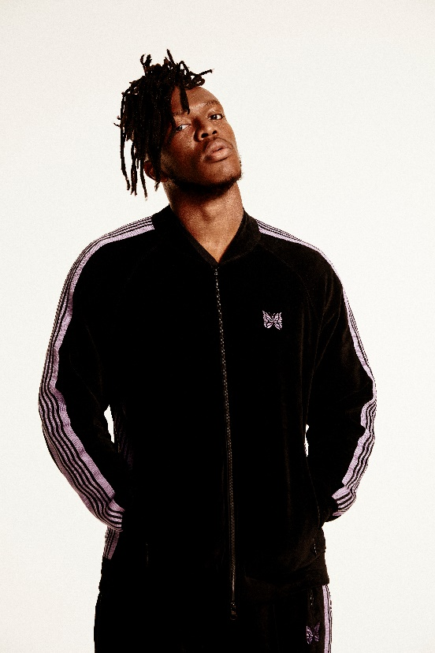
DOWNLOAD PRESS PHOTO HERE

CONNECT WITH KSI
Instagram | Twitter | Spotify | YouTube | Website

FOR MORE INFORMATION:
Paige.Rosoff@atlanticrecords.com
Atlantic Records | Big Beat Records

CONNECT WITH TOM GRENNAN
Instagram | Facebook | Twitter | YouTube | TikTok | Website

