YOUNGBOY NEVER BROKE AGAIN CELEBRATES HIS 23RD BIRTHDAY WITH
NEW MIXTAPE
MA’ I GOT A FAMILY (A GANGSTA GRILLZ SPECIAL EDITION HOSTED BY DJ DRAMA)
MIXTAPE IS PRECURSOR TO 3860 COLLAB MIXTAPE WITH QUANDO RONDO
FOLLOW UP TO RECENTLY RELEASED 3800 DEGREES MIXTAPE
RECENTLY WELCOMED HIS NINTH CHILD WITH HIS PARTNER
THE KING OF STREAMING MARKED RELEASE OF THE LAST SLIMETO WITH HISTORIC 100 RIAA CERTIFICATIONS
STREAM/DOWNLOAD MA’ I GOT A FAMILY
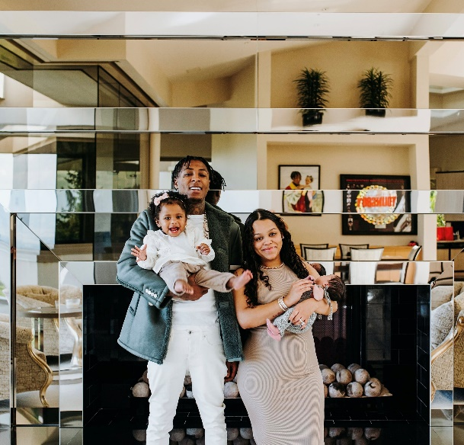
DOWNLOAD HI-RES ART

Multi-platinum certified rap superstar YoungBoy Never Broke Again has released his 6th project of 2022 Ma’ I Got A Family (A Gangsta Grillz Special Edition Hosted By DJ Drama), available to stream on all DSPs. The mixtape includes features from the legendary Nicki Minaj & Yeat and is executive produced by Generation Now co-founder, DJ Drama. This mixtape comes on the heels of his recently released 3800 Degrees & Realer 2 mixtapes. This past summer, YoungBoy also released his last official Atlantic Records album, The Last Slimeto, which debuted at #2 on the Billboard Top 200 and is available now for streaming. YoungBoy also recently welcomed the birth of his ninth child with his partner Jazlyn Mychelle, who is featured on his newest mixtape cover.

MA’ I GOT A FAMILY (A GANGSTA GRILLZ SPECIAL EDITION HOSTED BY DJ DRAMA) TRACKLIST

- Pop Out
- Rain
- Sedated
- Get Right
- Right Now
- McQueen
- Ben Lomond Mountain
- Kentrell Talk
- Sport Mode
- Pay Me
- All The Problems
- Chose
- Rose Gold
- I Admit (Feat. Nicki Minaj)
- Change On Me
- King Of The Jungle
- I Don’t Text Back (Feat. Yeat)
- Act A Fool
- Kick It

Earlier this year, the RIAA announced 100+ separate certified titles for the young superstar. This historic feat puts YoungBoy in a class all on his own as the youngest artist to ever achieve such a triumph. The Last Slimeto joins YoungBoy’s ever-burgeoning catalog of music after his latest mixtape, COLORS – which housed recent hit tracks, including “Emo Rockstar,” “Fish Scale,” “Foolish Figure,” “Emo Love,” “Bring The Hook,” and “Know Like I know” all now available at DSPs and streaming services everywhere HERE. COLORS only feature Quando Rondo, who also has an upcoming joint mixtape with YoungBoy and you can stream his latest single “War Baby” HERE.

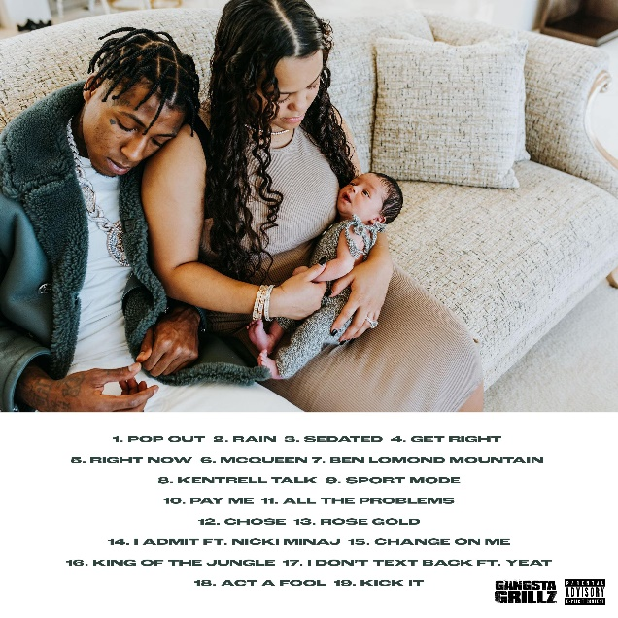

# # #

FOR MORE INFORMATION, PLEASE VISIT:
INSTAGRAM | TWITTER | FACEBOOK

FOR ALL PRESS INQUIRIES, PLEASE CONTACT:
ARIANA.WHITE@ATLANTICRECORDS.COM

