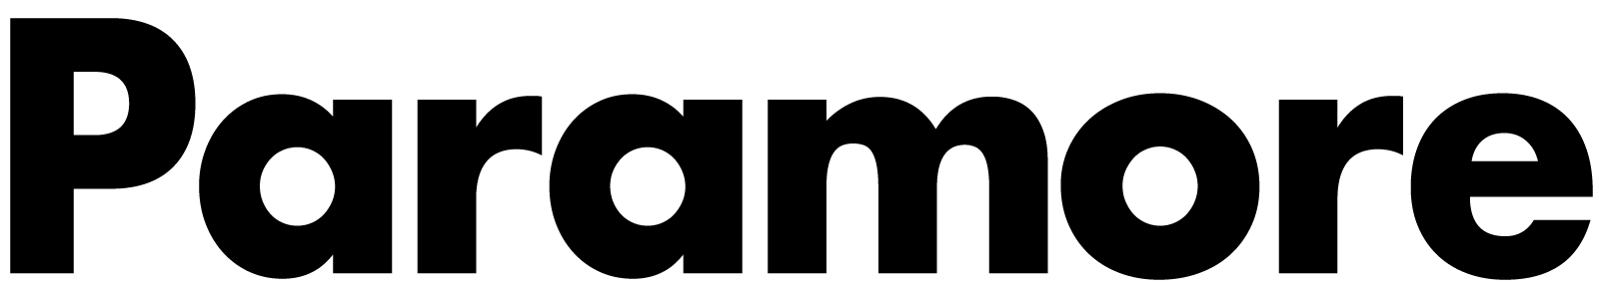
PARAMORE ANNOUNCE TWO INTIMATE LA SHOWS

CLAUD, OGI, ELKE + FAUX REAL ADDED TO DATES

REGISTER FOR LA TICKETS HERE

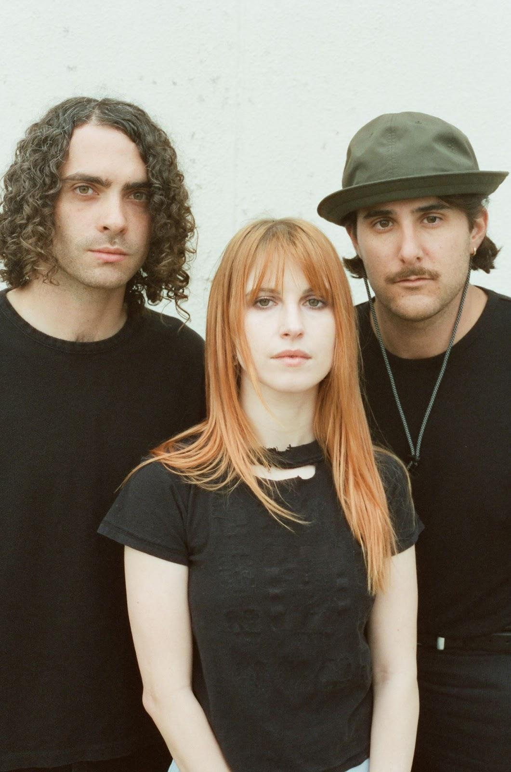

Paramore have added two Los Angeles dates to their run of intimate performances across the U.S. The band will be playing on October 20 at The Wiltern with Faux Real and October 27 at The Belasco with Elke. Fans can register HERE exclusively through Ticketmaster’s request platform from now until Wednesday, September 14th at 11:59 PM local to get access to tickets. A portion of ticket sales from both Los Angeles shows will be donated to Support + Feed, a non-profit that takes action for a global shift to an equitable, plant-based food system to combat food insecurity and the climate crisis.

Singer-songwriter Claud will accompany Paramore on their first slew of shows in Bakersfield, Magna, Omaha, Oklahoma City and Chesterfield. Young the Giant, Japanese Breakfast and Claud will join the band for a very special show in Bonner Springs. Ogi will be supporting for the remainder of the dates after the Los Angeles shows with Faux Real and Elke.

PARAMORE SHOW DATES
October 2, 2022 - Bakersfield, CA - Mechanics Bank Theater #
October 4, 2022 - Magna, UT - The Great SaltAir #
October 6, 2022 - Omaha, NE - Orpheum Theater Omaha #
October 8, 2022 - Oklahoma City, OK - The Criterion #
October 9, 2022 - Austin, TX - Austin City Limits
October 11, 2022 - Chesterfield, MO - The Factory #
October 14, 2022 - Bonner Springs, KS - Azura Amphitheater* &
October 16, 2022 - Austin, TX - Austin City Limits^
October 20, 2022 - Los Angeles, CA - The Wiltern ~
October 22, 2022 - Las Vegas, NV - When We Were Young Festival^
October 23, 2022 - Las Vegas, NV - When We Were Young Festival^
October 27, 2022 - Los Angeles, CA - The Belasco %
October 29, 2022 - Las Vegas, NV - When We Were Young Festival^
November 7, 2022 - Toronto, ON - HISTORY =
November 9, 2022 - Chicago, IL - The Chicago Theatre =
November 11, 2022 - Cincinnati, OH - The Andrew J Brady Music Center =
November 15, 2022 - Atlanta, GA - Tabernacle =
November 16, 2022 - St. Augustine, FL - The St. Augustine Amphitheatre =
November 19, 2022 - Mexico City, MX - Corona Capital Festival^

*Not a Live Nation Date
^Festival Date - Ticketmaster Verified Fan Presale Not Applicable
# with Claud
= with Ogi
& with Young the Giant, Japanese Breakfast and Claud
~ with Faux Real
% with Elke
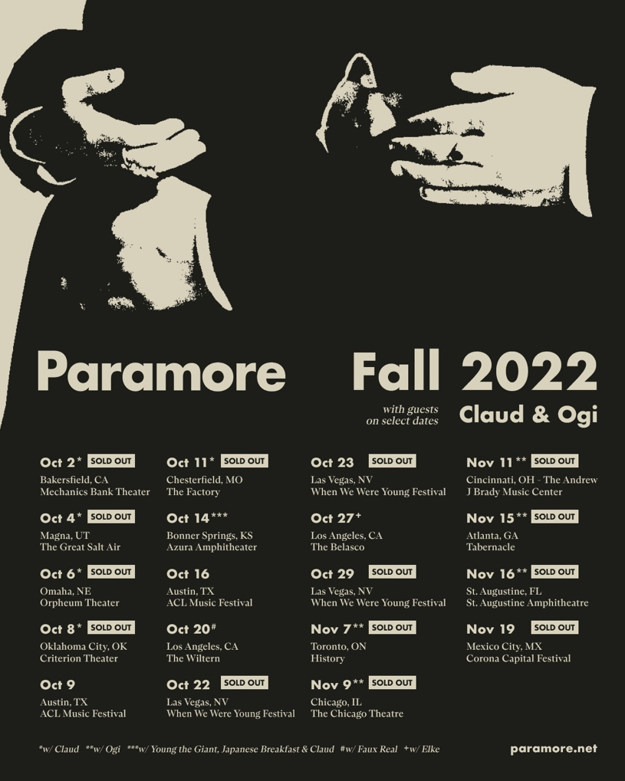

KEEP UP WITH PARAMORE:
Twitter / Instagram / Facebook / Web

About Live Nation Entertainment
Live Nation Entertainment (NYSE: LYV) is the world’s leading live entertainment company comprised of global market leaders: Ticketmaster, Live Nation Concerts, and Live Nation Sponsorship. For additional information, visit www.livenationentertainment.com.

