FOR IMMEDIATE RELEASE
OCTOBER 7, 2022

GENEVIEVE STOKES PLEADS “CAN I” WITH POWERFUL NEW SINGLE

ALT-POP SINGER-SONGWRITER ANNOUNCES NEW EP, CATCHING RABBITS, OUT JANUARY 20

US TOUR ALONGSIDE CHARLIE BURG KICKS OFF OCTOBER 12

LISTEN TO “CAN I” | WATCH OFFICIAL VISUALIZER
PRE-SAVE CATCHING RABBITS

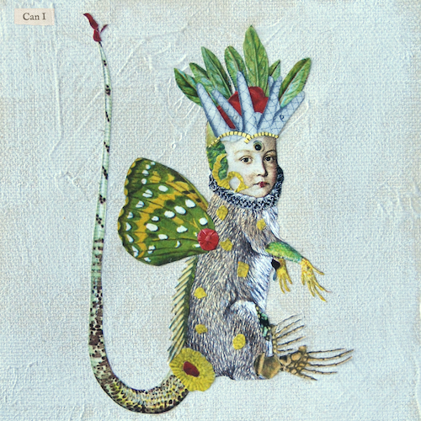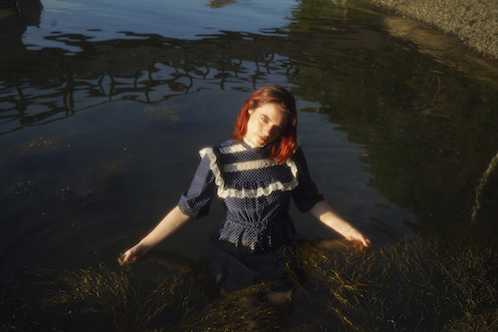
DOWNLOAD HI-RES ARTWORK + PRESS PHOTOS (CREDIT: ABBIE PITRE)

Acclaimed alt-pop singer-songwriter-pianist Genevieve Stokes has shared her most emotionally direct single thus far, “Can I,” available today at all DSPs and streaming services. Written by Stokes featuring additional production from the esteemed Tony Berg (Phoebe Bridgers, Paul McCartney, Taylor Swift), the pleading, powerful and lush new track arrived alongside the exclusive Rolling Stone announcement of the Portland, ME-based artist’s eagerly awaited new EP, Catching Rabbits, out Friday, January 20. Pre-save Catching Rabbits HERE and watch the beautiful visualizer for “Can I” HERE.

“‘Can I’ is an outpouring of emotions and fragmented memories,” shares Genevieve, “always coming back to the present moment and a sense of deep appreciation for the relationships in my life – no matter how fleeting.”

“This EP is more introspective and experimental than my first project and I think it reflects a change in my connection to reality and the relationships in my life,” Stokes told Rolling Stone. “‘Catching Rabbits’ is my more uplifting take on the phrase ‘chasing rabbits’— that it’s possible to achieve what seems out of reach, and to escape the tempting illusions of the mind.”

Catching Rabbits will also feature lead single and fan favorite, “Habits,” which earned over 50M views across a series of TikTok teases prior to release and has since garnered 13M+ global streams in addition to praise from PAPER, which applauded Stokes for channeling “beautiful scenery” and performing “gut wrenching ballads.” A fantastical Alice’s Adventures in Wonderland-inspired music video – directed by Abbie Pitre and Roman Spataro and hailed by TEEN VOGUE as “the woodland fairy fantasy of your dreams” – is streaming now at YouTube HERE. Also shot in Genevieve’s hometown of Portland, ME, a gorgeous live performance of “Habits” is available to watch HERE.

Stokes – who has spent much of the past year touring alongside artists including Noah Kahan, Briston Maroney, and Sarah Kinsley – will precede Catching Rabbits by joining Charlie Burg as special guest on his upcoming “Infinitely Tall Tour” beginning October 12 at Washington, DC’s Union Stage and traveling through mid-November. For complete details and ticket info, please visit genevievestokes.com/tour.

Named by Alternative Press as a “New Artist You Need To Hear, Genevieve made a striking debut with her 2021 debut EP, Swimming Lessons, which features standout tracks “Surface Tension,” “Parking Lot“ and “Running Away.” Recorded in a cabin just a stone’s throw from her childhood home, bringing a delicate, youthful, and intimate touch to her storytelling, the critically acclaimed EP went on to earn over 16M streams worldwide while receiving praise from publications including Flaunt, NYLON, Billboard, Refinery29, FLOOD, and more.

At only 21-years-old, Genevieve has quickly drawn attention and applause for her intimate yet lush approach to alternative pop. Having taught herself piano at the age of eight, Stokes spent much of her teens developing her own unique sound, inspired by iconic female musicians like Fiona Apple and Regina Spektor but infused with personal experience and perspective. Before releasing her debut EP, Stokes had already amassed over 7M streams independently, ascended esteemed playlists and garnered support from Complex, EARMILK, Ones to Watch and more.

GENEVIEVE STOKES NORTH AMERICAN TOUR 2022
* All Dates w/ Charlie Burg

OCTOBER
12 - Washington, DC - Union Stage
14 - Philadelphia, PA - The Foundry
15 - Syracuse, NY - Westcott Theater
17 - Nashville, TN - The Basement East
18 - Atlanta, GA - The Masquerade
21 - Dallas, TX - Club Dada
22 - Austin, TX - Empire Control Room & Garage
25 - Phoenix, AZ - The Rebel Lounge
26 - Los Angeles, CA - El Rey Theatre
28 - Oakland, CA - The New Parish

NOVEMBER
1 - Portland, OR - Holocene
2 - Seattle, WA - Barboza
4 - Salt Lake City, UT - Kilbey Court
5 - Denver, CO - Globe Hall
8 - Lawrence, KS - The Bottleneck
10 - Minneapolis, MN - 7th St Entry
11 - Des Moines, IA - xBk live

CONNECT WITH GENEVIEVE STOKES
OFFICIAL | INSTAGRAM | TWITTER | YOUTUBE | FACEBOOK | TIKTOK | PRESS ASSETS

PRESS CONTACT:
ANDREW.GEORGE@ATLANTICRECORDS.COM

