FOR IMMEDIATE RELEASE
OCTOBER 26, 2022

corook realizes self-worth with “smoothie”

comedic alt-pop artist shares introspective new track

listen to “smoothie”

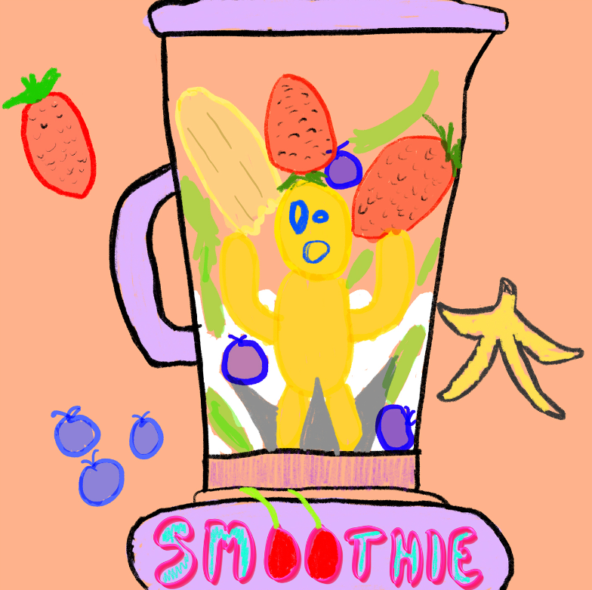
download artwork here

“If specificity is the soul of narrative, then corook is one of the most naturally gifted storytellers in the game.” – BILLBOARD

“corook is the next thing to bless your music downloads.”
– PEOPLE

Self-described “singer, songwriter, producer, multi-instrumentalist, and huge f*ckin dork” corook [pronounced ‘co-rook’] has shared her new track, “smoothie,” an ode to realizing your self-worth, available today at all DSPs and streaming services. Listen HERE.

“Smoothie is a song I wrote about realizing my worth and realizing i have ALWAYS been worthy,” shared corook. “‘I’ll buy new pants when I lose weight!’ ‘Or I can take a break when I get that promotion!’ ‘Or I’ll be happier when I’m dating somebody!’ Smoothie is a song about buying those pants, vacationing whenever you want and dating your damn self! I love me.”
Recently named one of The Advocate’s “7 Queer Artists For Your Fall Playlist,” the genre-busting, Nashville-based musician tackles deeply personal themes in her music and visuals through a unique, quirky and humorous lens. This past spring, she blessed the world with her debut achoo! EP, which features surprising and insightful tracks including “idk god,” “degree,” “bad friend,” and “sims,” in addition to the fan favorite, “snakes”. Since release, corook has shared her viral adult lullaby, “it’s ok!,” the unrestrained single “BDSM,” super-hot “hell yeah” and most recently, the heartfelt “your mom.”

corook – who lit up this summer’s Bonnaroo Music & Arts Festival with her debut festival performance, featuring in Rolling Stone’s Bonnaroo 2022 wrap-up – just wrapped up her US tour where she teamed up with NYC-based piano pop/rock trio Jukebox the Ghost. Next month will see corook travel to Mexico City for Mexico’s Festival Corona Capital, set for Friday, November 18. Earlier this year, she hit the road for her first-ever North American live run alongside K.Flay and opened for X Ambassadors at “A Night Benefitting Reproductive Rights” at The Troubadour. For all tour details and ticket information, please visit www.corook.com.

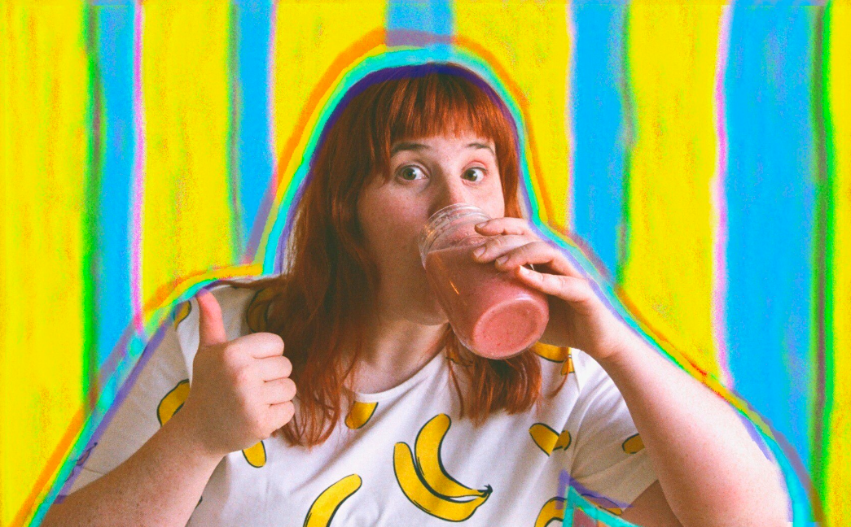
download press photo here
corook by corook
corook aka Corinne Savage (yes that’s her real last name) is a singer, songwriter, producer, multi-instrumentalist and a huge fuckin dork. No but seriously. She can solve a Rubix cube in under a minute (depending on how she’s feeling that day.) This ~freckled chubby babe~ was born and raised just outside of downtown Pittsburgh, Pennsylvania, where they grew up listening to Drake, Gwen Stefani and Mac Miller (RIP). She went to a performing arts high school (yes, just like Victorious) where she came out as QUEERAF her senior year. She then went to Berklee College of Music (wow – Owen Wilson voice) and graduated with TWO degrees (barely.) corook currently resides in Nashville, Tennessee (howdy.) She spends most of her time writing and producing music for her artist project “corook” (boop!) locked away in her room, alone (she blames it on Coronavirus but she’s actually just anti-social.) She’s 27 and VERY cute.

connect with corook:
corook.com | instagram | tiktok | press assets

press contact:
andrew.george@atlanticrecords.com

