FOR IMMEDIATE RELEASE
OCTOBER 27, 2022

QUANDO RONDO RETURNS WITH HIGH ENERGY TRACK “CREAM SODA”
SONG HAS ALREADY EARNED OVER 1.5M VIEWS ACROSS INSTAGRAM AND TIKTOK
ACCOMPANIED BY A VISUAL STREAMING NOW
LISTEN/DOWNLOAD “CREAM SODA”
WATCH/SHARE “CREAM SODA”
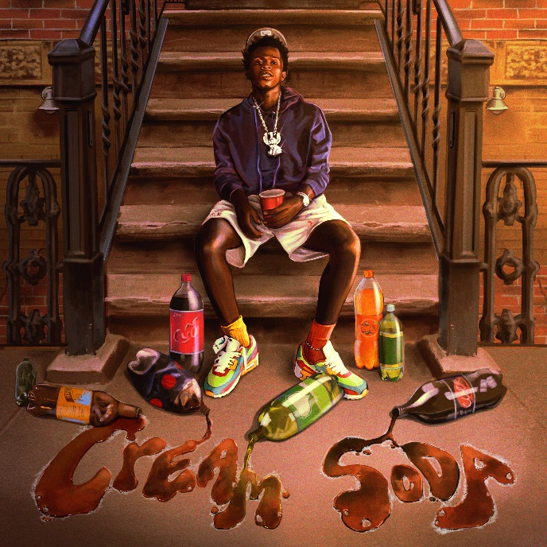
DOWNLOAD HI-RES ARTWORK
Multi-platinum rapper Quando Rondo is continuing his landmark year with today’s release of his latest single, “Cream Soda” available now at all DSPs. The upbeat new track features Quando’s signature vocals and catchy hooks and includes a visual to accompany the release. “Cream Soda” also comes on the heels of the YoungBoy assisted track, “Give Me A Sign.”
Prior to the release of “Cream Soda,” Quando previously teased the track/video on Instagram and TikTok, and the song quickly earned over 1.5M views and a slew of comments from eager fans who want to hear the full track. Following a deeply personal release with “Give Me A Sign (Feat. YoungBoy Never Broke Again), Quando is bringing the energy back on the new track that is set to reignite the fans and remind everyone that Quando is a hitmaker. “Give Me A Sign” served as Quando’s first public response after the untimely and tragic loss of his cousin/best friend earlier this year.
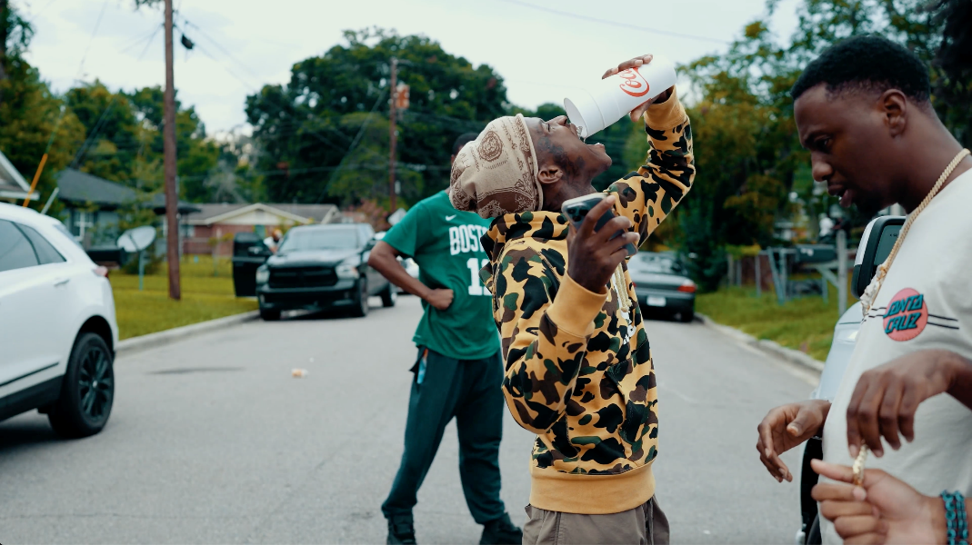
The multi-platinum Savannah, GA rapper spits with classic dexterity as he spouts off modern melodies with emotional precision and a head-nodding bounce. Since 2017, he has consistently amplified the spirit of the streets throughout the mainstream on his own terms, translating the struggles of Savannah (and hoods everywhere) into a dynamic documentary-style sound. “Give Me A Sign (Feat. YoungBoy Never Broke Again)” continues the rising star’s high-volume year, following such recently released tracks as “War Baby,” “24,” “10.27,” “Six-0 Business,” “Jakiyah” and his recent guest verse on YoungBoy Never Broke Again’s “Gangsta (Ft. Quando Rondo)” – the only feature on YoungBoy’s chart-topping 2022 mixtape, COLORS. What’s more, YoungBoy shouts out Quando on two of the mixtape’s standout tracks, “Bring It On” and “No Switch.”

Quando officially kicked off his busy 2022 with the recently released single, “Dead Wrong,” available for streaming and download HERE; an official music video is streaming HERE. The creative hot streak commenced with last year’s release of the critically acclaimed album, Still Taking Risks, and was swiftly followed by guest verses on the explosive Never Broke Again: The Compilation Vol. 1. A stunning series of singles also dropped, including “Blueprint,” “The Realest,” “Time Spent,” and “Shine,” all available now with official music videos streaming via YouTube.

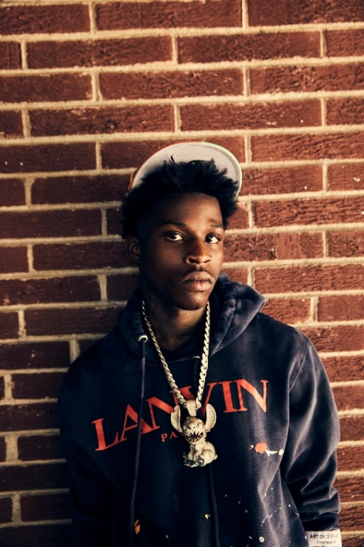

# # #

CONNECT WITH QUANDO RONDO
OFFICIAL | INSTAGRAM | TWITTER | FACEBOOK | YOUTUBE

FOR ALL PRESS INQUIRIES, PLEASE CONTACT:
ARIANA.WHITE@ATLANTICRECORDS.COM

