FOR IMMEDIATE RELEASE
OCTOBER 19, 2022

TAI’AYSHA RETURNS WITH SULTRY NEW SINGLE “SORRY” A FOLLOW UP TO DEBUT SINGLE “ONE NIGHT TING (FEAT SAWEETIE)”

MULTI-TALENTED DOMINICAN-CAMBODIAN STARLET
SHARES EAGERLY AWAITED SECOND SINGLE

LISTEN TO “SORRY” HERE | WATCH OFFICIAL MUSIC VIDEO HERE

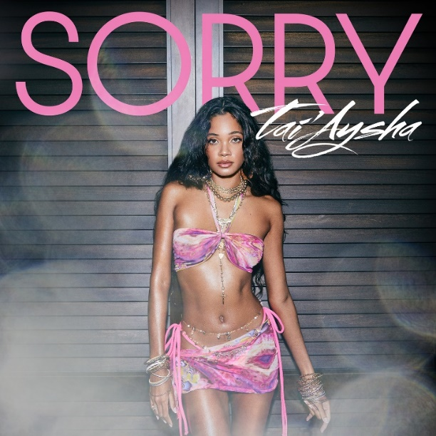
DOWNLOAD ARTWORK HERE

Multi-talented Dominican-Cambodian singer, songwriter, and dancer Tai’Aysha is back with her sweltering hot new single, “Sorry,” available now via Icon Music Group / Atlantic Records. Listen HERE. Produced by female songwriting duo Nova Wav (Beyonce, Pop Smoke, Rihanna, Nicki Minaj) the instantly infectious track is joined by a tropical and sultry visual directed by Cameron Dean. Watch HERE.

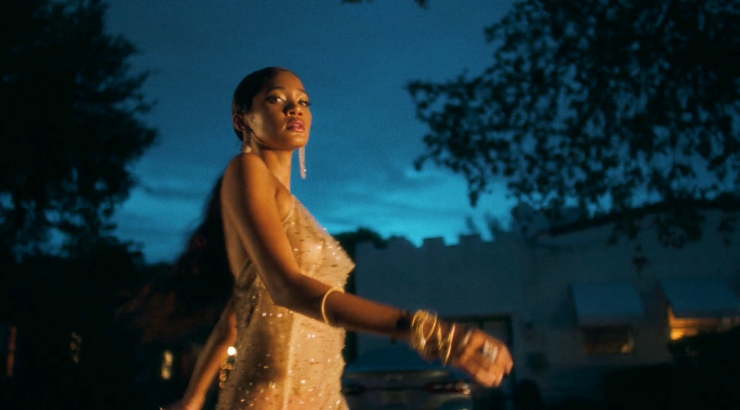
DOWNLOAD THUMBNAIL HERE

“Some people don’t know what they have until its gone, says Tai’Aysha.
And then they have to live with that for the rest of their lives.”

“Sorry” follows Tai’Aysha’s breakthrough debut single, “One Night Ting (feat. Saweetie)”. Listen HERE. Co-written and co-produced by GRAMMY® Award-winner Stephen “Di Genius” McGregor (Drake, Burna Boy, John Legend) alongside hit-making duo Money Well Spent – comprised of Verse Simmonds (Chris Brown, Kelly Rowland, Justin Bieber) and Akil “Fresh” King (Brandy, Beyoncé, Teyana Taylor) – “One Night Ting” proved an ideal embodiment of the Boston-born, Miami-based starlet’s effortless confidence and sensuality. The track – which interpolates a sample of Shabba Ranks’ 1992 dancehall classic, “Ting A Ling” – joined by an equally hot music visual streaming now at YouTube HERE following its exclusive premiere via PEOPLE.com. In addition, Tai’Aysha lit up clubs and dancefloors with exclusive new spins on “One Night Ting” by remix masters Gentlemen’s Club and Bloom Line, both available now at all DSPs and streaming services.

Tai’Aysha – whose bright personality shines through in her official VLOG, Tai’Aysha: A Day in the Life of Me, as well as her appearance on Complex’s “The Daily Drift on Twitch”– has spent much of her summer lighting up LGBTQ+ Pride events across the country, including New York City’s annual PrideFest and NYC Youth Pride event at Rumsey Playfield at Central Park. A free spirit in the truest sense, the Boston-born and Miami-based Dominican-Cambodian beauty radiates confidence, speaks without a filter, and moves through R&B, pop, bachata, merengue, reggae, and hip-hop moods with a nimble and natural elasticity tailormade for the dancefloor. Tai’Aysha started dancing almost as soon as she could walk. Growing up, she lit up every room she walked into and started modeling post-high school. In between a day job at a flower shop, her dance videos gained traction as she built an audience of hundreds of thousands on Instagram and local buzz from her home city. Seeing the bubbling local excitement, Icon Music Group founder Steve Morales (Enrique Iglesias, Céline Dion, Beyoncé) felt prompted to reach out. He recognized her talent as a dancer and believed it indicated a certain “tone” as a vocalist. Turns out, he was very right. After one Miami session, he signed her to Icon Music Group and recorded with her at a prolific pace. Within a year, she inked a deal with Atlantic Records. Inspired by Lauryn Hill, Rihanna, and Sade, Tai’Aysha has cultivated a simmering, seductive, and scorching signature style of her own.

“My music should make you feel fun, excited, and sexy,” Tai’Aysha says. “When you listen to me, I hope you’re like, ‘I want to be her friend.’ I’m here for you to know you’re confident, cool, and sexy. That’s it.”

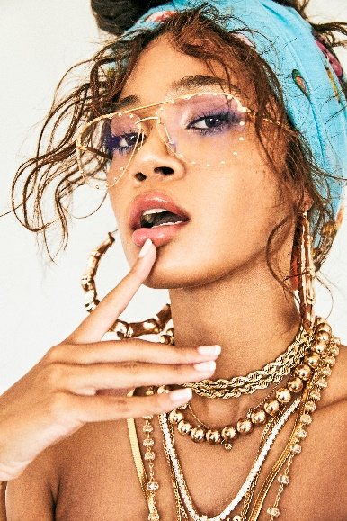
DOWNLOAD HI-RES PRESS PHOTO HERE
PHOTO CREDIT: JIMMY FONTAINE

CONNECT WITH TAI’AYSHA
INSTAGRAM | TWITTER | YOUTUBE

PRESS CONTACT
Fairley McCaskill | Fairley.McCaskill@atlanticrecords.com

