TIËSTO AND BLACK EYED PEAS TURN UP THE VOLUME WITH
“PUMP IT LOUDER” COLLABORATION

GLOBAL SUPERSTARS JOIN FORCES FOR EXCLUSIVE NEW SPIN
ON BLACK EYED PEAS’ WORLDWIDE HIT, “PUMP IT”

LISTEN HERE
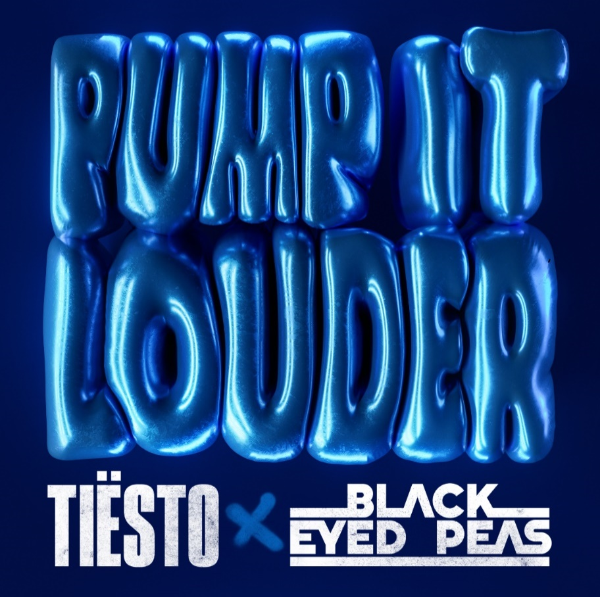
DOWNLOAD ARTWORK HERE

GRAMMY® Award-winning, RIAA platinum-certified international icon Tiësto collabs with the legendary Black Eyed Peas for a new version of their chart-topping single “Pump It”. Listen HERE. Already given the sound a vibe check, “Pump It Louder” has created an undeniable energy in Tiësto’s live sets all summer long.

“As a fan and supporter of will.i.am’s work and Black Eyed Peas, I couldn’t be more excited to collaborate directly with them on this project, said Tiësto. “Fans go absolutely crazy when I play this out live in clubs and festivals - I can’t wait to officially release this new version for the world to go wild to!"

“We’re so happy and honored to collaborate with Tiësto on this new version of ‘PUMP IT’” said Black Eyed Peas; “to keep the energy PUMPING and blasting LOUD!!!”
“Pump It Louder” follows this summer’s success of Tiësto & Charli XCX’s “Hot In It”, the fourth single from Tiësto’s upcoming Atlantic Records label debut album. “Hot In It” swiftly reached the top 10 on Billboard’s Hot Dance/Electronic Song” chart, fueled in part by over 200M views across TikTok and IG Reels, and 97.8M streams to date.

ABOUT TIËSTO:
Tiësto is a Grammy® Award-winning, platinum-certified, international icon. The DJ and producer is the only artist to ever hold the titles of “The Greatest DJ of All Time” courtesy of Mixmag, and “#1 DJ” according to Rolling Stone. From his underground dance floor bangers to his high-profile Las Vegas residency and crossover success, Tiësto created the blueprint that defines what it means to be a success in today’s dance music world. In Tiësto's true fashion, he continues to expand across genres, always evolving his craft. With over 36 million albums sold, 10+ billion cumulative streams, and a social platform with an audience exceeding 30 million fans spanning the globe, he continues to revolutionize the dance music landscape. Tiësto’s first release since signing with Atlantic Records, "The Business” has dominated airplay and charts worldwide since its September 2020 release, garnering over 1.5 billion streams to date, and was nominated for Best Dance/Electronic Recording at the 64th Annual GRAMMY Awards. It has also held a steady position on Apple & Spotify’s “Today’s Top Hits” & “Today’s Hits” playlists, and hit #1 at US Dance Radio. “The Business” is certified Platinum in 15 countries and gold in 8 countries and has held a place on the Top 10 official singles chart in 10 countries as well as Top 50 on Spotify in 31 countries. Tiësto made history with single “Don’t Be Shy” with Karol G, which marked the first English song ever for Karol G, and the first Latin Artist collaboration for Tiësto, and currently has 830M streams, over 1.2 million TikTok creates, and over 273 million views on the official music video. The third single from Tiësto’s upcoming album, “The Motto” with Ava Max, is out now with 884M streams to date, and his single “Hot in It” with Charli XCX continues to climb the charts with 97.8M streams.

ABOUT BLACK EYED PEAS:
With every move, Black Eyed Peas dictate the rhythm of culture. Over the past 25 years, the Los Angeles trio—will.i.am, Apl.de.ap, and Taboo—earned six GRAMMY® Awards and achieved sales of 35 million albums and 120 million singles across seminal releases such as Elephunk, The E.N.D., and more. One of the era’s biggest acts, they emerged as “the second best-selling artist/group of all-time for downloaded tracks,” (Nielsen) and landed on Billboard’s “Hot 100 Artists of the Decade.” In 2011, they dazzled the world with a landmark performance at the Super Bowl XLV Halftime Show. Their eighth studio album, 2020’s TRANSLATION, achieved staggering international success. Featuring collaborations J Balvin, Ozuna, Maluma, Shakira, Nicky Jam, and Tyga, itr garnered eight nominations at the Billboard Latin Music Awards, including ‘Crossover Artist of the Year” and “Hot Latin Song of the Year” for “RITMO” and a nomination at the 2021 Latin American Music Awards for ‘“Favourite Artists - Crossover”. “RITMO (Bad Boys For Life)” [feat. J Balvin] and “MAMACITA” [feat. Ozuna and J.Rey Soul], both achieved #1 status on three Billboard Charts, numerous award nominations, and gold, platinum, and diamond certifications globally. “GIRL LIKE ME” [feat. Shakira] continued this streak, achieving success on Latin and Top 40 radio, sparking a viral TikTok challenge, and scooping “Best Latin” award at the MTV VMAs, while ‘HIT IT’ with Saweetie and Lele Pons racked up 5.8M global audio streams, 1.1M US audio streams and almost 10M YouTube views in its first week alone. In 2022 the band reunited with Shakira and David Guetta for DON’T YOU WORRY, the first single from an as-yet unnamed ninth studio album. With close to 85M views on YouTube and +60M streams on Spotify in under two months, DON’T YOU WORRY opens up yet another brilliant chapter in the continuing story of the Black Eyed Peas.

DOWNLOAD PRESS PHOTO HERE

CONNECT WITH TIËSTO:
OFFICIAL | FACEBOOK | INSTAGRAM | SPOTIFY | TIKTOK | TWITTER | YOUTUBE

CONNECT WITH BLACK EYED PEAS
OFFICIAL | FACEBOOK | INSTAGRAM | SPOTIFY | TIKTOK | TWITTER | YOUTUBE

FOR MORE INFORMATION:
Paige Rosoff – Atlantic Records
Paige.Rosoff@atlanticrecords.com

