TY DOLLA $IGN AND MUSTARD RELEASE NEW SINGLE “MY FRIENDS (FEAT. LIL DURK)”

FIRST SINGLE FROM LONG-AWAITED, FORTHCOMING JOINT ALBUM

DOWNLOAD/STREAM “MY FRIENDS (FEAT. LIL DURK)”

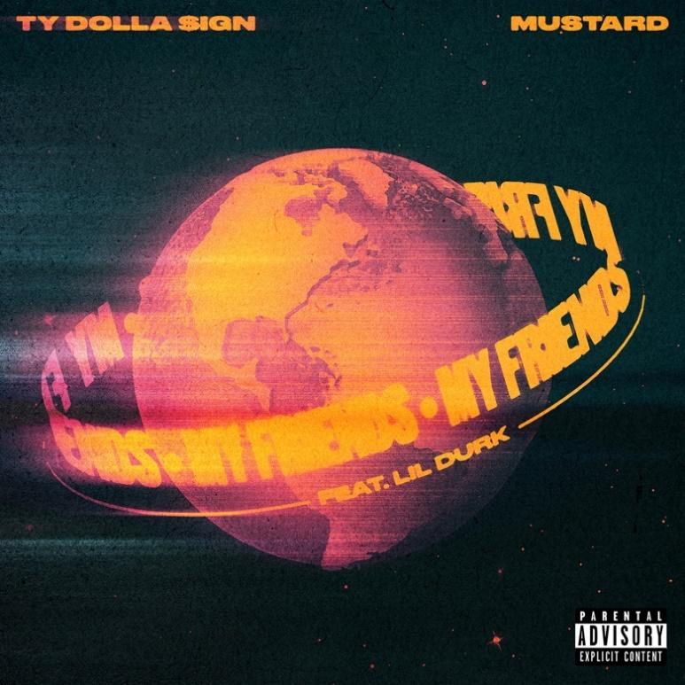
DOWNLOAD HI-RES ARTWORK HERE

New York, New York – October 5, 2022 – Multi-platinum, globally renowned musical powerhouses Ty Dolla $ign and Mustard recruit Lil Durk for “My Friends,” available everywhere today via Atlantic Records/10 Summers.

Ty Dolla $ign and Mustard are the cover of Apple Music’s New Music Daily today. “My Friends (feat. Lil Durk)” is the first single from Ty Dolla $ign and Mustard’s long-awaited, forthcoming joint album.

“Every time my brother Mustard and I link up, we make history; ”Paranoid,” “Or Nah” and now “My Friends.” What’s success and fortune if you ain’t getting it with your day ones? Big shout out to Durk for being a part of this song.”
-Ty Dolla $ign

“We’ve been doing this for more than a decade now and it’s always special when me and Ty link.”
-Mustard

Download/stream “My Friends (feat. Lil Durk)” here

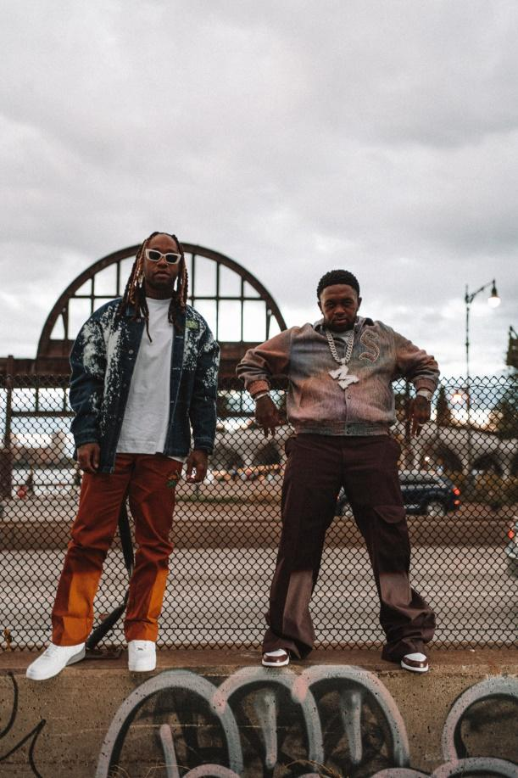
DOWNLOAD APPROVED IMAGES HERE

* * *

ABOUT TY DOLLA $IGN
Hailed as “one of the richest R&B talents of the last decade” by The New York Times, Ty Dolla $ign is a multiple GRAMMY-nominated musical powerhouse who has single-handedly shaped the music industry with his undeniable classic songs (“Paranoid,” “Or Nah,” “Blasé”,) chart-topping collaborations (“Psycho” with Post Malone, “Work From Home” with Fifth Harmony) and genre-defying songwriting and production contributions (JAY-Z & Beyonce, Kanye West, Rihanna, Mariah Carey, Drake, Chris Brown, Christina Aguilera, Khalid, Wiz Khalifa and more.)

With over 10 billion streams, 10 million singles sold and a career-to-date total of over 50 RIAA platinum and gold certifications, the Los Angeles native’s solo discography features the critically acclaimed albums Free TC (2015), Beach House 3 (2017) and Featuring Ty Dolla $ign (2020) and the timeless mixtapes Beach House, Beach House 2, Sign Language, Airplane Mode and Campaign.

Connect with Ty Dolla $ign: Instagram | Twitter | Facebook | YouTube | Website

ABOUT MUSTARD
Multi-platinum and Grammy-winning artist, Mustard, has achieved a serious milestone as 2022 marks over a decade of success for the South Los Angeles native. A triple-threat, Mustard has mastered several facets of the industry as an accomplished producer, DJ and artist. Since his 2010 debut, he has reigned as a pioneer of urban sound, serving up chart-toppers to some of music’s biggest names, including: YG, Tyga, Rihanna, Chris Brown, Jhene Aiko, Roddy Ricch and more. Through his imprint, 10 Summers Records, Mustard has been able to shine as both artist and music executive. Possessing a keen eye for discovering talent, Mustard shocked the world with the introduction of his artist and protégé, Ella Mai. The U.K. songstress’ record-breaking rise to fame included the release of her 2018 RIAA Certified 2x-platinum album, Ella Mai, executive-produced by Mustard, and a 7x platinum lead single, “Boo’d Up.” As an artist, Mustard has been equally impressive with his third studio album, Perfect 10, reaching RIAA Certified Platinum. He performed his 4x platinum hit “Pure Water”during the 2019 BET Awards and his 6x platinum single, “Ballin’” featuring Roddy Ricch on Jimmy Fallon; with the latter earning him a Grammy-nomination for “Best Rap Song Performance.” Mustard maintains a year-round schedule, complete with a residency at the esteemed Marquee Nightclub in Las Vegas, as well as his very own festival, Summers Fest. His work earned him the coveted DJ of the Year at the 2019 BET Hip Hop Awards. Working to build lasting success, Mustard made a major announcement in 2019 when he inked a Global Publishing Deal through Sony/ATV. In 2020 Mustard was named Producer of the Year in Variety’s Hitmakers issue, and most recently received the 2021 ASCAP Pop Music Award for both “Ballin’" and “High Fashion,” both being the most performed ASCAP songs of 2020.

PRESS CONTACTS

For Ty Dolla $ign press inquiries, please contact:
Jason Davis | Jason.Davis@atlanticrecords.com
Kathryn Frazier | Kathryn@biz3.net
Ryan Cunningham | Ryanc@biz3.net

For Mustard press inquiries, please contact:
Randy Henderson | Randy.Henderson@umusic.com
Vanessa Anderson | Anderson@amprgroup.com
Erin Patterson | Erin@amprgroup.com

