FOR IMMEDIATE RELEASE
OCTOBER 6, 2022

Daine drops new single “Stay Close”

song + Music video available now,
Sophomore full length project ‘shapeless’ coming soon

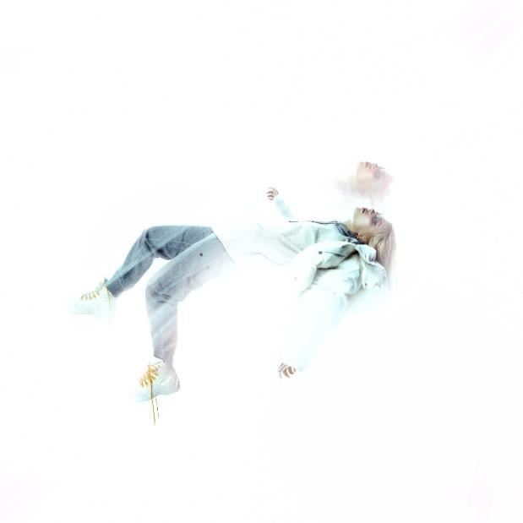
DOWNLOAD HIGH-RES ART/IMAGES

WATCH “STAY CLOSE” VIDEO: LINK
STREAM “STAY CLOSE”: https://daine.lnk.to/stay-close

After igniting imaginations with a wildly varied output across their still burgeoning career, daine’s reputation as one of the most chameleonic artists of their generation has been cemented. Running from the glitch laden, Dylan Brady of 100 gecs produced hyperpop of “boys wanna txt,” to the metal infused electronica of “Salt” featuring Bring Me The Horizon’s Oli Sykes, to August’s tongue-in-cheek dayglo pop of “boythots,” daine’s dynamic output has typified their output as the soundtrack to a generation equipped with postmodern, ever expanding tastes. Today, daine unveils their newest sonic hybrid; “Stay Close.”
A track that has been in high demand from fans ever since a demo emerged months ago, “Stay Close” captures daine at their most experimental. An devastating cut of emotionally charged electronic pop, the track finds daine pushing the emo-influenced side of their sound into the future; taking the heartfelt, melodramatic lyricism of their previous work and thrusting it amongst buzzsaw synths, intense low-end and contemporary hip-hop percussion. Created on a life changing trip to LA, “Stay Close” is the first track to be released from this fruitful period; marking a true realization of their own potential and real clarity regarding their creativity.

The track’s video was directed by Charles Buxton-Leslie and features daine visiting a racetrack alone with a love interest. Split between high octane race scenes and noticeable distance between the duo; the visual plays with the idea of the adrenaline rush of internalized romance, despite the reality being something markedly different.

An artist set on laying multiple elements of their personality on display for the world to see, daine’s ever expanding sonic universe is one for people of all walks of life to immerse themselves in, simultaneously finding something they can relate to. While their music maintains its otherworldly sensibilities, daine’s new era is powerful, direct and impossible to resist.

DOWNLOAD HIGH-RES ART/IMAGES

CONNECT:
Official | Instagram | Twitter | YouTube | Press Assets

CONTACT:
Ted Sullivan (Atlantic Records) | ted.sullivan@atlanticrecords.com

