FOR IMMEDIATE RELEASE
NOVEMBER 4, 2022

ARDEN JONES REACHES MILESTONE WITH age tape 0

10-TRACK COLLECTION FEATURES FIVE BRAND NEW SONGS
ALONGSIDE FAN FAVORITES FROM AMBITIOUS SERIES
OF MONTHLY 3-SONG PROJECTS

NORTH AMERICAN TOUR SUPPORTING CHELSEA CUTLER
TRAVELS THROUGH MID-NOVEMBER

age tape 0 AVAILABLE NOW VIA vnclm_ X ATLANTIC RECORDS
INCLUDING STANDOUT SINGLE “not afraid at all”

LISTEN HERE

DOWNLOAD HI-RES ARTWORK

“Arden Jones has provided fans with a consistent roster of upbeat, exciting, and unique tracks that take listeners across a wellspring of genres, ranging from R&B, alternative, pop, and high-paced bedroom production.”
– ONES TO WATCH

Rising California singer/songwriter/rapper/multi-instrumentalist Arden Jones has shared age tape 0, a 10-track collection featuring 5 brand new songs alongside 5 fan favorites from his acclaimed series of monthly age tapes, 3-song projects released the 1st Thursday of every month. age tape 0 is available now via vnclm_ x Atlantic Records at all DSPs and streaming services – Listen HERE.

“i can't believe the end is finally here.. the final age tape,” shared Arden. “this has been the coolest year of my life - releasing the age tapes, connecting with all of you, touring. i cant thank you enough for all your support over this journey. we decided to put a little extra on this last tape to say thank you for being here ❤️ this is for u.”

The 10th release in the age tape series, age tape 0 is celebrated by today’s premiere of the five new singles, including standout track “not afraid at all.” The collection also includes such fan favorites as “mr. sunshine,” “horror story,” “indifferent,” “serotonin highs (feat. Allen Haley),” and the viral hit “starstruck,” the latter of which has garnered Jones more than 20M views across TikTok and Instagram Reels.

Currently boasting 1.6M monthly Spotify listeners, Jones set himself on a wildly ambitious path towards releasing three new songs on the first Thursday of every month. The past nine months have seen the 21-year-old Marin County, CA-born artist sharing age tape 1, age tape 2 , age tape 3, age tape 4, age tape 5, age tape 6, age tape 7, age tape 8, and age tape 9, all available now for streaming and download.

Known for an irresistible pop approach that bottles the sunshine of an endless California summer with elastic rhymes, radiant hooks, and euphoric, piano-laced beats, Jones has already earned over 75M worldwide streams for such hugely popular tracks as last year’s acclaimed vnclm_ x Atlantic Records debut single, “rollercoaster,” as well as the viral hit, “Parallel Parking.”

Hailed by EARMILK for his “joviality and a starry-eyed innocence,” Jones – who recently toured alongside fellow breakout pop stars Tai Verdes and Thomas Headon – is currently traveling as special guest on Chelsea Cutler’s “When I Close My Eyes Tour,” with North American dates set through mid-November.

ARDEN JONES
NORTH AMERICAN TOUR 2022

NOVEMBER
4 - Bozeman, MT - Elm
5 - Spokane, WA - Knitting Factory
6 - Vancouver, BC - Commodore Ballroom
8 - Oakland, CA - Fox Theater
9 - Los Angeles, CA - The Wiltern
11 - San Diego, CA - Soma

All Dates w/Chelsea Cutler “When I Close My Eyes Tour”

# # #

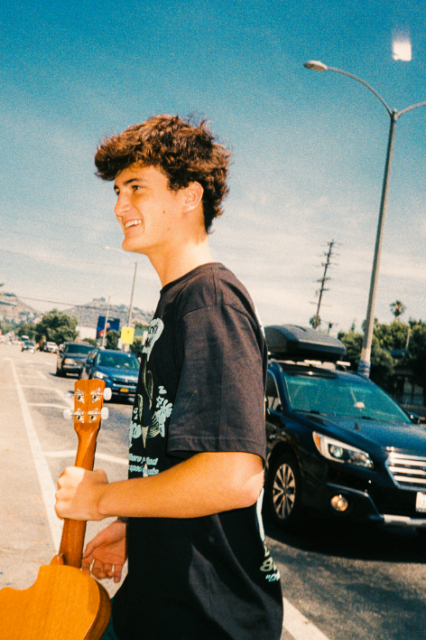

DOWNLOAD HI-RES PRESS PHOTO // CREDIT: SJ SPRENG

CONNECT WITH ARDEN JONES
WEBSITE | INSTAGRAM | TIKTOK | TWITTER | YOUTUBE | SPOTIFY

For press inquiries, please contact:
Jessica Nall // Jessica.Nall@atlanticrecords.com
Gabrielle Reese // Gabrielle.Reese@atlanticrecords.com

