FOR IMMEDIATE RELEASE
NOVEMBER 4, 2022

LONDON-BASED ELECTRONIC DUO AUSTIN TATE KICK OFF THE WEEKEND WITH “LNBL (FEAT. JUST CHARLII)”

SMOLDERING NEW DANCEFLOOR ANTHEM PREMIERES TODAY
LISTEN HERE

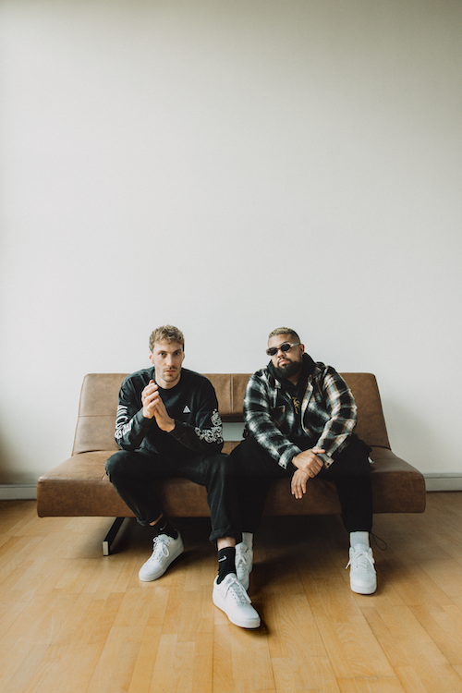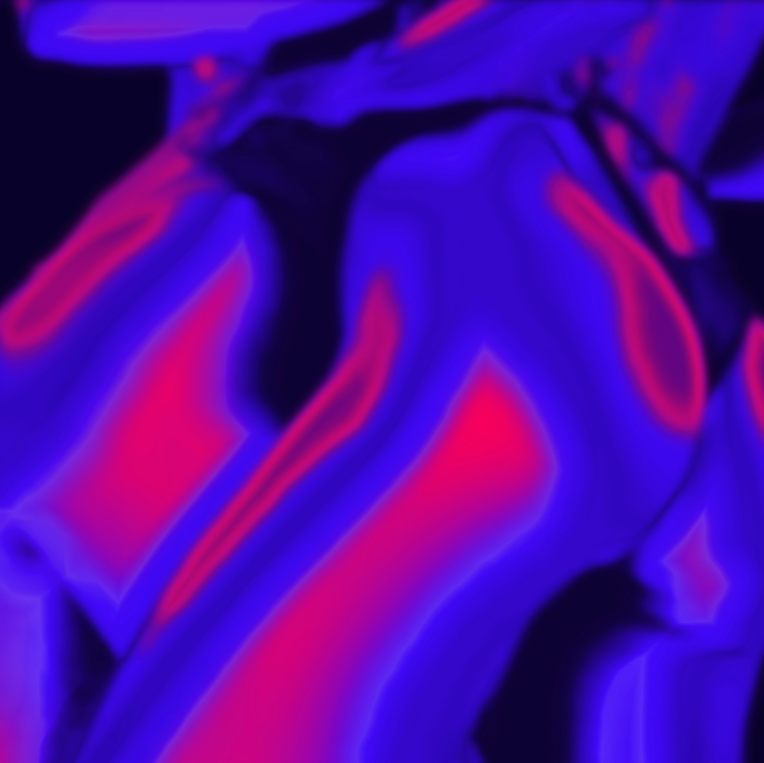

DOWNLOAD ART + PRESS PHOTO HERE

Genre-bending, London-based duo Austin Tate return with their smoldering new dancefloor anthem, “Late Night Body Language (LNBL) - Feat. Just Charlii,” available now at all DSPs and streaming services HERE.

On the track, neon synths pulsate through a beat tailor made for the club. At the same time, Just Charlii’s smoldering and soaring vocals instantly transfix with a command, “Show me your late night body language babe.”

“The title says it all,” states vocalist/songwriter Lee Paul Williams “LPW”, “It’s about getting together with someone, exploring, and learning about each other more intimately. It’s a sexy song with a lot of bounce in the melody.”

“We layered Lee’s vocals over the production, but we also kept it raw and open,” DJ/producer Ed “Billon” Butler goes on. “The vocal rhythm was so important to us.”

The creative union of DJ/producer Ed “Billon” Butler and vocalist/songwriter Lee Paul Williams (a.k.a. “LPW”), Austin Tate serve up a distinctive fusion of unexpected styles, merging house music energy and underground unpredictability with nocturnal R&B and neo-soul to shape a sound unlike anything else on the dancefloor.

“We’re mixing a lot of different elements to reach a new level,” says LPW.

“My teenage years were all about old school early house music,” says Butler. “It’s influenced my writing big time, and we bring those elements into Austin Tate. We’re definitely inspired by London and the scene around us, but we’re incorporating a strong influence from the U.S. on the R&B side. It’s gritty, yet it’s also soulful.”

The two artists came together as Austin Tate in 2021 having already made worldwide waves with their own prodigious output. Butler has produced a variety of club anthems over the past decade, combining crisp, cutting edge production with a love of classic analogue synths on remixes for high profile stars like Avicii, Childish Gambino, and SG Lewis, as well as hit tracks such as “They Know,” named an “Essential New Tune” by the BBC’s legendary Pete Tong. Meanwhile, LPW has fast grown a global reputation as both singer and songwriter, with co-writing credits that include Craig David’s latest single “DNA” featuring Galantis as well as MK’s multi-million streaming smash, “Body 2 Body,” lending vocals to the latter.

Joining forces as Austin Tate, LPW and Butler instantly unlocked a unique creative chemistry, channeling their individual strengths to collectively set a new rhythm for electronic music spiked with R&B. Tracks like “Hurt This Way” and the SOMMA & Yuma & Austin Tate collaboration, “Harder We Fall,” have quickly amassed close to 10 million worldwide streams along with support from such top DJs and artists as Gorgon City, Jamie Jones, and Rudimental, to name a few.

“It’s gratifying to have the outlet to be able to create on our own terms,” says LPW. “We’re able to experiment and run with it. It’s rare to find creative collaborators who empower you to be yourself, but we have.”

“We both bring different skills to Austin Tate,” says Ed Butler. “We’ve learned a lot, and we’re navigating this journey together. We have the sonic elements, the songwriting, and the vocals. Now, our goal is to give the world something new.”

# # #

CONNECT WITH AUSTIN TATE
INSTAGRAM

FOR PRESS INQUIRIES, PLEASE CONTACT
Jessica Nall // Jessica.Nall@atlanticrecords.com

