FOR IMMEDIATE RELEASE
NOVEMBER 7, 2022

TUNE IN TOMORROW: BRELAND TO PERFORM ON ABC’S JIMMY KIMMEL LIVE!
NOVEMBER 8 AT 11:35 PM/10:35 PM (cT)

FIRST-TIME NOMINEE TO PRESENT AT THE 56TH ANNUAL CMA AWARDS LIVE ON ABC 11/9

LAUNCHING FALL HEADLINE HERE FOR IT TOUR THIS MONTH IN OXFORD, OH 11/16

JOINS SHANIA TWAIN’S QUEEN OF ME TOUR
THIS SUMMER FOR SELECT DATES

LISTEN TO CROSS COUNTRY HERE

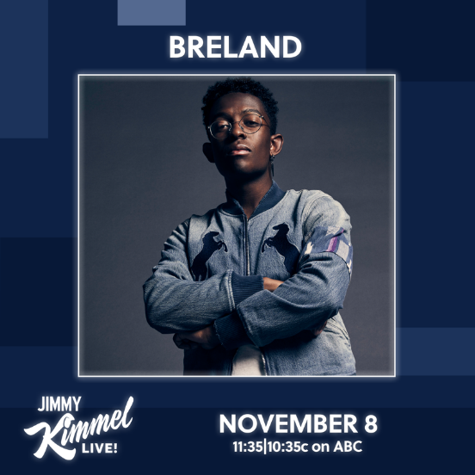
DOWNLOAD HERE

LOS ANGELES, CA. (November 7, 2022) – Tune in as PLATINUM-selling artist BRELAND will take the stage at ABC’s Jimmy Kimmel Live! tomorrow November 8, airing at 11:35 pm /10:35 pm (CT). Marking the TV performance debut of his chart-climbing Country radio single “For What It’s Worth,” the “absolutely radio ready” (MusicRow) song is featured on his wildly popular debut album CROSS COUNTRY. Then jetting from LA to Nashville, he’ll appear the next night as a Presenter at the 56th Annual CMA Awards and vie for his first CMA trophy in the category Musical Event of the Year alongside Dierks Bentley and HARDY for their GOLD-certified, #1 collaboration “Beers On Me.” The CMA Awards air live on Wednesday, November 9 at 8 pm/7 pm (CT) on ABC.

On the heels of the announce of his late-night performance, the Amazon Music Breakthrough Spotlight Artist also revealed that he will be joining one of Country music’s biggest names, Shania Twain, for her QUEEN OF ME TOUR. As direct support on summer dates, including his dream venue Madison Square Garden in New York City, BRELAND will play nine dates across the U.S. with Twain. With his Twain-inspired song “Natural,” the announce of BRELAND’s support on the tour brings the track full circle.

Up next, the NJ native is readying to take his signature Cross Country sound and more to his fall headline HERE FOR IT TOUR, kicking off in Oxford, OH, at Brick Street on November 16. With SOLD-OUT shows in major markets – Mercury Lounge in New York, NY, and The Foundry at The Fillmore in Philadelphia, PA, two new dates have been added on 11/28 and 12/4 respectively. The tour continues through December and tickets are on-sale now via brelandmusic.com. See here for full list of BRELAND’s tour stops.

ABOUT BRELAND:
With PLATINUM breakout “My Truck,” singer/songwriter/producer BRELAND has emerged as a bold new force on today’s music landscape. The Amazon Music Breakthrough Spotlight Artist first popped off when the Hip-Hop and Country hybrid hit #1 on Spotify’s Global Viral 50 in 2019, and a remix featuring Sam Hunt landed on best-of-the-year lists from NPR to The New York Times. Adding to his 1 BILLION+ career streams, BRELAND’s debut album CROSS COUNTRY is out now and features infectious releases “Told You I Could Drink (feat. Lady A),” “Natural,” “Praise The Lord (feat. Thomas Rhett),” GOLD-certified “Throw It Back (feat. Keith Urban) and title track (feat. Mickey Guyton). Hailed as the “symbol of Country music’s ongoing evolution” (Rolling Stone), the Bad Realm Records/Atlantic Records/Warner Music Nashville artist has scored high profile looks on ABC’s Good Morning America, ABC’s Jimmy Kimmel Live!, CBS Mornings, CBS’ New Year’s Eve Live: Nashville’s Big Bash, CMT Crossroads, NBC’s TODAY, The Kelly Clarkson Show, plus performances on the ACM, CMT, and CMA Awards, Currently, BRELAND is readying to launch his fall headline HERE FOR IT TOUR later this month, with high-profile performances in 2023 on deck at Stagecoach Festival and as direct support for select summer dates of Shania Twain’s QUEEN OF ME TOUR.

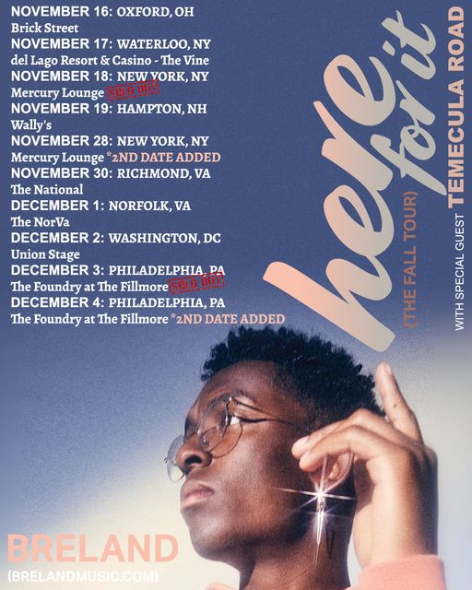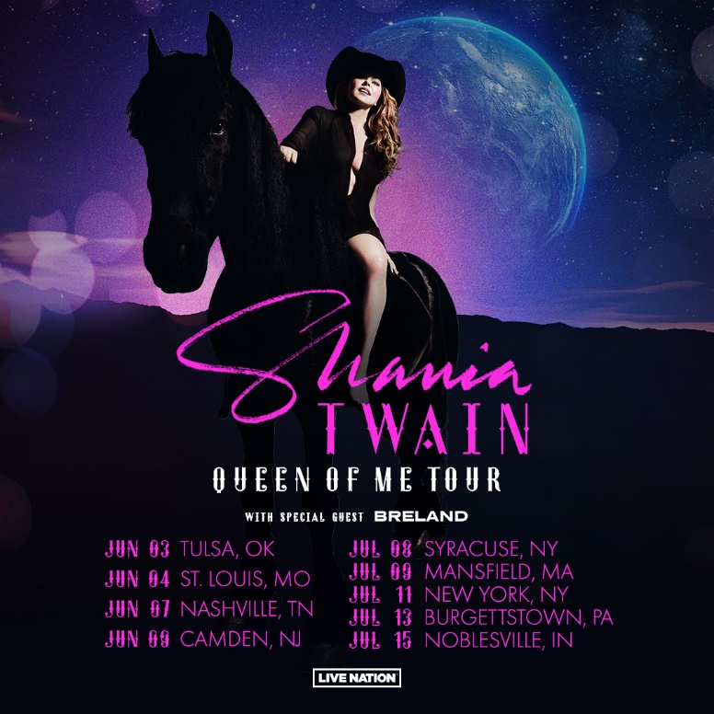

# # #

CONNECT WITH BRELAND
WEBSITE | INSTAGRAM | FACEBOOK | TWITTER | YOUTUBE | SOUNDCLOUD | AMAZON MUSIC

BRELAND PR CONTACTS
Fairley McCaskill / Fairley.McCaskill@atlanticrecords.com
Jensen Sussman / jensen@sweettalkpr.com
Mary Catherine Rebrovick / MaryCatherine@wmg.com

