FOR IMMEDIATE RELEASE
NOVEMBER 22, 2022

DON TOLIVER PREMIERES VISUAL FOR “DO IT RIGHT”
PRESENTED BY ROTATION | CACTUS JACK
WATCH HERE

“DO IT RIGHT” AVAILABLE NOW VIA CACTUS JACK/ATLANTIC

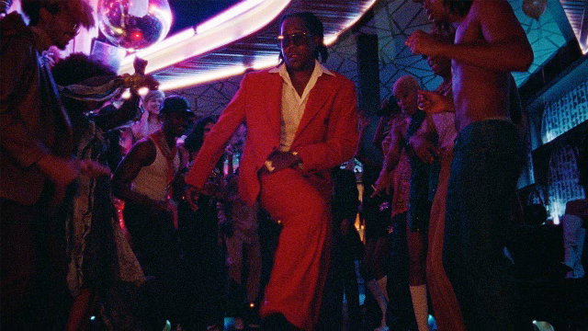
DOWNLOAD HI-RES SINGLE ARTWORK | DOWNLOAD PRESS IMAGE

Don Toliver shares visuals for his latest single, “Do It Right,”. Presented by Cactus Jack | Amazon Music | Rotation and directed by Alex Moors (Adele, Kendrick Lamar, Miley Cyrus), the visual drops fans into a lit 70’s disco serving as a bright prequel to Don’s new era. Watch HERE.

Don’s new visual arrives on the heels of the records’ official release last week and his live performance at Rihanna’s Savage X Fenty Show Vol. 4. Don performed a medley of “Do It Right” and Life of a Don’s “Way Bigger”, which premiered November 9 on Prime Video. The star-studded annual fashion experience can be viewed HERE.

For Don, this year we have seen him featured on Justin Bieber’s “Honest”, Kid Cudi’s “Somewhere To Fly” and “Burrow”; Baby Keem’s “Killstreaks”, Trippie Redd’s “Ain’t Safe” and Wizkid’s “Special”. “Do It Right” follows last year’s arrival of Don Tolliver’s critically acclaimed sophomore album, Life of a DON, available everywhere now HERE. The album made a spectacular chart debut upon its October 2021 release, landing at #2 on Billboard’s “Top R&B/Hip-Hop Albums” and the Billboard 200 – Toliver's second US top 10 debut on the overall chart and highest charting album to date. Life of a DON includes such hit singles as “Drugs N Hella Melodies (Feat. Kali Uchis),” “Way Bigger,” “Flocky Flocky (Feat. Travis Scott),” and the RIAA gold certified “What You Need,” all of which are joined by dramatic visuals that have earned a combined 60M+ views via the official Don Toliver YouTube channel HERE.

ABOUT DON TOLIVER:
Soul singer, songwriter, artist, and Houston, Texas native Don Toliver displays a unique sound that calls out his musical influence of Hip-hop, smoked-out R&B, ambitious pop, and a bit of rock, creating a genre-bending lane of his own. After the 2018 mixtape Donny Womack, Don assembled his full-length debut, Heaven Or Hell. Plus, he joined forces with Internet Money, NAV, and Gunna for the 3x platinum banger “Lemonade,” which they also performed on The Tonight Show Starring Jimmy Fallon. Within three years, he gathered billions of streams, scored platinum plaques, and received praise from V Man, W Mag to Interview Magazine. After being featured on the F9: The Fast Saga soundtrack and on a record alongside Justin Bieber in 2021, Don dropped his sophomore album, Life of a DON, featuring gold-certified singles "What You Need" and "Drugs n Hella Melodies.” Debuting at number two on the US Billboard 200 chart and featuring production by Mike Dean, Hit-Boy, Mustard, and more, Life of a DON showcased Don’s fluid ability to exist in multiple soundscapes. Don has recently been featured by heavy hitters Ye, Pusha T, Baby Keem, Wizkid, and Trippie Redd. Coming off the heels of his newest single, “Do It Right”, 2023 will mark a new era for Don and his fans as he takes fans into a new world. Stay tuned.
# # #

CONNECT WITH DON TOLIVER
OFFICIAL I INSTAGRAM| TWITTER |FACEBOOK |YOUTUBE

PRESS CONTACT:
Brittany Bell, Brittany.Bell@atlanticrecords.com

