FOR IMMEDIATE RELEASE
NOVEMBER 18, 2022
ENCHANTING DROPS DEBUT FULL LENGTH PROJECT NO LUV

EXPLOSIVE MIXTAPE FEATURING GUCCI MANE, BIG SCARR, KALI, COI LERAY & MORE

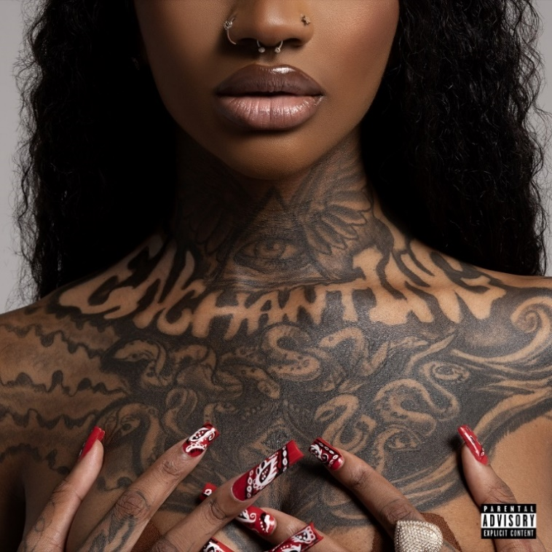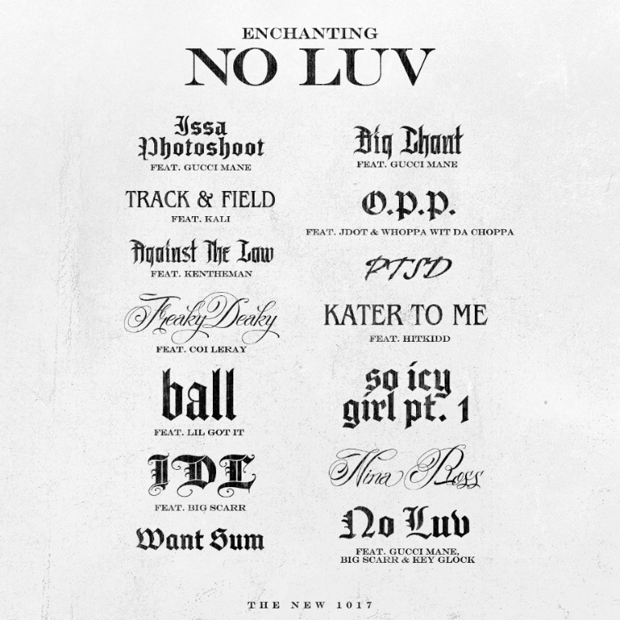
DOWNLOAD ARTWORK HERE
BUY/STREAM: LINK
1017 Global Music’s Rap and R&B princess Enchanting has dropped her debut full length project, No Luv featuring Gucci Mane, Big Scarr, Kali, Coi Leray and more. No Luv showcases Enchanting’s hip-hop skills with 14 tracks, including standout “Against The Law” feat. KenTheMan, and is available everywhere now via 1017 Global Music/Atlantic Records.
No Luv follows recent singles “Keep It Playa,” “What I Want” featuring Jacquees and Enchanting’s appearance on the 1017 compilation deluxe extension SO ICY GANG: THE REUP with “Large Amounts (ft. Gucci Mane).” Earlier this year, Chant shared the vulnerable “Take It Back” after a series of hard-hitting collabs in 2021 including “Track & Field (Feat. Kali)” and “Freaky Deaky (Feat. Coi Leray),” adding to her combined 100M global streams to date. Both followed Enchanting’s release of “Want Sum,” a fan favorite that’s surpassed 2.5M official video views and 9M streams to date. The rising Rap and R&B star has garnered 38M+ US Streams and 15M+ YouTube views to date.

DOWNLOAD PRESS PHOTOS HERE

TRACKLIST
Issa Photoshoot feat. Gucci Mane
Track & Field feat. Kali
Against The Law Feat. KenTheMan
Freaky Deaky Feat. Coi Leray
Ball feat. Lil Got It
IDL feat. Big Scarr
Want Sum
Big Chant feat. Gucci Mane
O.P.P feat. JDot & Whoppa wit Da Choppa
PTSD
Kater To Me (Enchanting, HitKidd)
So Icy Girl Pt. 1
Nina Ross
No Luv (Enchanting, Gucci Mane feat. Big Scarr & Key Glock)
ABOUT ENCHANTING
Enchanting’s stage name speaks for itself. Pressing play on an Enchanting verse, you’re instantly mesmerized by the ethereal textures the 24-year-old songstress brings to the mic. Coming out of Fort Worth, Texas, Enchanting began to pursue music around the age of 18. She defines her style as something chill with a dash of neo-Soul, a twinge of old school R&B, with some modern trap flavor sprinkled in. “It’s like Trap-n-Blues,” Enchanting expresses. The genre blend is perfect for Enchanting, who uses music as a vehicle of expression, not only for herself but for others.
Enchanting has appeared alongside her 1017 Global Music labelmates on Gucci Mane’s compilation tape Gucci Mane Presents: So Icy Summer, So Icy Christmas, and more. Enchanting credits Dallas’ superproducer J. White Did It for making the connection between herself and Atlanta rap icon Gucci Mane. “I guess he told Gucci about me,” Enchanting explains with excitement and gratitude; “Gucci called me the next day.” Working on her upcoming mixtape, her legacy is one of showing other aspiring artists from her city they can do it too- more than a natural artist, she’s a natural-born motivator with a sterling personality.
###
CONNECT WITH ENCHANTING
TWITTER
INSTAGRAM
YOUTUBE
PRESS CONTACTS
Ted Sullivan | Ted.Sullivan@atlanticrecords.com
Ashley Kalmanowitz | Ashley.Kalmanowitz@atlanticrecords.com

