FOR IMMEDIATE RELEASE
NOVEMBER 11, 2022

FINESSE2TYMES CONTINUES MOMENTUM WITH THE RELEASE OF “SUMMO”
ACCOMPANIED BY AN OFFICIAL COMPANION VISUAL AVAILABLE NOW
OFFICIALLY ANNOUNCES NEW MIXTAPE, 90 DAYS
ARRIVES 12/2, AVAILABLE FOR PRE-ORDER NOW
STREAM/DOWNLOAD “SUMMO”
WATCH/SHARE “SUMMO”
PRE-ORDER 90 DAYS
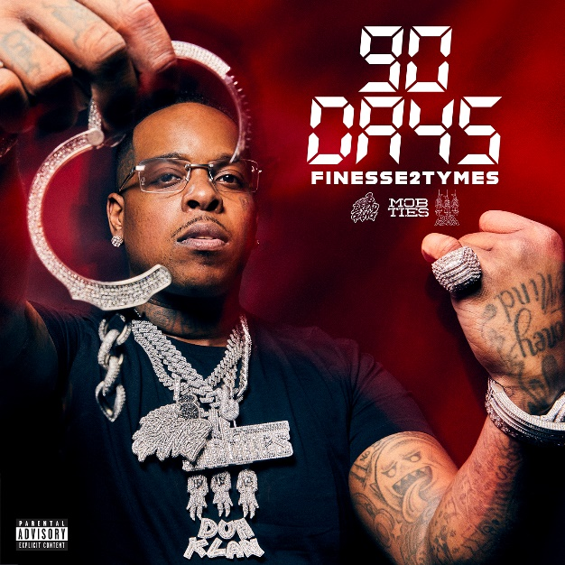
DOWNLOAD HI-RES ARTWORK

Today, Memphis rising star Finesse2tymes, has officially announced his upcoming mixtape 90 DAYS and released his latest single, “Summo.” The single is accompanied by an official visual directed by Rodney Pinz and comes on the heels of last month’s “Humble” (4M+ views). The mixtape, slated for a December 2nd release, is now available for pre-order.
Download/stream: link
Watch/share: link (directed by Rodney Pinz)
Pre-order 90 DAYS: link
90 DAYS is representative of the pivotal 90 days since his release from prison earlier this summer and the belief that he’s manifested all of his current success. From dropping several singles that instantly skyrocketed to inking a deal with Mob Ties/Bread Gang/Atlantic Records around his 90th day of release. “I’m talking about my life and my struggles and who I am today,” he says of the project. “I don’t rap about what I do, I rap about what I did.” The mixtapes pre-order arrives with four additional instant gratification tracks including “Back End,” “Humble,” “Get Even,” and “Black Visa” ft Moneybagg Yo.
Since coming home in July, he quickly solidified himself as one of the hottest hip-hop artists emerging from the South. So far he’s garnered over 40M US streams and a combined 97M+ views on YouTube. His viral single “Back End” (which sparked the “It’s A Problem When I Do It” popular TikTok trend) has accumulated over 23M US audio streams and over 26M views on YouTube alone. “Back End” has also peaked at #8 on the top music videos on YouTube and has over 400K creates on TikTok proving it to be a viral hit. Finesse also recently sat down with podcast Million Dollaz Worth of Game and delivered an explosive freestyle that is now at over 750K views.

# # #
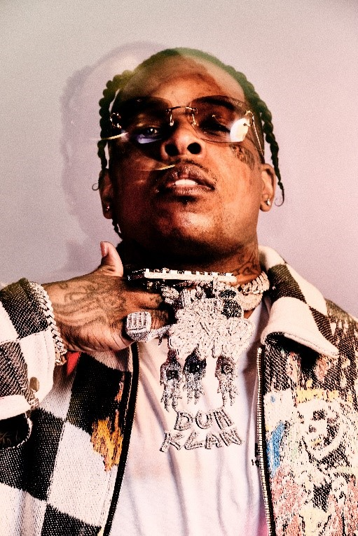
DOWNLOAD PRESS IMAGES
(CREDIT: JIMMY FONTAINE)
---
FINESSE2TYMES
It took rapper Finesse2tymes just 90 days to remix his life, following five years in prison. The Memphis, Tennessee native (turned Houston resident) not only repaired broken relationships, but he inked a deal with Mob Ties/Atlantic Records and recorded arguably some of the best music in his career. The culmination of that time is his upcoming project 90 Days. Finesse has weathered the storm, changed his stars, and is now geared for his place in the sun.
Born and raised on the East Side of Memphis, most of Finesse’s young adulthood was surrounded by the walls of a prison cell. His first prison stint happened at 14 and he was in and out of prison until his most recent release. At 21, he started formally making music, forming a collective called Memphis Greatest Underrated with several local artists including Blac Youngsta and Moneybagg Yo. The crew released a self-titled EP in 2019 while Finesse was serving his final stint in prison as the group disbanded. While away, Finesse perfected his craft, writing rhymes and plotting his next moves to ensure this prison sentence will be his last. He found a way to keep track of the major players in the industry who followed his music. Among them was Mob Ties Founder and CEO J Prince Jr., son of legendary Rap-A-Lot kingpin J. Prince, who later signed him. At the top of July 2022, Finesse left prison and boarded a private jet bound for Houston. The start of his new life had finally begun.
He dropped the menacing “Get Even” within the first week of his release, cracking the 26 million mark in views on YouTube alone. He chased it with “Back End,” showcasing a more sophisticated style that still harbored his gruff delivery. He even mended fences with Moneybagg Yo, surprising fans everywhere with their collaborative “Black Visa” track and informally inaugurating his signing with Bagg’s Bread Gang. Few can comprehend Finesse’s hustle, yet it’s a combination of age, experience, understanding, and healing. Finesse2Tymes is plotting the release of 90 Days, an autobiographical work that will run the gamut of his life and career. The work will undoubtedly secure Finesse’s place in rap stardom, though for him, his goal is even bigger than music; it’s to change lives.
CONNECT WITH FINESSE2TYMES
TWITTER | FACEBOOK | INSTAGRAM | YOUTUBE
PRESS CONTACT
SELAM BELAY SELAM.BELAY@ATLANTICRECORDS.COM

