JACK HARLOW ANNOUNCES “NO PLACE LIKE HOME” ARENA SHOW AT LOUISVILLE’S KFC YUM! CENTER ON DECEMBER 18

RAP SUPERSTAR SET TO HOST & PERFORM ON SATURDAY NIGHT LIVE ON OCTOBER 29

2X-PLATINUM RIAA CERTIFIED SMASH HIT “FIRST CLASS” NAMED
‘ONE OF THE BIGGEST SONGS OF 2022’

ARTIST PRE-SALE BEGINS OCTOBER 20 AT 10AM EST
GENERAL ON-SALE BEGINS OCTOBER 21 AT 10AM EST

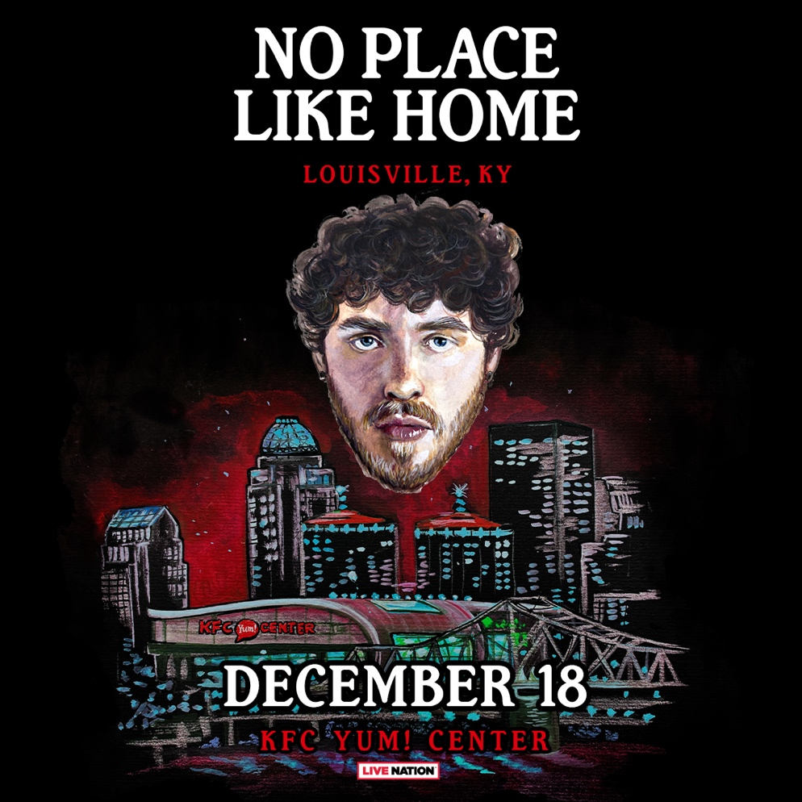

(October 18, 2022 – New York, NY) 3X GRAMMY-nominated rap superstar Jack Harlow has announced plans to return home to Louisville, KY for the 2nd annual, “No Place Like Home” show, taking place on December 18 at Louisville’s KFC Yum! Center, produced by Live Nation and Production Simple. Harlow’s long-awaited return to Louisville follows last year’s “No Place Like Home” debut, which saw the rap superstar performing 5 unforgettable shows at 5 iconic venues.

Artist presale begins on Thursday, October 20 at 10am EST.
Fans can sign-up for exclusive artist presale access HERE.

Tickets go on sale to the general public this Friday, October 21 at 10am EST at https://www.ticketmaster.com/event/16005D4EBAC960FF.

The announcement of this year’s “No Place Like Home” show comes days after Harlow wrapped his North American ‘Come Home The Kids Miss You Tour’ on Sunday, October 16 at Atlanta, GA’s State Farm Arena. With over 200,000 tickets sold, the ‘Come Home The Kids Miss You Tour’ became the most attended tour of Harlow’s career, to date. The 26-date tour – named after and in support of his sophomore album released in May – saw Harlow selling out iconic arenas nationwide including Los Angeles’ The Forum and Brooklyn’s Barclays Center.

Harlow – who TIME Magazine named to their TIME100 Next list of next generation leaders – was announced as both host and musical guest for the October 29 episode of Saturday Night Live, marking his hosting debut and second time as musical guest.

This is just the latest milestone in an already blockbuster year for the rapper, which also included gracing the cover of Rolling Stone, celebrating his first solo Hot 100 #1, topping charts of nearly every radio format, co-hosting and performing at the 2022 MTV Video Music Awards, co-hosting The Tonight Show Starring Jimmy Fallon and so much more.

For all Jack Harlow press inquiries, please contact:
Jason Davis jason.davis@atlanticrecords.com

* * *

ABOUT JACK HARLOW
Hailed as the “hitmaker of tomorrow” by Variety, Jack Harlow is one of music’s greatest new stars. The Louisville, KY native boasts three GRAMMY Award nominations, two #1 singles, 12 RIAA platinum certifications, and over 7.3 billion career streams to date. Harlow released his critically acclaimed, RIAA platinum certified debut album, THATS WHAT THEY ALL SAY in December 2020, which featured the 7x Platinum worldwide hit, “WHATS POPPIN,” which peaked at #2 on the Billboard Hot 100 chart and earned the 24-year-old his first GRAMMY nomination for “Best Rap Performance,” along with a wide array of other award nominations.

The Generation Now/Atlantic Records star has graced the covers of Rolling Stone, Forbes, Variety, Complex, SPIN, Footwear News and XXL’s coveted Freshman Class Issue, and brought his captivating live show to TV with performances on Saturday Night Live, The Tonight Show Starring Jimmy Fallon, Jimmy Kimmel Live!, the 2021 MTV Video Music Awards, and the 2022 Kids Choice Awards, to name a few.

Harlow is now poised to reach even greater heights following the release of his now Gold-certified sophomore album, COME HOME THE KIDS MISS YOU, highlighted by the bombastic lead single “Nail Tech” and the chart topping 2X platinum single “First Class,” which made a spectacular debut at atop the Billboard “Hot 100,” marking his first solo #1 single, while earning the biggest streaming week of 2022, thus far.

ABOUT LIVE NATION ENTERTAINMENT
Live Nation Entertainment (NYSE: LYV) is the world’s leading live entertainment company comprised of global market leaders: Ticketmaster, Live Nation Concerts, and Live Nation Sponsorship. For additional information, visit www.livenationentertainment.com.

Media Contact: Monique Sowinski | moniquesowinski@livenation.com

ABOUT PRODUCTION SIMPLE
Launched in 2005, Production Simple is a boutique talent-buying, promotion company based in Louisville, KY. Since its inception the ProSim team has worked with Louisville’s premiere venues, including its sister company and flagship venue, Headliners Music Hall, Kentucky Performing Arts, Old Forester's Paristown Hall, Iroquois Amphitheater, The Louisville Palace and Waterfront Park as well as regionally in Lexington, Covington, Cincinnati and Pikeville.

With 50 years of combined experience in the concert and event promotion field they are dedicated to delivering the highest level of quality to fans and artists. From the most intimate of venues to the large scale outdoor events, they continue to nurture and grow these artists along the way and to bring the best and brightest entertainment to the ever growing Louisville music scene. Production Simple is proud to be a part of the Louisville community and part of keeping it local and “weird.”

# # #

