FOR IMMEDIATE RELEASE
NOVEMBER 18, 2022

THE MELODY GAD KRANIUM RELEASES FOURTH PROJECT IN TOO DEEP
7 SONGS OF STORY TELLING, SMOOTH MELODIES, AND CLEVER LYRICISM
EP ACCOMPANIED BY RELEASE OF VISUAL FOR “6EX IN THE MORNING”
WITH FEATURES FROM QUEEN NAIJA AND B-LOVEE
EP INCLUDES THE HIT TRACKS “WI DEH YAH,” “PARANOID,” AND “WITHOUT YOU”
STREAM/DOWNLOAD IN TOO DEEP
WATCH/SHARE “6EX IN THE MORNING”
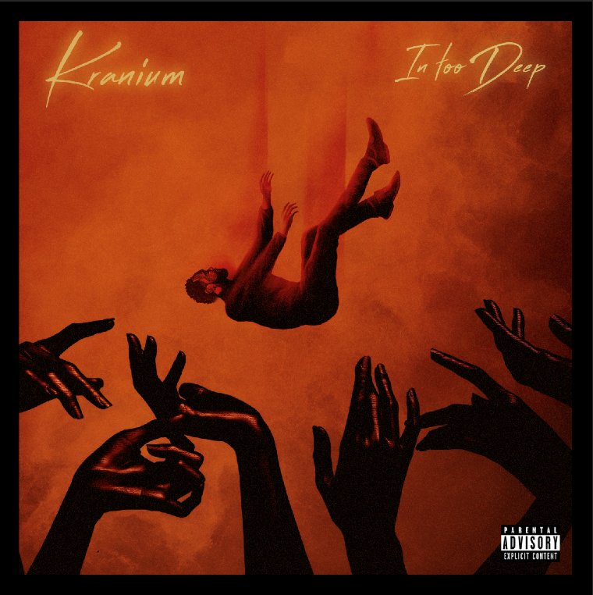
DOWNLOAD HI-RES ARTWORK

Global Dancehall giant, Kranium, returns with his fourth official project, In Too Deep. The EP includes the notable track “Wi Deh Yah” and recent collaborations “Without You (Feat. Queen Naija)” and “Paranoid (Feat. B-Lovee).” At this point in Kranium's life he's in too deep in his career, key relationships, and his determination for global success to turn back now. This and a beautifully toxic relationship serves as the inspiration behind the EP’s title as we see the dancehall star blending elements of modern dancehall, hip-hop, R&B, afrobeats, and soul. In Too Deep is by far one of Kranium’s most personal projects to date and he’s ready for the world to hear it.

In Too Deep includes production credits from Non Native (Grammy nominated multi-platinum producer; “Calling My Phone” by Lil Tjay & 6lack. He also produced “Wi Deh Yah”), iO, Frankie Music (Grammy award winning producer; Koffee “Raggamuffin”), and Hardwerk (Grammy nominated producer; “Bad Kinda Butterflies” Camila Cabelo). Preceding the album is the genre breaking, “Paranoid (Feat. B-Lovee)” and the R&B heavy “Without You (Feat. Queen Naija).” “Paranoid” features the Maryland born, South Bronx based Bronx based drill rapper B-Lovee, offering the perfect blend of hip-hop, drill, and modern dancehall. “Without You (Feat. Queen Naija)” shows the softer side of Kranium and unlike most of his sexy, party driven catalog, its built on the idea of finding true love, losing it, going through withdrawal, and wanting to do anything to get it back.

IN TOO DEEP TRACKLIST

- Wi Deh Yah
- Paranoid ft. B-Lovee
- 6ex In The Morning
- No Regret
- Without You ft. Queen Naija
- Early In The Morning
- Special Woman

With multiple plaque achievements within the U.S., Canada, and U.K. markets, Kranium has proven to be one of R&B/Dancehall’s greatest superstars, driving Dancehall music and culture into the future on his own characteristic terms. The dancehall superstar is now also currently boasting nearly 1 BILLION streams globally.

Over the span of his career, Kranium has established himself as one of the hottest international dancehall artists in the world. In 2019, Kranium unveiled his debut album, Midnight Sparks to the world. The album saw Kranium continuing to craft a simmering sonic cocktail of reggae, R&B, hip-hop, and soul, including superstar features from the likes of AJ Tracey, Mahalia, Burna Boy, and longtime collaborator Ty Dolla $ign. The album showcased fiery singles as “So Me Move,” “Just The Style (Feat. Alkaline),” “Talkin’ (Feat. PJ),” and “In Charge.” Kranium’s sparkling debut was followed in 2020 with the release of “Gal Policy,” a fan-favorite with a lyric video that accumulated over 14 million views in six months of its release. In addition, Kranium also unveiled “Through The Window,” afterwards closing out the year with a fiery collaboration “Block Traffic (feat. Rytikal).” In 2021, Kranium released his EP, Toxic, and followed up with the “Wi Deh Yah” single earlier this year. A true “set the tone” record that showcases Kranium’s clever lyricism, gift for melodies, and the perfect balance of vocals, “Wi Deh Yah,” displayed the smoothness he’s known for but with a bit of street Dancehall flare. Kranium supported the single with his “Wi Deh Yah” Tour and followed up with an appearance and performance at the 2022 Essence Music Festival. Recently, he released a sexy new single “Without You (Feat. Queen Naija)” and spoke with Billboard about his upcoming EP. Carl Lamarre of Billboard noted when listening to the forthcoming EP: "I've always respected the music and I've always known you were a beast but there is a different kind of machine and mindset you're on. You're going full fledge of R&B [while effortlessly blending it with dancehall]. A lot of people can't make that transition. You are doing it seamlessly and this is going to be something special!”

CONNECT WITH KRANIUM
OFFICIAL | TWITTER | INSTAGRAM | FACEBOOK | YOUTUBE

FOR ALL INQUIRIES
SYDNEY MARGETSON
SYDNEY.MARGETSON@ATLANTICRECORDS.COM

