FOR IMMEDIATE RELEASE
NOVEMBER 4, 2022

KRANIUM AND B-LOVEE BREAK GENRE BARRIERS WITH THEIR LATEST COLLABORATION “PARANOID”
FOLLOW-UP TO QUEEN NAIJA ASSISTED “WITHOUT YOU” SINGLE
WILL BE INCLUDED ON HIS UPCOMING EP
STREAM “PARANOID (FEAT. B-LOVEE)”
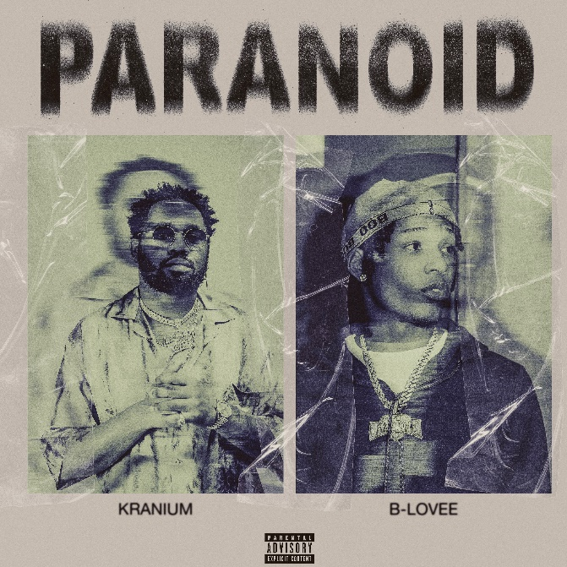
DOWNLOAD HI-RES ARTWORK

Global Dancehall superstar Kranium and drill icon, B-Lovee, team up for an authentic “this is what New York sounds like” collaboration on their single, “Paranoid.” The eclectic single is produced by Grammy Winning and Jamaican based producer Frankie Music (Koffee "Raggamuffin"). The single also comes on the heels of his previously released single, “Without You (Feat. Queen Naija)”. Both singles, including “Wi Deh Yah,” will all be featured on his upcoming EP slated for release later this month.

When New York Drill comes to mind, one of the voices that have helped cultivate its presence worldwide is B-Lovee. “Paranoid" features the Maryland born, South Bronx based drill rapper B-Lovee, offering the perfect blend of hip-hop, drill, and modern dancehall. This collaboration has been a long time in the making and this was the perfect song for them to choose.

With multiple plaque achievements within the U.S., Canada, and U.K. markets, Kranium has proven to be one of R&B/Dancehall’s greatest superstars, driving Dancehall music and culture into the future on his own characteristic terms. The dancehall superstar is now also currently boasting nearly 1 BILLION streams globally.

Over the span of his career, Kranium has established himself as one of the hottest international dancehall artists in the world. In 2019, Kranium unveiled his debut album, Midnight Sparks to the world. The album saw Kranium continuing to craft a simmering sonic cocktail of reggae, R&B, hip-hop, and soul, including superstar features from the likes of AJ Tracey, Mahalia, Burna Boy, and longtime collaborator Ty Dolla $ign. The album showcased fiery singles as “So Me Move,” “Just The Style (Feat. Alkaline),” “Talkin’ (Feat. PJ),” and “In Charge.” Kranium’s sparkling debut was followed in 2020 with the release of “Gal Policy,” a fan-favorite with a lyric video that accumulated over 14 million views in six months of its release. In addition, Kranium also unveiled “Through The Window,” afterwards closing out the year with a fiery collaboration “Block Traffic (feat. Rytikal).” In 2021, Kranium released his EP, Toxic, and followed up with the “Wi Deh Yah” single earlier this year. A true “set the tone” record that showcases Kranium’s clever lyricism, gift for melodies, and the perfect balance of vocals, “Wi Deh Yah,” displayed the smoothness he’s known for but with a bit of street Dancehall flare. Kranium supported the single with his “Wi Deh Yah” Tour and followed up with an appearance and performance at the 2022 Essence Music Festival. Recently, he released a sexy new single “Without You (Feat. Queen Naija)” and spoke with Billboard about his upcoming EP. Carl Lamarre of Billboard noted when listening to the forthcoming EP: "I've always respected the music and I've always known you were a beast but there is a different kind of machine and mindset you're on. You're going full fledge of R&B [while effortlessly blending it with dancehall]. A lot of people can't make that transition. You are doing it seamlessly and this is going to be something special!”

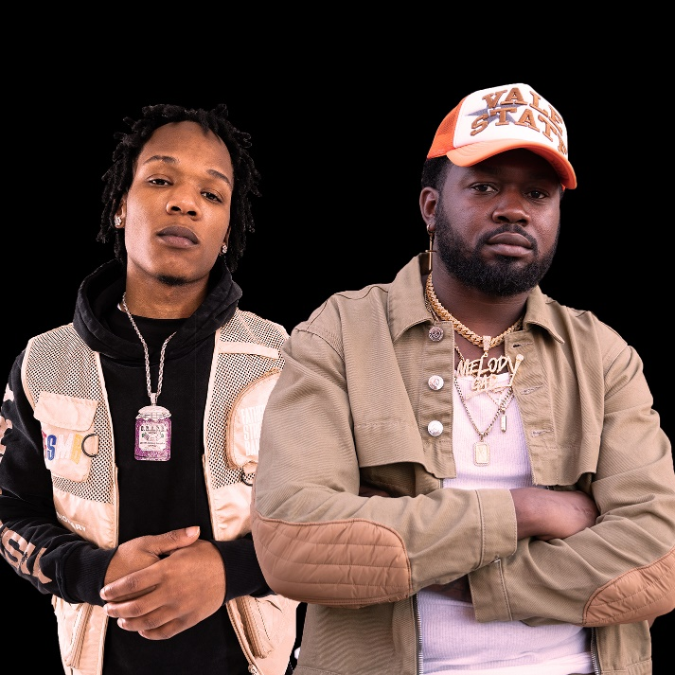

CONNECT WITH KRANIUM
OFFICIAL | TWITTER | INSTAGRAM | FACEBOOK | YOUTUBE

FOR ALL INQUIRIES
SYDNEY MARGETSON
SYDNEY.MARGETSON@ATLANTICRECORDS.COM

