GRAMMY NOMINATED ARTIST LIL UZI VERT RELEASES VISUAL FOR
“JUST WANNA ROCK”
VISUAL WILL BE PROJECTED LIVE IN LONDON, LA, NEW YORK, AND PHILLY
SINGLE HAS NOW SURPASSED 126M GLOBAL STREAMS
RECENTLY ANNOUNCED UPCOMING 2023 HEADLINING TOUR
WATCH/SHARE “JUST WANNA ROCK”
DOWNLOAD/STREAM “JUST WANNA ROCK”

Today, Grammy nominated artist Lil Uzi Vert released the visual for “Just Wanna Rock” with direction for the masterful visual by Gibson Hazard via his company House of Hazard. The release will be followed up by wall projections of the visual in cities around the globe including London, New York, LA, and Philly. The New York projection in particular is going to be right where the actual visual was shot. TikTok and dance influencers from around the nation were seen throughout the video, including the originator of the dance challenge, @drewjeeezy. The previous release of the single served as the official follow up to his Red & White EP released this past summer which now has over 175M global streams. The single is now boasting over 126M global streams.

ABOUT LIL UZI VERT

In addition to Lil Uzi Vert’s 2018 Grammy nomination as “Best New Artist”, the artist also received the “Breakout Artist of the Year Award” and the “Breakthrough Artist” award during Billboard’s 2017 Touring Awards. The rap superstar has also been featured on several record-breaking tracks including Travis Scotts’ RIAA 3X platinum certified “Wasted” featuring Kanye West, the RIAA gold certified single with Future “Drankin and Smokin” and Lil Baby’s RIAA platinum certified “Commercial” single to name a few. In 2020, Uzi dropped the deluxe edition of the long-awaited release, Eternal Atake, which includes part two of the album, titled LUV vs. The World 2, reaching #1 on the Billboard 200. Eternal Atake would go on to gain RIAA Platinum certification and was nominated for favorite rap/hip hop album at the 2020 American Music Awards. Immediately following these projects, Uzi and Future released both Pluto x Baby Pluto and the deluxe version in the same year. The Eternal Atake would go on to peak at #2 on Billboard 200 and features the notable singles “Patek” and “Over Your Head.” Uzi made his 2022 return a strong one with a flood of national festival performances and the release of the EP Red & White. He followed up the EP release with his latest single “Just Wanna Rock.”

# # #

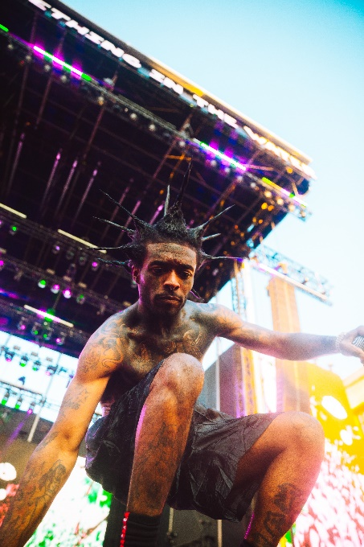

CONNECT WITH LIL UZI VERT
INSTAGRAM | FACEBOOK | TWITTER | SOUNDCLOUD | OFFICIAL

FOR ALL INQUIRIES, PLEASE CONTACT
SYDNEY.MARGETSON@ATLANTICRECORDS.COM
JANA FLEISHMAN
JANAF@ROCNATION.COM

