FOR IMMEDIATE RELEASE
NOVEMBER 11, 2022

MAHALIA RETURNS WITH HEARTWARMING NEW TRACK “BAG OF YOU”
ACCOMPANIED BY THE MAHALIA & OLI KANE DIRECTED VISUAL
COMES ON THE HEELS OF RECENTLY WRAPPED “LETTER TO YOUR EX” TOUR
LISTEN TO “BAG OF YOU”
WATCH “BAG OF YOU”
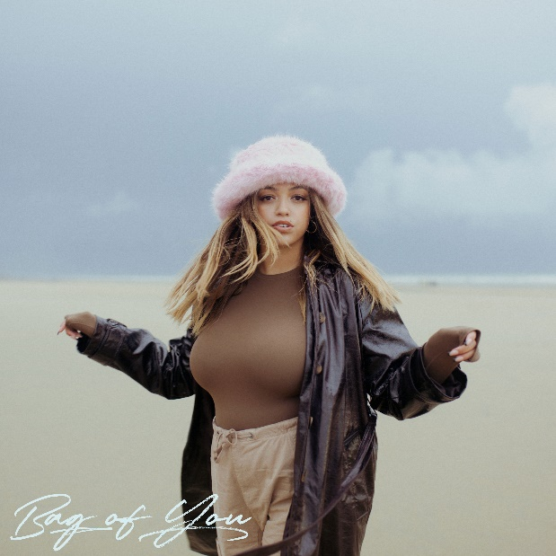
DOWNLOAD HI-RES ARTWORK

Today, GRAMMY-nominated R&B star Mahalia has returned with her deeply touching new track ‘Bag Of You’ - available now, globally via Atlantic Records.

The first release since her brilliant EP, ‘Letter To Ur Ex’, which featured the singles, ‘Letter To Ur Ex’, ‘Whatever Simon Says’, ‘Forever’ and ‘In The Club’, Mahalia has made a triumphant return with this beautiful ode to healthy, romantic attachment. Produced by JD Reid and Max Pope, Mahalia hones in on her signature style as she writes about the nitty gritty of everyday life, managing to make the unremarkable remarkable as she illuminates the mundane.

Reuniting with close collaborator Oli Kane to co-direct this beautiful visual, the video opens on a sun-lit beach with Mahalia narrating the beauty of solitude. The sun begins to set and Mahalia is joined by her love as they hold one another in the moonlight.

On the release, Mahalia states; “This song is one of my favourites so far. ‘Bag Of You’ is all about that sweet spot in a relationship when everything is just lovely. where the idea of being without that person - even just for a second - is too much to bare. I love everything about this record. It’s definitely the start of what’s to come next year.”
The last couple of years have marked many achievements for the Leicester-born star. Beginning 2020 with her second BRIT nomination, Mahalia featured on up-and-coming fellow Midlands rapper Pa Salieu’s debut mixtape, ‘Send Them To Coventry’, whilst also gracing the tracklist of Headie One’s #1 album ‘Edna’. Subsequently, Mahalia also received a GRAMMY nomination for ‘All I Need’ - Jacob Collier’s single of which she features alongside US rapper, Ty Dolla $ign. Shortly after, Mahalia concluded the year with three MOBO nominations for ‘Best Female Act’, ‘Best R&B/Soul Act’ and ‘Album Of The Year’ for her debut album, ‘Love and Compromise’, winning in the first two categories. In 2021, Mahalia was also nominated for her first ever Ivor Novello award for her 2020 collaboration with UK lyricist Pa Salieu for his single ‘Energy’ and subsequently concluded the year with an incredible headline show at London’s prestigious venue, O2 Brixton Academy. Adding to her long list of achievements Mahalia opened for Adele at her 2022 BST shows in Hyde Park this Summer and Alicia Keys for her o2 Arena shows in London as well as performing at the 2022 Commonwealth games in Birmingham.
Besides the awards and nominations, it’s also been a time of deep personal growth, one that Mahalia describes as a real rollercoaster in her personal and professional life. Reflection has been the thread running through Mahalia’s writing and while the current global situation offers little more than uncertainty, the singer hopes that her music will encourage her listeners to carve out time to also look back and re-evaluate: “We’re all fixated on how we can make ourselves better during and after this period of time but I want people to also reminisce on lovely or painful situations they’ve lived through and how they’ve helped shape the people they are now.”

Listen ‘Bag Of You’ here
Watch ‘Bag Of You’ here

# # #
CONNECT WITH MAHALIA
OFFICIAL WEBSITE | TWITTER | FACEBOOK | INSTAGRAM
FOR PRESS INQUIRIES PLEASE CONTACT
ARIANA.WHITE@ATLANTICRECORDS.COM

