FOR IMMEDIATE RELEASE
NOVEMBER 1, 2022

WEST COAST RAP HERO OHGEESY JOINS
YG’S THE RED CUP TOUR FOR SPECIAL GUEST RUN

THE RED CUP TOUR, TICKETS ON SALE NOW
PURCHASE HERE

SHORELINE MAFIA CELEBRATES FIVE YEAR ANNIVERSARY OF
DEBUT MIXTAPE, SHORELINEDOTHATSHIT WITH VINYL
AVAILABLE VIA WEB STORE ON NOVEMBER 25TH
PRE-ORDER HERE

WRAPPED SOLD-OUT GEEZYWORLD TOUR WITH BLUE BUCKS CLAN ON SEPTEMBER 27

STREAM/DOWNLOAD GEEZYWORLD DELUXE HERE | LISTEN TO “KNOCK KNOCK” HERE

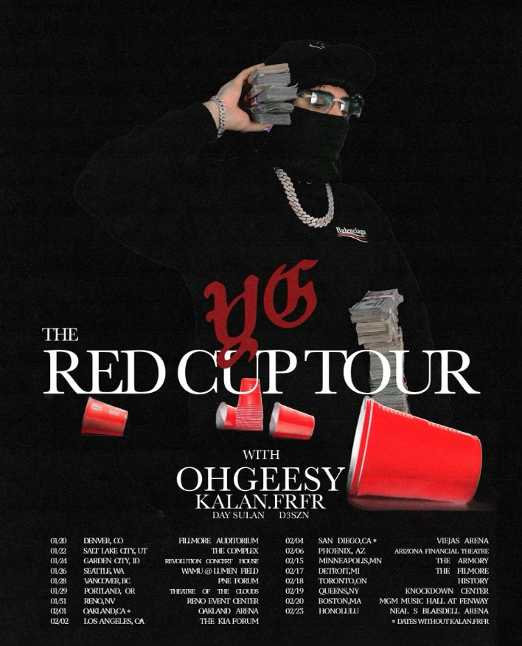
DOWNLOAD HERE

Platinum-selling artist OHGEESY will kick off the new year with a special guest run on Grammy nominated West Coast rapper, YG’s The Red Cup Tour. Beginning January 20th, 2023, at Denver, Colorado’s Filmore Auditorium and making stop across North America before wrapping up at Honolulu, HI’s Neal S Blaisdell Arena on February 23rd, the fans are in for a West Coast treat. Tickets are on sale now. Purchase HERE.

What’s more, OhGeesy’s former hip hop group Shoreline Mafia, will celebrate the fifth-year anniversary of the group’s debut mixtape ShorelineDoThatShit with an official vinyl. Available for pre-order now the ShorelineDoThatShit vinyl, can be purchased via web store on Black Friday, 11/25. The groundbreaking mixtape was released on Soundcloud, October 30th, 2017, in turn leading to their first RIAA gold certification.

Last month, the California rapper released his trenchant new track “Knock Knock” produced by DJ Vision alongside the Kuno-directed visual. The single heralds the arrival of OHGEESY’s eagerly awaited new mixtape, GEEZYWORLD 2, due top of next year making this his second solo project. The project will also include the boisterous first single, “Up.” The track – produced by ENRGY (EST Gee, Lil Yachty) – arrived comprised of an official music video, filmed on the streets of London and streaming now HERE.

OHGEESY spent his summer traveling North America on his epic GEEZYWORLD headline tour, presented by Cookies that wrapped September 27 at Victoria, BC’s Cabaret Upstairs. Special guests included BlueBucksClan, with support from DJ Vision and Hawaii Slim. While on tour, OHGEESY made show-stopping performances at Rolling Loud Miami and Rolling Loud Toronto.

OHGEESY made his smash solo debut with last year’s acclaimed GEEZYWORLD, available now in an extended deluxe edition HERE. Highlights include such hit singles as “Get Fly (Feat. DaBaby),” “Big Bad Wolf (Feat YG),” “Who Else (Feat. BlueBucksClan),” “Secret Service,” “Go Fast (Feat. Eladio Carrion),” “Appetizer (Shoreline Mafia),” and “Make It Happen (Feat. Pressa & Bun Dog),” all accompanied by official visuals streaming now at YouTube.

ABOUT OHGEESY:
California never gave rise to a rapper quite like OHGEESY. The Los Angeles-born Mexican-American multi-platinum artist, entrepreneur, and visionary not only continues the legacy of his hometown, but he also puts a whole culture rarely represented in hip-hop on his back with pride, poise, and power. As such, he emerges as a trailblazer with vicious wordplay, vibrant storytelling, and a vital message. Breathing new life into the culture, he co-founded Shoreline Mafia during 2016. He locked down the group’s legacy with their gold certified ShorelineDoThatShit mixtape, 2x platinum “Bands,” platinum certified records such as “Musty” and “Nun Major, ”OHGEESY served up his solo debut, GEEZYWORLD, in 2021 followed by his first sold-out headline tour. Among its many highlights, “Get Fly (Feat. DaBaby)” raked in over 32M Spotify streams, while “Keeper (Feat. A Boogie Wit Da Hoodie)” posted up 21M Spotify streams. Right out of the gate, Pitchfork proclaimed, “GEESY is well placed to thrive as a lone star. GEEZYWORLD is a quintessential L.A. rap record.”

OHGEESY’s still-expanding world now features exclusive merchandise with his OTXBOYZ line (sold through his GEEZYWORLD web site). He also co-owns Mexican seafood spot Sunset Mariscos inside of the famed Fred Segal store in West Hollywood. Posting up hundreds of millions of streams and attracting widespread praise from GQ, Complex, UPROXX, XXL, OkayPlayer, and HotNewHipHop, OHGEESY instigates another era for new music to come and much more.

# # #

CONNECT WITH OHGEESY
GEEZYWORLD.COM | FACEBOOK | INSTAGRAM | TWITTER | YOUTUBE

PRESS CONTACT:
Brittany Bell | Brittany.Bell@atlanticrecords.com

