SEDDY HENDRINX RELEASES NEW VISUAL FOR “PASSION”
SONG APPEARS ON HIS WELL SED (GANGSTA GRILLZ) MIXTAPE
WELL SED (GANGSTA GRILLZ) MIXTAPE NOW BOASTING 10.7M GLOBAL STREAMS
KICKING OFF UPCOMING TOUR WITH OMB PEEZY NEXT MONTH IN
HOUSTON AT THE HOUSE OF BLUES
WATCH/SHARE “PASSION” VISUAL
DOWNLOAD/STREAM WELL SED (GANGSTA GRILLZ) MIXTAPE
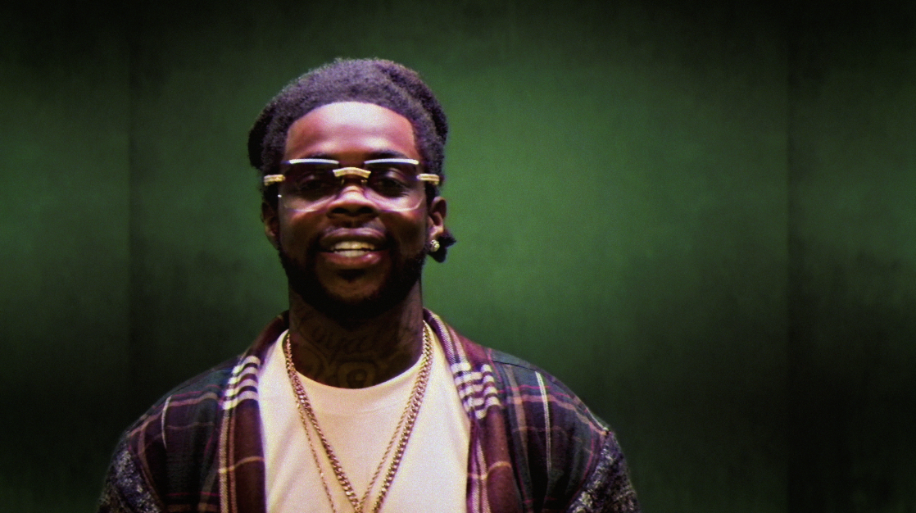
# # #
THE WELL GUIDED TOUR
DECEMBER
6 – Houston, TX – Bronze Peacock @ House of Blues
7 – Dallas, TX – Ruins
9 – Oklahoma City, OK – Ponyboy
11 – Denver, Co – Cervantes Other Side
13 – Chicago, IL – Reggie’s
16 – Atlanta, GA – Purgatory at the Masquerade
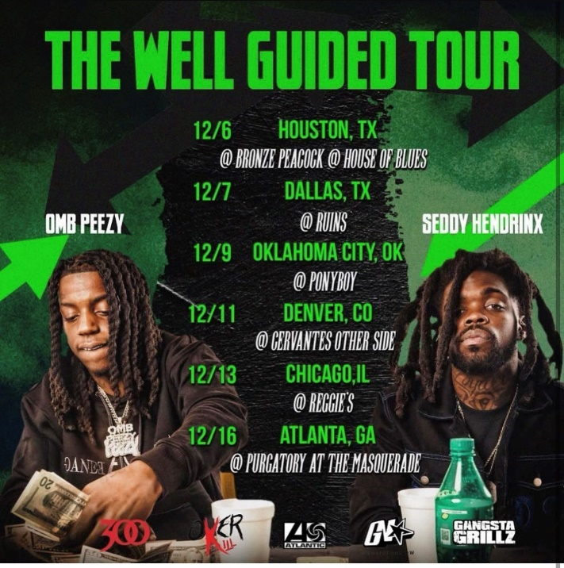
SEDDY HENDRINX
Seddy Hendrinx bobs and weaves between moments of unfiltered emotion, upbeat elation, and undeniable excitement. Through flaunting unmatched unpredictability, the Duval County rapper and singer presents a slick signature style unlike anything else in the game. He asserts himself as a dynamic and diverse disruptor whose uncanny melodic sensibility matches his unbridled intensity. Born and raised in Jacksonville, Florida, music always spoke to Seddy. He immersed himself in records by Tupac, Lauryn Hill, André 3000, DMX, Future, and Erykah Badu. While dying from a gunshot wound, his best friend Johnell urged Seddy to “Ball out for me.” So, Seddy picked up a microphone and did just that. Making waves on Soundcloud, he unleashed music at a prolific pace with projects such as The Roots, Just Cause EP, Death B4 Dishonor: Loyalty Over Everything, Roots II, and B.H.D. (Black Hearted Demon). However, he leveled up on 2020’s Sayless powered by collaborations a la “Plus 10” [feat. Jack Harlow], “Run It Up” [feat. G Herbo], and “45” [feat. A Boogie Wit Da Hoodie]. In addition to plugs from REVOLT, Respect, and more, Earmilk raved, “Hendrinx has quickly become a creative force to be reckoned with, releasing a series of superb albums including Sayless and Roots II.” After racking up tens of millions of streams and views, he perfects this vision on his 2022 mixtape, Well Sed (GANGSTA GRILLZ) [Generation Now/Atlantic Records].
# # #
DOWNLOAD HI-RES ART

CONNECT WITH SEDDY HENDRINX
FACEBOOK | TWITTER | INSTAGRAM | SOUNDCLOUD | YOUTUBE

PRESS CONTACT
SELAM.BELAY@ATLANTICRECORDS.COM

