SEDDY HENDRINX RELEASES NEW VISUAL, “WELL SED”
CREATIVE DIRECTED BY SEDDY HENDRINX WITH SPECIAL APPERANCES BY
DJ DRAMA, OMB PEEZY, VIC BLENDS, CEO TRAYLE & MANY MORE

INSPIRED BY CLASSIC FILM BELLY
SET TO APPEAR ON SELECT DATES OF WIZ KHALIFA’S “VINYL VERSE TOUR”
TICKETS FOR UPCOMING HEADLINE SHOW AT THE ROXY ON SEPTEMBER 15 AVAILABLE NOW
WATCH/SHARE “WELL SED” VISUAL | DOWNLOAD/STREAM WELL SED (GANGSTA GRILLZ) MIXTAPE
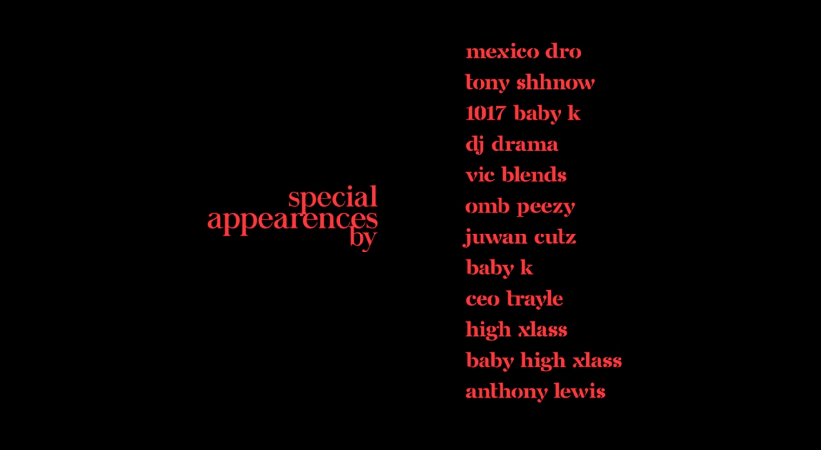
# # #
UPCOMING PERFORMANCES
8/12 – Wiz Khalifa Vinyl Verse Tour - Lakewood Amphitheatre (Atlanta, GA)
8/13 – Wiz Khalifa Vinyl Verse Tour – Veterans United Home Loans Amphitheater (Virginia Beach, VA)
8/14 – Wiz Khalifa Vinyl Verse Tour – Freedom Mortgage Pavilion (Camden, NJ)
8/16 - Wiz Khalifa Vinyl Verse Tour – Barclays Center (Brooklyn, NY)
8/17 - Wiz Khalifa Vinyl Verse Tour – PNC Bank Arts Center (Holmdel, NJ)
8/19 - Wiz Khalifa Vinyl Verse Tour – Jiffy Lube Live (Bristow, VA)
9/15 – Headline Show - The Roxy (Los Angeles, CA)
# # #
SEDDY HENDRINX
Seddy Hendrinx bobs and weaves between moments of unfiltered emotion, upbeat elation, and undeniable excitement. Through flaunting unmatched unpredictability, the Duval County rapper and singer presents a slick signature style unlike anything else in the game. He asserts himself as a dynamic and diverse disruptor whose uncanny melodic sensibility matches his unbridled intensity. Born and raised in Jacksonville, Florida, music always spoke to Seddy. He immersed himself in records by Tupac, Lauryn Hill, André 3000, DMX, Future, and Erykah Badu. While dying from a gunshot wound, his best friend Johnell urged Seddy to “Ball out for me.” So, Seddy picked up a microphone and did just that. Making waves on Soundcloud, he unleashed music at a prolific pace with projects such as The Roots, Just Cause EP, Death B4 Dishonor: Loyalty Over Everything, Roots II, and B.H.D. (Black Hearted Demon). However, he leveled up on 2020’s Sayless powered by collaborations a la “Plus 10” [feat. Jack Harlow], “Run It Up” [feat. G Herbo], and “45” [feat. A Boogie Wit Da Hoodie]. In addition to plugs from REVOLT, Respect, and more, Earmilk raved, “Hendrinx has quickly become a creative force to be reckoned with, releasing a series of superb albums including Sayless and Roots II.” After racking up tens of millions of streams and views, he perfects this vision on his 2022 mixtape, Well Sed (GANGSTA GRILLZ) [Generation Now/Atlantic Records].
# # #
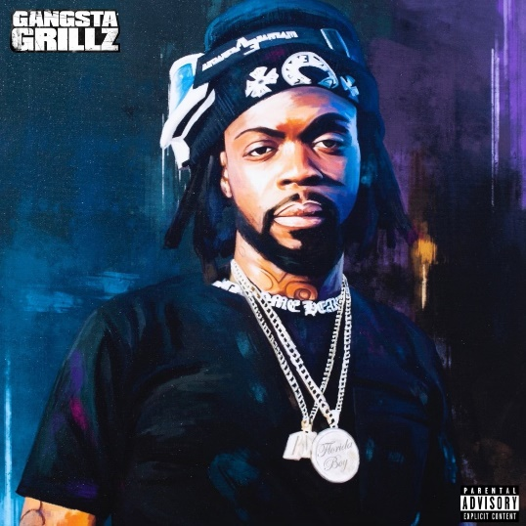
DOWNLOAD HI-RES ART

CONNECT WITH SEDDY HENDRINX
FACEBOOK | TWITTER | INSTAGRAM | SOUNDCLOUD | YOUTUBE

PRESS CONTACT
SELAM.BELAY@ATLANTICRECORDS.COM

