FOR IMMEDIATE RELEASE
OCTOBER 31, 2022

ONE MORE TIME FOR THE PEOPLE IN THE BACK!!!
R&B SUPERSTAR
TANK
"SLOW" FT. J VALENTINE #1 @ R&B RADIO
THIRD #1 RADIO HIT OFF “R&B MONEY” &
7TH OVERALL HIT SONG
NOMINATED FOR "BEST COLLABORATION" &
"ALBUM OF THE YEAR" @ THE 2022 SOUL TRAIN AWARDS
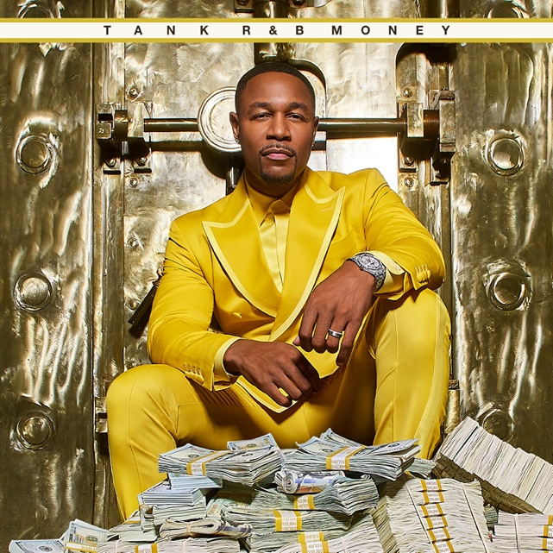
R&B MONEY OUT NOW!
The number seven represents the fullness of life…perfection! And Tank has hit excellence as he celebrates his seventh #1 hit R&B radio hit with "Slow" featuring J Valentine. This stimulating ballad will pierce into your imagination as the two tap into the very essence of R&B taking fans on a ride of sensual sounds and musical bravado. The single is also the third #1 hit featured on Tank's 10th and final album, R&B Money, which includes "Can't Let It Show" and "I Deserve.” In addition, both “Slow” and R&B Money received nominations for “Best Collaboration” and “Album of The Year” at the 2022 Soul Train Awards.
CLICK HERE TO WATCH “SLOW”
CLICK HERE TO STREAM “R&B MONEY”
In addition to the release of this album, Tank and J. Valentine launched their “R&B Money” Podcast via iHeartMedia and Charlamagne tha God's Black Effect Podcast Network (click here), which has featured guests Jamie Foxx, Babyface, JoJo, LeToya Luckett, Jon B., Ray parker Jr. Isaac Carree and more. Debuting as the #1 Music Podcast, the show celebrates the genre of R&B, representing the culture like no other, highlighting the genre with exceptionally compelling storytelling while building a place of discovery for the fans.

Throughout his 20+ year career, Tank has garnered over seven #1 hits and has written and produced for names like Aaliyah, Chris Brown, Jamie Foxx, Alicia Keys, Beyonce, Kelly Rowland, and more. From his first #1 double-platinum single, “Maybe I Deserve,” Tank has been able to touch listeners that have garnered him a cult following with releases like “Slowly,” “Please Don’t Go,” and “I Can’t Make You Love Me.”

In 2021, Tank celebrated the long-overdue streaming debut of his landmark first three solo albums, 2001’s RIAA gold-certified, #1 debut, FORCE OF NATURE (over 1 Mil copies sold), 2002’s ONE MAN (over 500k copies sold), and 2007’s chart-topping, GRAMMY® Award nominated SEX, LOVE & PAIN (over 500k copies sold). Rolling Stone acknowledged the historic streaming premiere with an exclusive interview with Tank, writing, “For the first time, fans will also be able to travel through his catalog in reverse, rewinding from 2021 to 2000.”

###
FOLLOW TANK:
IG: @therealtank
TW: @therealtank
FB: @therealtank

FOR PRESS INQUIRIES
SYDNEY.MARGETSON@ATLANTICRECORDS.COM
TASHA@STRONGARMMEDIA.COM

