FOR IMMEDIATE RELEASE
NOVEMBER 11, 2022

gnash returns with two

second installment in ongoing series of double-sided singles
includes the brand new “Family, Man” backed with the previously released “Money, Love & Death”

additional double-sided singles to follow throughout the year and into 2023

listen to two here

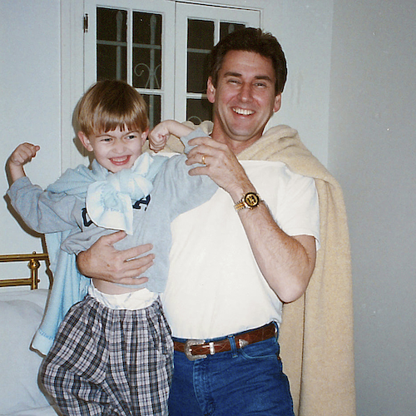
DOWNLOAD HI-RES ARTWORK

6x RIAA platinum-certified singer-songwriter gnash is back with two, the second installment in his ongoing series of new double-sided singles set to be released throughout the remainder of the year and into 2023. two – which includes the brand new track, “Family, Man” (co-written and co-produced by gnash with singer-songwriter Annika Bennett) backed with the previously released “Money, Love & Death” – is available now via Atlantic Records/Overall Recordings at all DSPs and streaming services HERE.

Last month saw the series of new singles begin with one, featuring “Seasons” backed by the previously released “Palm Trees.” one is available now via Atlantic Records/Overall Recordings at all DSPs and streaming services HERE.

Both one and two follow the recent premiere of gnash’s acclaimed collaboration with fellow chart-topping singer-songwriter Annika Wells for the playfully organic new duet, “granola bars,” available now at all DSPs and streaming services HERE. Written by gnash – a.k.a. Garrett Nash – and Wells (Illenium, BTS, Steve Aoki) and produced by Nash, Wells, and Giulio Cercato, the track was met by praise from such online outlets as The Honey Pop, which raved, “‘granola bars’ is a simple but moving track with minimal background music and a focus on the back-and-forth between gnash and Annika. With lyrics that describe the perfect getaway and vibes that are upbeat and happy, this track is a shoo-in for that camping-for-two playlist.”

“granola bars” follows a stunning series of deeply personal singles released by gnash under his birth name of Garrett Nash, including “Where The Sidewalk Ends“ (a collaboration with 7x JUNO Award-nominated Canadian singer-songwriter Scott Helman), “The Middle Of Nowhere,” “Super Glue,” Shwayze x Garrett Nash’s “Breathe In,” and a nostalgic cover of his childhood favorite, Fountains of Wayne’s “Stacy’s Mom.”

Known for his genre-blurring brand of modern pop, gnash made his global breakthrough with 2016’s multi-platform blockbuster hit single, “i hate u, i love u.” The stripped-bare track reached the top 10 on Billboard’s “Hot 100” – where it spent an impressive 39 weeks – and singles charts around the world, earning 6x RIAA platinum certification and more than 2B global streams. Furthermore, the “i hate u, i love u” companion video is an unadulterated blockbuster, now with over 699M individual views via YouTube alone.

Along with his world-straddling popular success, gnash began receiving rapt attention from worldwide media, drawing critical acclaim from such top tier publications as the New York Times, Entertainment Weekly, Billboard, Vogue, and NYLON, to name but a few. 2019 saw gnash follow a series of EPs with his RIAA gold certified full-length debut album, we, drawing praise from such outlets as The Guardian for its “highly intimate confessionals about doubt, anxiety and insecurity…the combination of charming tunes and humbling insights are truly lovely.”

As charming and idiosyncratic on stage as in the studio, gnash traveled North America on a number of tours, including 2019’s 40-date “the broken hearts club tour,” while also finding time for high-profile TV performances on NBC’s TODAY and Late Night with Seth Meyers. A strong advocate for mental health, gnash has long been open about his struggles, publicly acknowledging the benefits of therapy while also encouraging fans to find their own unique way to express themselves.

# # #

CONNECT WITH gnash
WEBSITE | FACEBOOK | INSTAGRAM | TIKTOK | TWITTER | YOUTUBE

For press inquiries, please contact:
Jessica Nall // Jessica.Nall@atlanticrecords.com

