FOR IMMEDIATE RELEASE
APRIL 15, 2022

KENNDOG PUTS A TWIST ON A THROWBACK R&B SOUND WITH NEW SINGLE “DOOWOP”
STREAM HERE
WATCH HERE

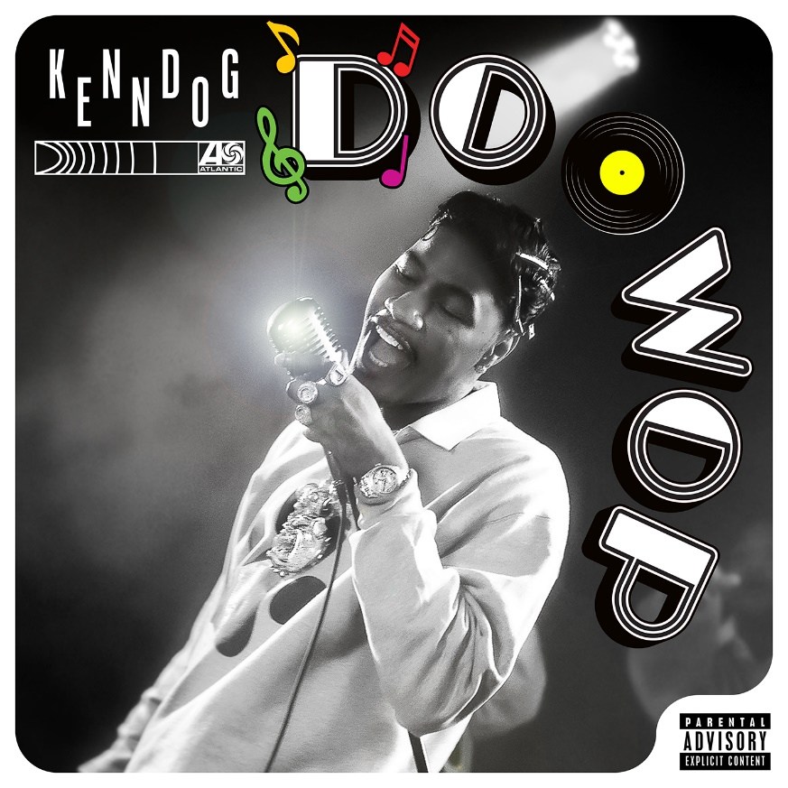
DOWNLOAD ARTWORK HERE

South Central LA native and Tik Tok viral sensation, Kenndog, takes fans back in time in style with his new single “DooWop.” The track combines his G-funk flow with the 1950s R&B and mainstream rock ‘n’ roll sound. Imitating his best Frankie Lymon & The Teenagers impression in visuals directed by JakeTheShooter, fans get to experience a blast from the past live TV styled performance.

Last year Kenndog tapped rising Michigan rapper DDG for his remix of “Beethoven.” The duo starred in the cinematic Ben Proulx-directed horror parody. That followed the release “Beethoven (feat. YN Jay),” a remix which was added to Spotify playlists Westside Story (686K), New Joints (153K) and The Culture – Hip Hop Vibes (123K). Amazon Music supported by adding the remix to their playlist Brand New Music.

The original release of “Beethoven” racked up over 90M global streams to date and debuted on the Rolling Stone Trending 25 chart. It’s been featured on the Spotify US Viral 50 charts and on numerous viral charts worldwide. The track seen streaming success across DSPs landing placements on the likes of Spotify’s Viral Hits (1.8m), Apple Music’s Viral Hits and Amazon Music’s Viral Hits. The sound on TikTok has over 500k video creates to date. The official video has over 16M views via YouTube where he’s been feature as a YouTube artist on the Rise Trending.

ABOUT KENNDOG:
At six feet seven inches tall, Kenndog naturally becomes the center of attention anytime he pulls up. However, the Watts-born rapper holds that attention with a dynamic, dizzying, and deft flow punctuated by razor sharp wit and a knack for a hard-hitting hook. Sitting in the pocket between nineties South Central G-Funk and modern internet-breaking boundlessness, he introduces himself as an unapologetic outlier. He grew up the youngest of four kids in Watts. Eventually, he started to rap on Facebook, inciting buzz and building an audience. After getting fired from his job at the 99-Cent Store, he learned how to cut hair, attracting a rapid customer base. Dropping tracks online, “Drip Like Me” caught fire in 2020. He urged friends, “Listen to it, and if you don’t like it, I’ll CashApp you $2.” He didn’t end up CashApping anyone, but TikTok titan Charli D’Amelio utilized the sound. It unleashed a viral flurry with support from Vice President Kamala Harris, California Governor Gavin Newsom, ESPN SportsCenter, Jayda Cheaves, Clarence White, and many more. UPROXX hailed him as “an instant favorite.” In mid-2021, he approached his producer with an idea to sample Beethoven’s “Für Elise” as the foundation for his next single “Beethoven.” Right out of the gate, it piled up 40 million-plus streams and counting. Amassing 100 million-plus streams total independently and lighting up millions of TikTok videos, he pursues a singular mission on a series of singles and his debut project for Atlantic Records.

CONNECT WITH KENNDOG
INSTAGRAM | TIKTOK | TWITTER | YOUTUBE | WEBSITE

PRESS CONTACT
BRITTANY BELL | BRITTANY.BELL@ATLANTICRECORDS.COM

