ALT-POP BROTHER DUO BALU BRIGADA
RETURN WITH “OH! NOT AGAIN”

NEW SINGLE PREMIERES TODAY - LISTEN

DOWNLOAD ARTWORK CREATED BY BALU BRIGADA HERE

“Balu Brigada is the groove-pop duo you've been waiting for.” - PEOPLE

Alt-pop brother duo Balu Brigada is back with their latest single, “OH! Not Again,” available now at all DSPs and streaming services HERE.

“‘OH! Not Again’ is about being let down so many times that you can’t even be surprised when you get screwed over again,” say Balu Brigada. “At some point you just roll your eyes and say ‘F*** it, I’m gonna do it my way, because it never seems to be enough for you when I do it your way.’ It’s not the most romantic premise in the world, but there’s something freeing about throwing it all at the wall and having no expectations for the response.”

“OH! No Again” follows the Auckland, NZ-based duo’s critically acclaimed debut EP, I Should Be Home, available now HERE. Embodied by the overarching metaphor of an epic night out, the 7-track EP includes such cinematic tracks as “I Should Be Home“ and “Moon Man,” both joined by official visuals streaming now via YouTube.

Hailed by i-D as “an actual band of brothers making tunes stacked with hooks that’ll run circles around your brain for days,” multi-instrumentalist/songwriter/producer brothers Henry and Pierre Beasley, are habituated to finishing each other’s sentences both in everyday discourse and in song. The Beasleys have spent much of the past few years creating a unique future-facing sound of their own, prioritizing dual vocals, prominent bass hooks, and punchy drums while showcasing a left-of-center pop sensibility and natural ability to skate genres. Tracks such as “Preview,” “How It Would End,” “Number One,” and “Favourite Clothes“ – all included on I Should Be Home – have already earned applause from such outlets as Coup de Main, i-D, and Ones To Watch, which praised their “soaring falsetto choruses, synth hooks and an irresistible, underlying groove.” In addition, an exclusive OnesToWatch live performance and Q&A – filmed at Everybody’s in Auckland, NZ – is streaming now via YouTube HERE.

ABOUT BALU BRIGADA:
Born into a creative home, their dad a dancer and mother an actress/musician, Henry and Pierre Beasley each dipped their toes in acting during school before fully immersing themselves in their love for music. A truly homegrown talent, they started making music together young, when a 12-year-old Henry capitalized on his older brother status by appointing himself lead guitarist and forcing Pierre to learn bass – officially forming Balu Brigada when Pierre was old enough to almost pass as 18 and play in bars. The duo have spent the past few years fine tuning their skills in every aspect of their output. This increased tenfold during COVID and New Zealand’s strict lockdowns. “The pandemic forced us to focus on doing production entirely ourselves,” the Beasley brothers say, noting, “It’s allowed us to experiment more and pursue more ambitious ideas.” The result is a cohesive set of tracks that are distinctly their own – “a little dirtier, but in a good way.”

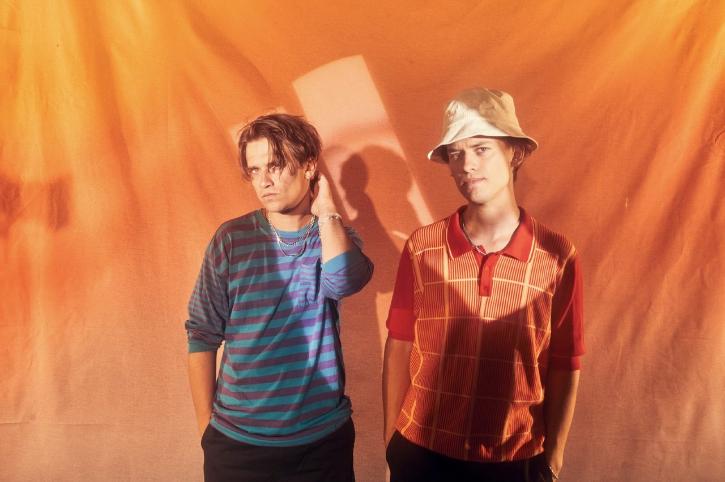
DOWNLOAD PRESS PHOTO HERE

CONNECT WITH BALU BRIGADA
FACEBOOK | INSTAGRAM | TWITTER | YOUTUBE

Press Contact:
Paige.Rosoff@atlanticrecords.com

