FOR IMMEDIATE RELEASE
SEPTEMBER 23, 2022

1017 GLOBAL MUSIC’S BIGWALKDOG DROPS TRICK CITY

MISSISSIPPI RAPPER RELEASES DEBUT MIXTAPE
AVAILABLE NOW VIA 1017 GLOBAL MUSIC/ATLANTIC RECORDS HERE

STACKED 20-TRACK RELEASE INCLUDES FEATURES FROM GUCCI MANE, LIL BABY,
POOH SHIESTY, AND BIG30

UPCOMING LIVE SCHEDULE INCLUDES DATES SUPPORTING
KEVIN GATES’ BLOCKBUSTER “BIG LYFE TOUR”

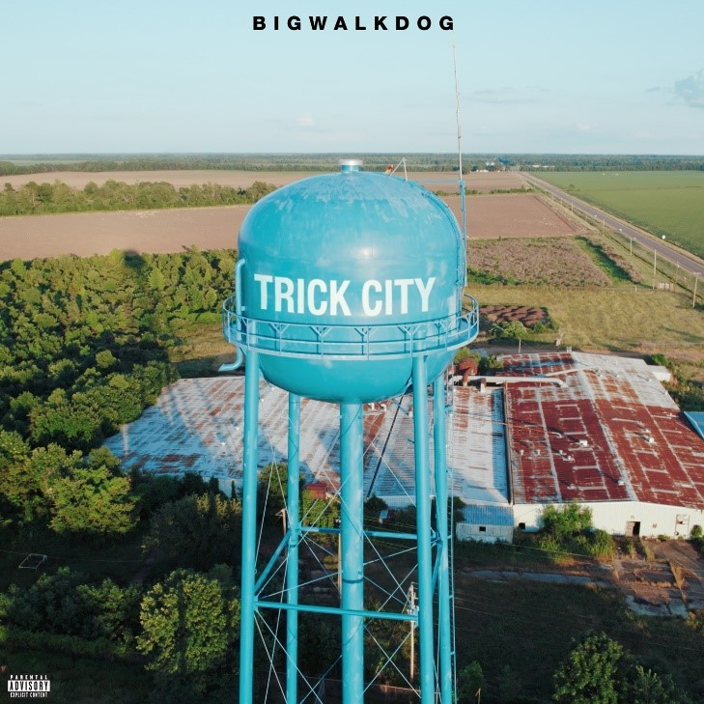
(DOWNLOAD HI-RES ART HERE)

“It’s BigWalkDog season.” – THE SOURCE

Today, September 23rd, BigWalkDog celebrates the release of his stacked 20-track debut mixtape. TRICK CITY arrives via 1017 Global Music/Atlantic Records and is available now at DSPs and streaming services HERE. The project includes features from Gucci Mane, Lil Baby, Pooh Shiesty, and Big30. TRICK CITY follows a series of hard-hitting singles that have helped BigWalkDog amass over 200M worldwide streams and more than 165M video views thus far. TRICK CITY is highlighted by tracks such as “For Certain (feat. Big30),” accompanied by a music video premiered today via YouTube HERE.

Further standouts include “Whole Lotta Ice (Feat. Lil Baby & Pooh Shiesty),” which is joined by an official music video currently boasting over 20M views via YouTube after earning nearly 1 million views in its first 24 hours alone. The project also features Gucci Mane & BigWalkDog’s smash collaboration “Poppin,” accompanied by an official music video now with over 37M views after rising to #2 on YouTube’s “Trending” chart. “Poppin” also served as BigWalkDog’s late night TV debut, and was introduced with a fiery performance of the track on Jimmy Kimmel Live!

BigWalkDog is fast proving one of the most compelling new artists on the 1017 Global Music roster. The 6’8” Magnolia State rapper will mark the arrival of TRICK CITY with a number of dates supporting Kevin Gates’ “Big Lyfe Tour,” including Nashville, TN’s Nashville Municipal Auditorium (September 30), and Birmingham, AL’s Legacy Arena at The BJCC (October 7).

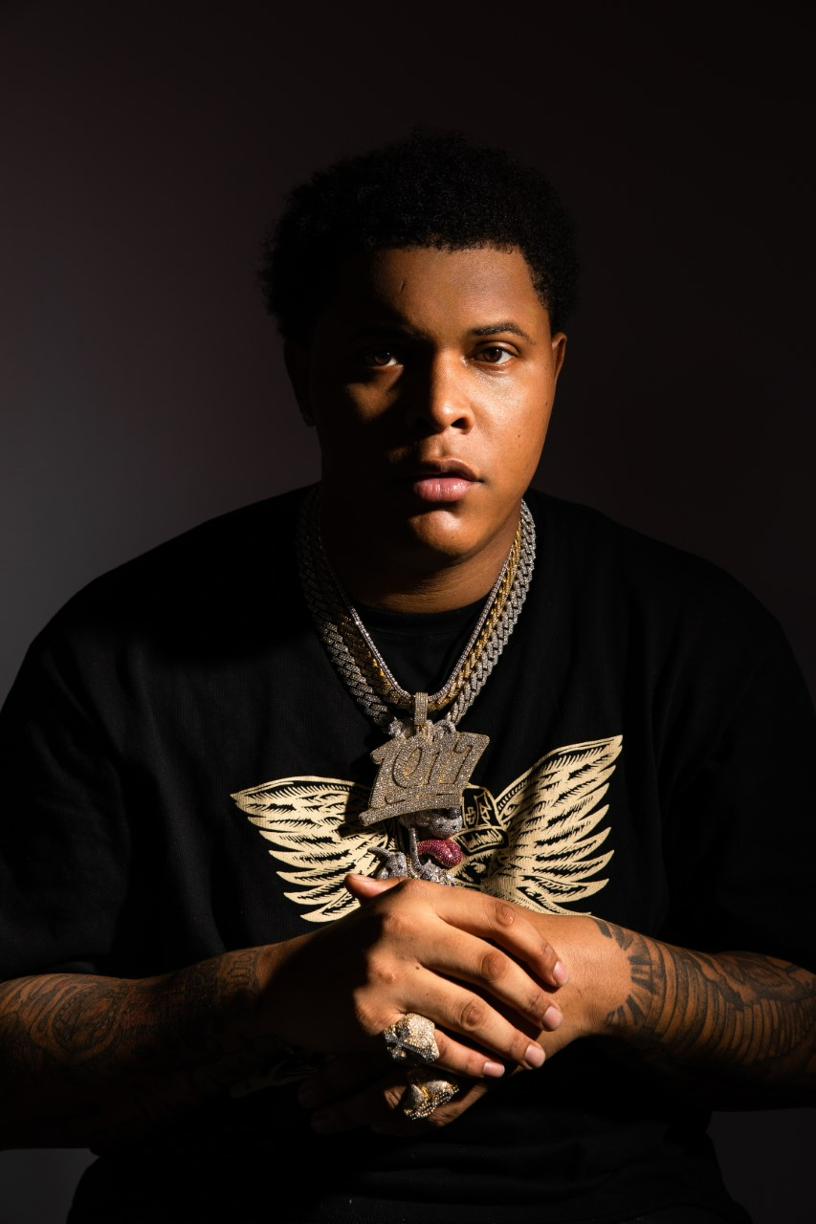
(DOWNLOAD PRESS PHOTOS HERE)

Born in Tutwiler, MI, BigWalkDog moved to Memphis, TN in 2020 where he unleashed a string of independent releases that showcased commanding bars and knockout hooks that prove impossible to shake, all spiced with the rapper’s one-of-a-kind brand of Southern gusto. Tracks such as “Tyson” and “B.T.D.” soon caught catching the attention of Gucci Mane, who swiftly signed BigWalkDog to his fast-growing 1017 Global Music label.

A wide span of powerful releases followed, including striking appearances on 1017 Global Music label’s RIAA Certified Gold compilations SO ICY BOYZ and the recently released SO ICY GANG: THE REUP, all of which drew millions of streams alongside critical acclaim from such media outlets as REVOLT, which raved, “BigWalkDog is quickly becoming one of the bigger faces on the Southern rap scene.”

“Mississippi made me,” says BigWalkDog, “but I want BigWalkDog to be for the world. You can take your own feelings from it – whether they’re good or bad. I’m just being honest.”

TRACKLIST

1 Trick
2 Know What I Mean feat. Gucci Mane
3 Mary Jane
4 Pray
5 Whole Lotta Ice feat. Lil Baby & Pooh Shiesty
6 I'm the One
7 What You Hear Pt. 1
8 Poppin (BigWalkDog & Gucci Mane)
9 Uncle Tommy
10 Beep
11 For Certain feat. BIG30
12 Skywalka
13 What You Hear Pt. 2
14 How It Go
15 I Chose
16 Onion Peeler
17 Trap God feat. Gucci Mane
18 Nino
19 Son of A Gun
20 Came From The Bottom

# # #

CONNECT WITH BIGWALKDOG
BIGWALKDOFMUSIC.COM | FACEBOOK | INSTAGRAM | YOUTUBE

BIGWALKDOG + 1017 GLOBAL MUSIC PRESS CONTACT:
Ashley Kalmanowitz | Ashley.Kalmanowitz@atlanticrecords.com

