FOR IMMEDIATE RELEASE
DECEMBER 14, 2022

ICYMI:
PLATINUM-SELLING STAR BRELAND SHOWS OFF HIS VOICE LAST NIGHT (12/13)

PERFORMED CHART-RISING SINGLE "FOR WHAT IT'S WORTH" ON SEASON 22 FINALE OF NBC'S THE VOICE

SURPRISED BACKSTAGE WITH RIAA GOLD-CERTIFIED PLAQUE FOR "PRAISE THE LORD (FEAT. THOMAS RHETT)"

JOINING WALKER HAYES' DUCK BUCK TOUR FOR 2023

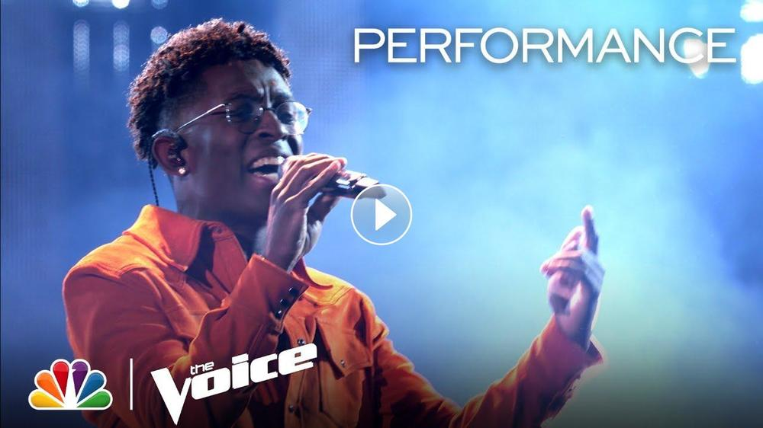

LOS ANGELES, CA. (December 14, 2022) – PLATINUM-selling star BRELAND brought his current chart-rising single, “For What It’s Worth" to new heights on NBC's The Voice Season 22 finale last night (12/13). Commanding the stage in a Coût Desss La Liberté fit, BRELAND performed live the no-hard-feelings moving-on anthem that he co-wrote.

Moments before his appearance, the Bad Realm Records / Atlantic Records / Warner Music Nashville multi-talent was surprised backstage with a plaque to celebrate the RIAA GOLD-certification of his infectious song "Praise The Lord (feat. Thomas Rhett)" that PEOPLE raves "took us all to church." Both “For What It’s Worth” and “Praise The Lord” are featured on his acclaimed debut album, CROSS COUNTRY.

As announced earlier this week, BRELAND will join Walker Hayes’ DUCK BUCK TOUR for 2023. During this run, the Amazon Music Breakthrough Spotlight Artist will perform in more than a dozen cities spanning the Midwest and Southern U.S. BRELAND fans can get their tickets early - via Artist Presale - tomorrow, Thursday, December 15 at 10 a.m. LOCAL through Thursday, December 15 at 10 p.m. LOCAL. Use code BRELANDCXC. Public onsale starts Friday, December 16 at 10 a.m. LOCAL.

This news comes on the heels of BRELAND wrapping his headline HERE FOR IT TOUR, and adds to his stacked tour schedule for 2023, including high-profile stops at Stagecoach and select dates as direct support of Shania Twain’s QUEEN OF ME TOUR.
Spotlighted on PEOPLE’s “Ones To Watch” list, BRELAND recently released BRELAND & Friends: Amazon Music Live (Breakthrough Live) EP, which captured his headlining debut at Nashville’s Ryman Auditorium and featured guest appearances by Nelly, Dierks Bentley, Sam Hunt, Charles Kelley, Thomas Rhett, and Seaforth, raising $140,000 the Oasis Center youth outreach program.

ABOUT BRELAND:
With PLATINUM breakout “My Truck,” singer/songwriter/producer BRELAND has emerged as a bold new force on today’s music landscape. The Amazon Music Breakthrough Spotlight Artist first popped off when the Hip-Hop and Country hybrid hit #1 on Spotify’s Global Viral 50 in 2019, and a remix featuring Sam Hunt landed on best-of-the-year lists from NPR to The New York Times. Adding to his 1 BILLION+ career streams, BRELAND’s debut album CROSS COUNTRY is out now and features infectious releases “Told You I Could Drink (feat. Lady A),” “Natural,” “Praise The Lord (feat. Thomas Rhett),” GOLD-certified “Throw It Back (feat. Keith Urban) and title track (feat. Mickey Guyton). Hailed as the “symbol of Country music’s ongoing evolution” (Rolling Stone), the Bad Realm Records/Atlantic Records/Warner Music Nashville artist has scored high profile looks on ABC’s Good Morning America, ABC’s Jimmy Kimmel Live!, CBS Mornings, CBS’ New Year’s Eve Live: Nashville’s Big Bash, CMT Crossroads, NBC’s TODAY, The Kelly Clarkson Show, plus performances on the ACM, CMT, and CMA Awards. BRELAND just wrapped his fall headline HERE FOR IT TOUR, with high-profile performances in 2023 on deck at Stagecoach Festival, tour dates on Walker Hayes’ DUCK BUCK TOUR, and as direct support for select summer dates of Shania Twain’s QUEEN OF ME TOUR.

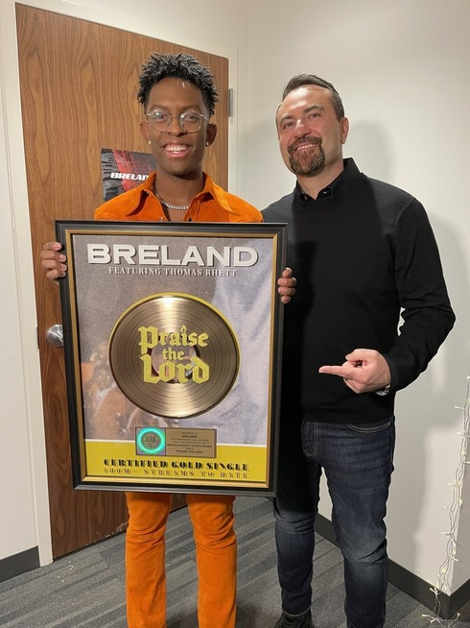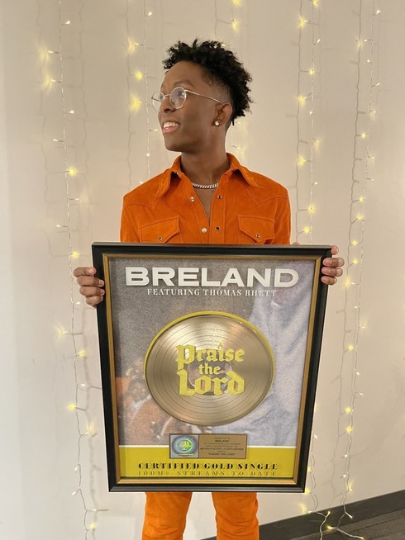
(L-R) BRELAND; KEVIN WEAVER, PRESIDENT OF ATLANTIC RECORDS ON THE WEST COAST
DOWNLOAD | PHOTO COURTESY OF BRELAND

# # #

CONNECT WITH BRELAND
WEBSITE | INSTAGRAM | FACEBOOK | TWITTER | YOUTUBE | SOUNDCLOUD | AMAZON MUSIC

BRELAND PR CONTACTS
Fairley McCaskill / Fairley.McCaskill@atlanticrecords.com
Jensen Sussman / jensen@sweettalkpr.com
Mary Catherine Rebrovick / MaryCatherine@wmg.com

