FOR IMMEDIATE RELEASE
DECEMBER 16, 2022

CKAY WRAPS 2022 WITH VISUAL FOR HIS LATEST SINGLE ‘BY NOW’
SONG FEATURED ON HIS ALBUM SAD ROMANCE
FOLLOW-UP TO ‘MMADU’ VISUAL STREAMING NOW
RECENTLY ANNOUNCED THROUGH THE EYES OF CKAY –
THE "BY NOW" YOUTUBE PREMIUM AFTERPARTY LAUNCHING 12/20
RECENTLY WRAPPED HIS EUROPEAN TOUR
WATCH/SHARE ‘BY NOW’
DOWNLOAD/STREAM SAD ROMANCE
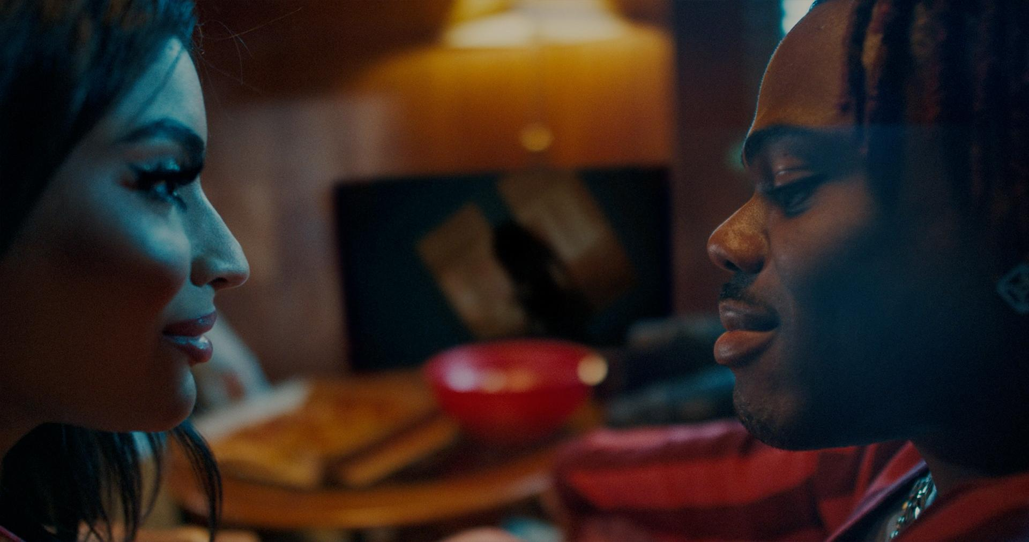

It is an exciting time to be an African musician and perhaps an even more exciting time to be CKay as he sits at the helm of contemporary African music alongside other superstars who have been able to traverse geographical and cultural borders with their music. To end what has been a pivotal year in his career as a global artist, the Nigerian singer-songwriter pairs up with director Tee Tash to deliver his newest music video for ‘by now’, a fan-favorite off his debut album Sad Romance.

His most recent video for ‘Mmadu’, which premiered on the 9th of November, is a work of art in itself. The song and its visual companion piece celebrate intimacy and sensuality. With ‘by now’, the storytelling is more direct, helping the viewer to misunderstand very little about CKay’s intentions. Tash follows CKay as he pursues a love interest who isn’t as forthcoming as the singer hopes she would be. As such, it is his persistence that drives the story from scene to scene; steadfast and unrelenting.

CKay took fans on a journey with Sad Romance, one perhaps not all were expecting. The superstar’s music was always going to be dissimilar to other Afrobeats releases at any given time by virtue of both the singer’s dedication to and his fans’ infatuation with Emo-Afrobeats but, his debut album dove much deeper into that fantasy. From the choice of instrumentation, production, collaboration, and the overall soundscape the album orbits around, Sad Romance is a unique project that is reflective and emotionally charged. It’s an album that requires fans to go further than merely listening but asks them to reimagine the breadth of what an Afrobeats record might sound like. The intrigue of the album is its devotion to vulnerability and tension, which are consummate elements of the rich energy the project holds.

To celebrate the premiere of the ‘by now’ visuals and surpassing one billion views on the platform, CKay will be hosting a live Q&A session on YouTube. This will give fans a chance to catch up with their favorite musician hours after he’s performed in Lagos, Nigeria, since his album launch in September.

ABOUT CKAY

Chukwuka Ekweani, known publicly as CKay, is the rising star in the ever-burgeoning Afrobeats scene. A multi-talented artist, whether behind the boards as a producer or in front of the mic performing his self-penned songs, it is CKay’s single-minded vision that shines through. The self-defined Emo-Afrobeat star has and continues to soar up charts across the globe thanks to his first globally recognized single ‘love nwantiti’.

The Nigerian singer, songwriter, and producer originally released ‘love Nwantiti (ah ah ah)’ back in 2019 as part of his debut EP, CKay The First. In 2021, CKay became the most streamed artist of the year and became the first African artist with two tracks on the Global Spotify Top 30 simultaneously. ‘love nwantiti’ has been certified platinum/multi-platinum in five countries, including the United States, India, and Italy. The viral hit has also been certified gold in the UK, Australia, South Africa, and New Zealand. CKay became the first African artist in 50 years to hold a top 5 position on the UK Singles Chart for 4 straight weeks with ‘love nwantiti’.

CKay has continued to create a global presence with accomplishments such as the “most Shazam-ed song in the world”. His most recent globally recognized single, ‘Emiliana’, has followed suit and racked in global chart positions and currently has just under 100 million streams. ‘Emiliana’ peaked at #1 on the UK Afrobeats Chart, #2 on Shazam Top 200 (Afrobeats), and #1 in six countries on Apple Music.

CONNECT WITH CKAY:
TWITTER | FACEBOOK | INSTAGRAM | TIKTOK | YOUTUBE

PRESS CONTACT:
ARIANA.WHITE@ATLANTICRECORDS.COM

