FOR IMMEDIATE RELEASE
DECEMBER 2, 2022

FINESSE2TYMES RELEASES HIGHLY ANTICIPATED MIXTAPE 90 DAYS
ACCOMPANIED BY AN OFFICIAL VISUAL FOR “OVERDOSE”
MIXTAPE INCLUDES FEATURES FROM GUCCI MANE, MONEYBAGG YO, LIL BABY, & TAY KEITH
“FIRST 90 DAYS OUT” VLOG SERIES NOW LIVE
DOWNLOAD/STREAM 90 DAYS
WATCH/SHARE “OVERDOSE”

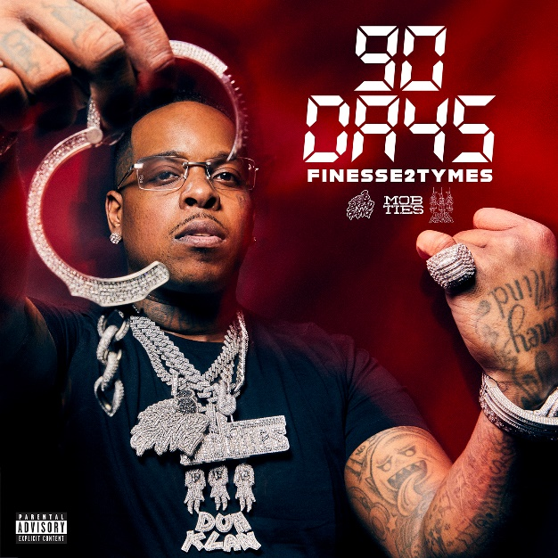
DOWNLOAD HI-RES ARTWORK
“I’m talking about my life and my struggles and who I am today.
I don’t rap about what I do, I rap about what I did.”
– FINESSE2TYMES

Today, Memphis rising star Finesse2tymes, has officially debuted his first major label mixtape, 90 DAYS. The project is accompanied by an official visual for “Overdose” (which he recently teased on TikTok) directed by DieselFilmz and comes on the heels of last month’s “Summo” (3M+ views). The 15-track mixtape sees appearances from Gucci Mane, Moneybagg Yo, Lil Baby and Tay Keith and quickly garnered over 50K pre-adds within just a couple weeks. Finesse has also launched his “First 90 Days Out” vlog series which is now live. The 5-part series documents the pivotal moments since his release from prison earlier this year.
Download/stream 90 DAYS: https://finesse2tymes.lnk.to/90Days
Watch/share “Overdose”: https://finesse2tymes.lnk.to/OverdoseVideo (directed by DieselFilmz)

90 DAYS TRACKLIST
- Goin’ Straight In 2 (Intro)
- Outside
- Get Even
- Finesse Duh P
- Rules To The Streets
- Still Wit It (Feat. Tay Keith)
- Back End
- Nobody (Feat. Gucci Mane)
- Lil Baby
- Overdose
- Black Visa (Feat. Moneybagg Yo)
- Humble
- If You Still Wit Me (Feat. Lil Baby)
- Summo
- Go
90 DAYS is Finesse’s time to shine. The highly anticipated mixtape is representative of the fundamental 90 days since his release from prison in July of 2022. From dropping several singles that instantly skyrocketed to finalizing his deal with Mob Ties/Bread Gang/Atlantic Records around his 90th day of release.
Since coming home, he quickly solidified himself as one of the hottest hip-hop artists emerging from the South. So far, he’s garnered over 70M+ US audio streams and a combined 118M+ views on YouTube. His viral single “Back End” (which sparked the “It’s A Problem When I Do It” popular TikTok trend) has accumulated over 36M US audio streams and over 31M views on YouTube alone. “Back End” has also peaked at #8 on the top music videos on YouTube and has over 430K+ creates on TikTok proving it to be a viral hit. Finesse also recently sat down with podcast Million Dollaz Worth of Game and delivered an explosive freestyle that is now at over 947K views.
# # #
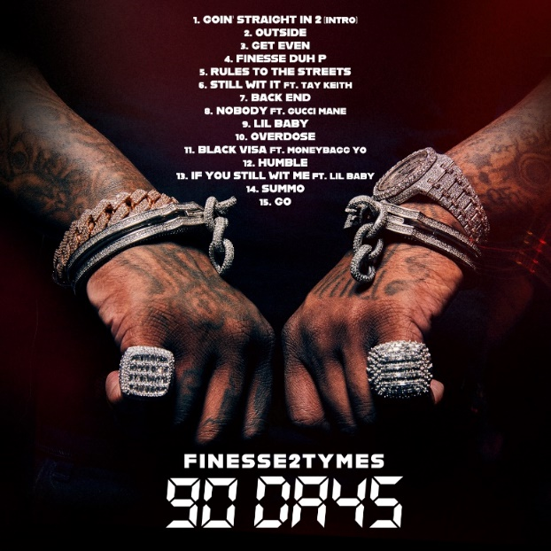
DOWNLOAD HI-RES ART
---
FINESSE2TYMES
It took rapper Finesse2tymes just 90 days to remix his life, following five years in prison. The Memphis, Tennessee native (turned Houston resident) not only repaired broken relationships, but he inked a deal with Mob Ties/Atlantic Records and recorded arguably some of the best music in his career. The culmination of that time is his upcoming project 90 Days. Finesse has weathered the storm, changed his stars, and is now geared for his place in the sun.
Born and raised on the East Side of Memphis, most of Finesse’s young adulthood was surrounded by the walls of a prison cell. His first prison stint happened at 14 and he was in and out of prison until his most recent release. At 21, he started formally making music, forming a collective called Memphis Greatest Underrated with several local artists including Blac Youngsta and Moneybagg Yo. The crew released a self-titled EP in 2019 while Finesse was serving his final stint in prison as the group disbanded. While away, Finesse perfected his craft, writing rhymes and plotting his next moves to ensure this prison sentence will be his last. He found a way to keep track of the major players in the industry who followed his music. Among them was Mob Ties Founder and CEO J Prince Jr., son of legendary Rap-A-Lot kingpin J. Prince, who later signed him. At the top of July 2022, Finesse left prison and boarded a private jet bound for Houston. The start of his new life had finally begun.
He dropped the menacing “Get Even” within the first week of his release, cracking the 30 million mark in views on YouTube alone. He chased it with “Back End,” showcasing a more sophisticated style that still harbored his gruff delivery. He even mended fences with Moneybagg Yo, surprising fans everywhere with their collaborative “Black Visa” track and informally inaugurating his signing with Bagg’s Bread Gang. Few can comprehend Finesse’s hustle, yet it’s a combination of age, experience, understanding, and healing. Finesse2Tymes has long plotted on the release of 90 Days, an autobiographical work that will run the gamut of his life and career. The work will undoubtedly secure Finesse’s place in rap stardom, though for him, his goal is even bigger than music; it’s to change lives.
CONNECT WITH FINESSE2TYMES
TWITTER | INSTAGRAM| TIKTOK| FACEBOOK| YOUTUBE

PRESS CONTACT
SELAM BELAY SELAM.BELAY@ATLANTICRECORDS.COM

