FOR IMMEDIATE RELEASE
DECEMBER 12, 2022

IGGY POP UNLEASHES “STRUNG OUT JOHNNY”
SECOND SINGLE FROM FORTHCOMING ALBUM EVERY LOSER

2023 WEST COAST DATES ANNOUNCED

ALBUM OUT JANUARY 6 VIA ATLANTIC RECORDS X GOLD TOOTH RECORDS

EVERY LOSER SET ATOP A ROCK-SOLID FOUNDATION PROVIDED BY MEMBERS OF
BLINK 182, GUNS N’ ROSES, JANE’S ADDICTION, PEARL JAM, RED HOT CHILI PEPPERS & MORE

PRE-ORDER / PRE-SAVE EVERY LOSER HERE

LISTEN TO “STRUNG OUT JOHNNY”

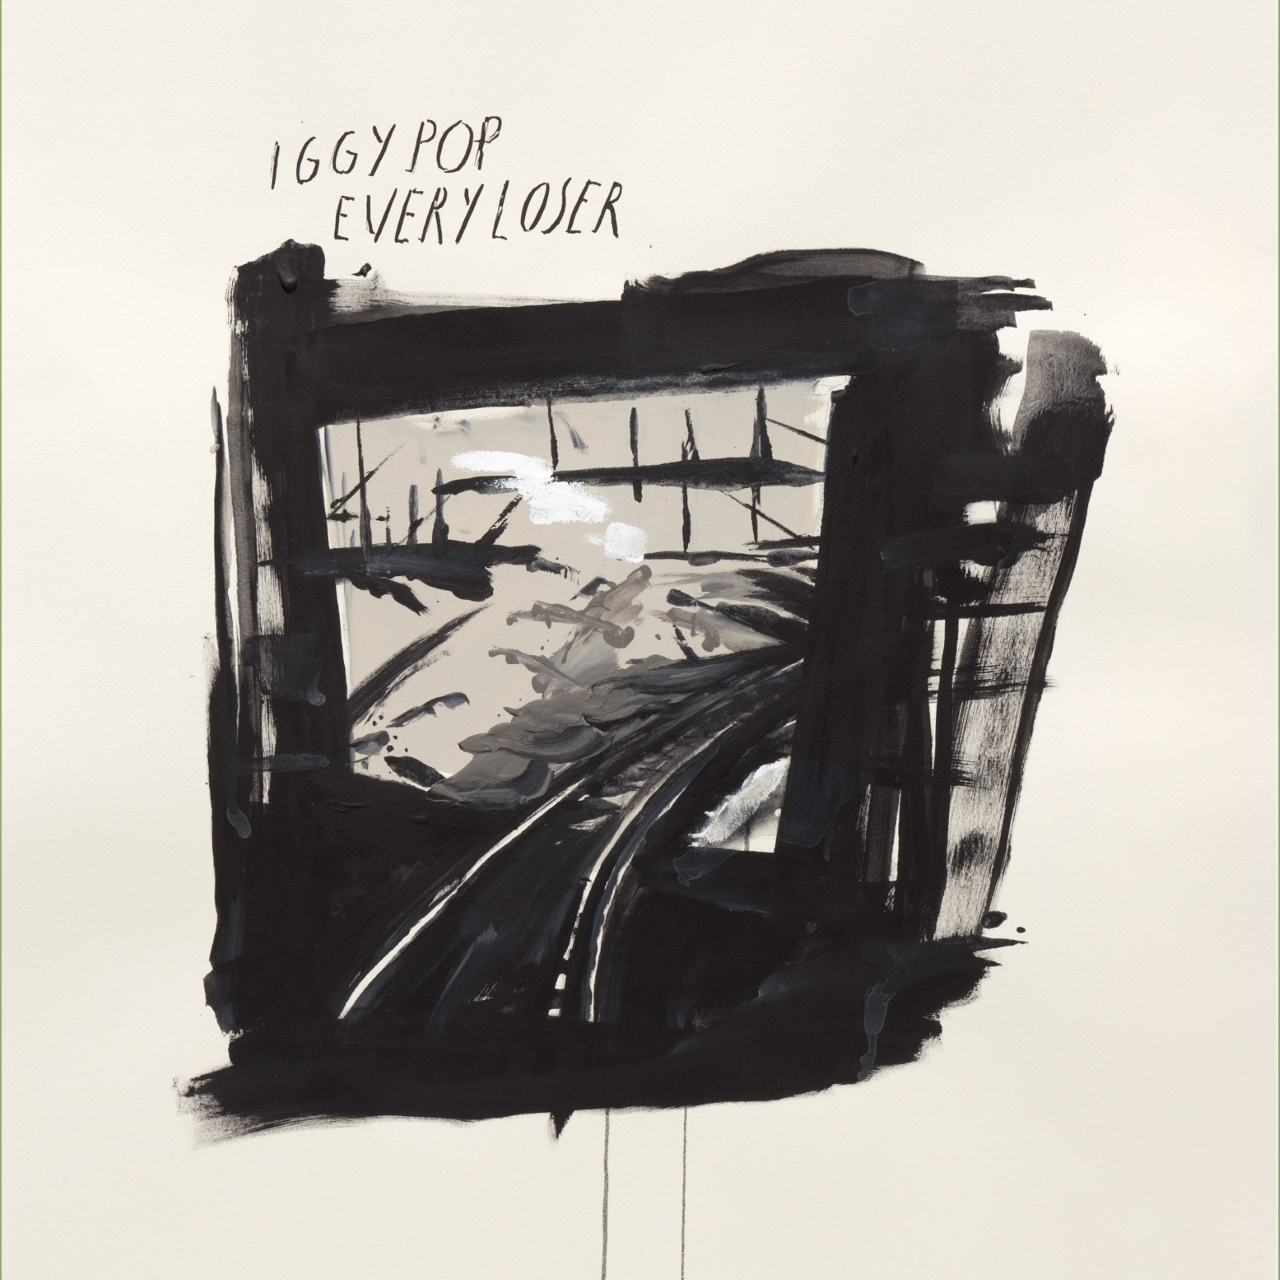
DOWNLOAD ARTWORK HERE
CREDIT RAYMOND PETTIBON

“...a return to the irreverent, erratic chaos that made him the godfather of punk.”
– NEW YORK MAGAZINE (15 Albums We Can’t Wait to Hear This Winter)

Fresh off the heels of announcing the highly anticipated forthcoming record EVERY LOSER (Atlantic Records/Gold Tooth Records) and “buzz-bombing, hard-riffing rock” (NEW YORK TIMES) single “Frenzy,” which recently debuted on Billboard’s Mainstream Rock Airplay chart, Iggy Pop has unleashed a second track to whet our collective appetites–”Strung Out Johnny,” available HERE.

Along with the brand new single, Iggy Pop has also confirmed four new live dates spanning the west coast. Kicking off in Los Angeles on April 20, the Godfather of Punk’s raw power will be in full force as he performs tracks off his impending 19th solo album.

These limited dates include stops at Los Angeles’ Regent Theater and Hollywood Palladium, San Francisco’s Masonic Theater, and Las Vegas’ The Pearl, and will mark the epic debut of Iggy Pop & The Losers–featuring Andrew Watt, Chad Smith and Duff McKagan.

Pre-sales begin Tuesday, December 13th at 10am PT, with general on–sale beginning Friday, December 16th at 10am PT. Grab tickets at iggypop.com and see below for all announced dates.

EVERY LOSER–out January 6, 2023–is Iggy’s first album to be released via the recently announced partnership between Atlantic Records and Gold Tooth Records, the new label founded by the album’s GRAMMY Award-winning, multi-platinum executive producer, Andrew Watt.

Featuring a murderers’ row of modern day rock icons including the Iggy Pop & The Losers lineup of Watt, McKagan and Smith, Every Loser sets Iggy’s lyrical aggressions toward physical and existential nemeses atop a rock solid foundation provided by members of Blink 182 (Travis Barker), Foo Fighters (Taylor Hawkins), Guns N’ Roses (Duff McKagan), Jane’s Addiction (Chris Chaney, Dave Navarro, Eric Avery), Pearl Jam (Josh Klinghoffer, Stone Gossard) and Red Hot Chili Peppers (Klinghoffer, Chad Smith). The result is 11 songs by the man who refused to go gently into that good night on Free, and is once again charging fearlessly at life itself on EVERY LOSER.

IGGY POP & THE LOSERS 2023 U.S. DATES

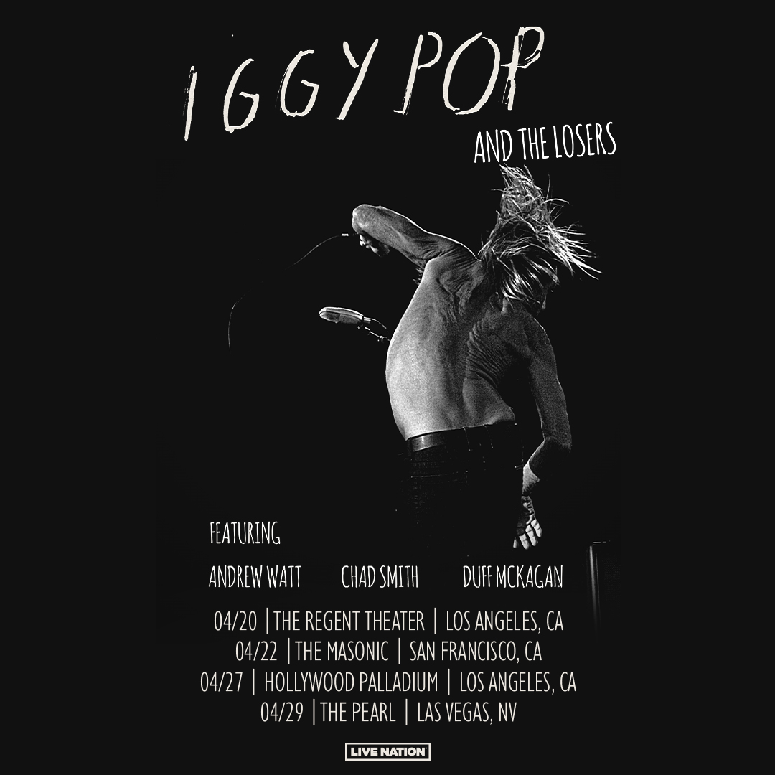

April 20, 2023– Los Angeles, CA – The Regent Theater – Tickets HERE
April 22, 2023 – San Francisco, CA – Masonic Theater – Tickets HERE
April 27, 2023 – Los Angeles, CA - Hollywood Palladium – Tickets HERE
April 29, 2022 – Las Vegas, NV – The Pearl – Tickets HERE

The new album will also be available as limited-edition vinyl, cassettes and CDs – Available HERE. As part of the release of EVERY LOSER, Iggy is offering an exclusive relaunch of legendary fanzine, PUNK Magazine, from founder and legendary editor John Holmstrom with a full Iggy issue, which contains an exclusive interview with Iggy by Flea. Iggy originally graced the cover of the John Holmstrom Fanzine in July 1976.

CONNECT WITH IGGY POP
IGGYPOP.COM | FACEBOOK | INSTAGRAM | TWITTER | YOUTUBE

CONTACT FOR IGGY POP
Steve Martin & Michele Hug / Nasty Little Man
steve@nastylittleman.com / michele@nastylittleman.com

CONTACT FOR ANDREW WATT
Bianca Bianconi & Greg Cortez / 42West
Bianca.Bianconi@42West.net / Greg.Cortez@42West.net

CONTACT FOR ATLANTIC RECORDS
Kelly McWilliam / Atlantic Records
Kelly.McWilliam@AtlanticRecords.com

