FOR IMMEDIATE RELEASE
DECEMBER 7, 2022

SOUTH CENTRAL RAPPER KENNDOG CELEBRATES THE HOLIDAY SEASON WITH “THIS CHRISTMAS”

LISTEN TO “THIS CHRISTMAS” HERE

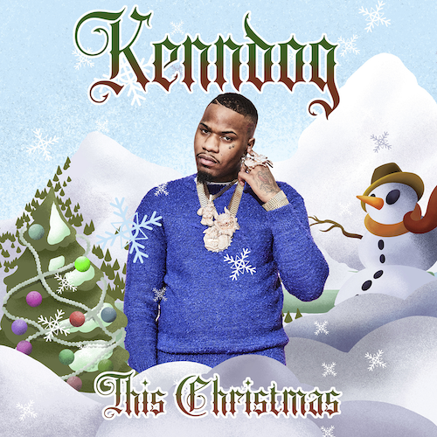
DOWNLOAD HI-RES ARTWORK

Multimillion-streaming South Central LA rapper Kenndog is celebrating the season with his brand new holiday single, “This Christmas,” available now via Atlantic Records at all DSPs and streaming services HERE.

“This Christmas” – which Kenndog has been teasing in recent days on his hugely popular TikTok – marks the latest in a series of viral hit singles that includes “Meeska Maska,” “Fresh Prince of the Eastside” and “Doo Wop,” the latter of which was recently featured on an episode of VH1’s Love & Hip Hop: Miami. A Frankie Lymon & the Teenagers-inspired music video – directed by JakeTheShooter (Sueco, Bankrol Hayden) – is streaming now at the official Kenndog YouTube channel HERE.

Kenndog’s 2020 release, “Drip Like Me,” caught fire when TikTok titan Charli D’Amelio utilized the sound, unleashing a viral flurry with support from Vice President Kamala Harris, California Governor Gavin Newsom, ESPN SportsCenter, Jayda Cheaves, Clarence White, and many more.

Boasting over 200M global streams to date and having reached Rolling Stone’s Trending 25, Spotify’s US Viral 50, numerous viral charts worldwide, and hailed by UPROXX as “an instant favorite,” Kenndog conceived the idea to sample Beethoven’s “Für Elise” as the foundation for his next single, “Beethoven.” The irresistible track proved his breakthrough with the original “Beethoven” sound on TikTok seeing over 500K video creates thus far, while also being featured in countless dance videos including Allendale, MI’s GVSU Laker Dance Team, who posted their routine to "Beethoven" via TikTok en route to winning the Dance Team Union’s 2022 College Classic National Championship.

The official video for “Beethoven” has earned over 21M views via YouTube (where Kenndog was recently featured as a Trending Artist on the Rise). Kenndog followed up on “Beethoven” with remixes featuring rising Michigan rappers YN Jay and DDG, the latter joined by a cinematic horror parody official video directed by Ben Proulx (Chris Brown, P Diddy, J. Cole) and streaming now at
YouTube HERE.
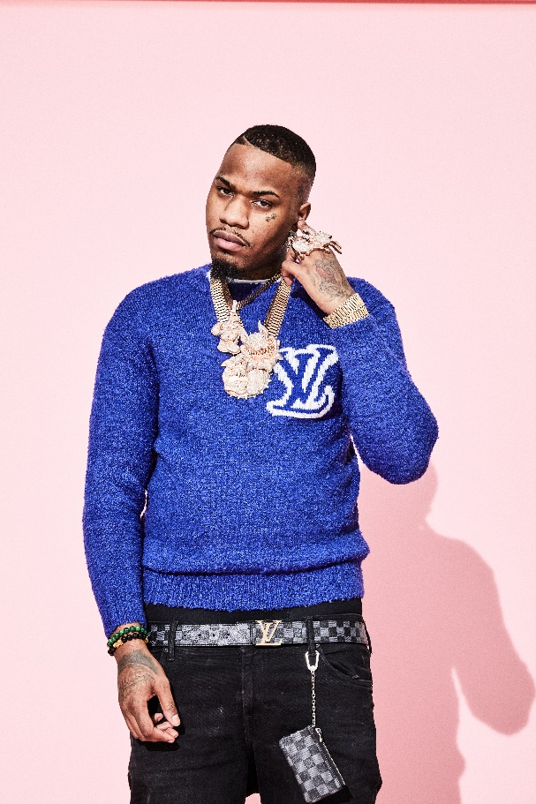
DOWNLOAD HIGH-RES PRESS IMAGE | PHOTO CREDIT: JIMMY FONTAINE

# # #

CONNECT WITH KENNDOG
INSTAGRAM | TIKTOK | TWITTER | YOUTUBE | WEBSITE

PRESS CONTACT:
Brittany Bell | Brittany.Bell@atlanticrecords.com

