FOR IMMEDIATE RELEASE
DECEMBER 2, 2022

ALEX WARREN IS “CHASING SHADOWS”

MULTI-TALENTED SINGER-SONGWRITER SHARES HEARTFELT AND ANTHEMIC NEW SINGLE

LABEL DEBUT SINGLE “HEADLIGHTS” OUT NOW

LISTEN TO “CHASING SHADOWS” | WATCH OFFICIAL MUSIC VIDEO

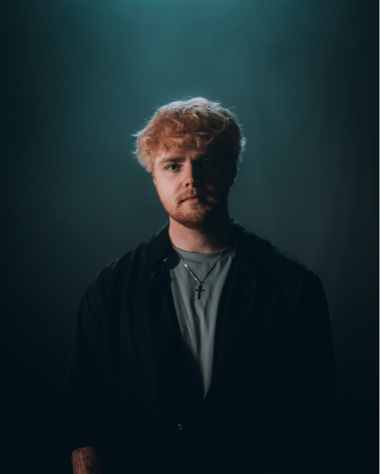
DOWNLOAD PRESS PHOTOS (CREDIT: CAMERON DRISKILL) + HI-RES ARTWORK

“Alex Warren's story is one you'll want to sit down for — and his music is everything and more.”
– PEOPLE MAGAZINE

Multi-talented singer-songwriter Alex Warren has shared his heartfelt and anthemic new song, “Chasing Shadows,” available now at all DSPs and streaming services HERE. Co-written and produced with Adam Yaron (“Headlights”) and Nolan Sipe (Benson Boone, James TW, Andy Grammer), “Chasing Shadows” embodies Warren’s soulful songwriting and passionate melodies. Watch the official music video in which Alex navigates the turbulent emotions that arise with memories of his late parents, streaming now via YouTube HERE.

“Chasing Shadows’ is extremely special because it’s the first song I ever wrote that made me cry,” shared Alex. “Growing up without a parent, everyone always told me they were in a better place and that they’d be proud of me for who for who I’d become, but that never sat well with me because it just felt like I was chasing a shadow of something I could never have – my parents’ approval. Oddly enough, I was inspired to write ‘Chasing Shadows’ after seeing my dog, Koda, chasing a shadow, crying and whining over the fact she couldn’t actually get to it. The way she was chasing shadows reminded me of chasing the approval of my parents and that feeling you have after you’ve lost someone and realize you’ll never be able to be with them again.”

“Chasing Shadows” follows Alex’s critically acclaimed label debut single, “Headlights,” which first garnered 74M views on TikTok prior to release and has since earned over 5.4M streams worldwide in addition to getting AirPlay on Sirius XM The Pulse. The song’s official music video, based on Alex’s ongoing struggles with anxiety and depression, premiered exclusively on Rolling Stone and is available to view HERE. An acoustic version of the magnetic and deeply moving track is also available HERE with an official performance visual now streaming on YouTube HERE.

Known for his vulnerable pop melodies, passionate vocals, and lyrical candor, Alex shared the news of his signing with Atlantic Records in August via an exclusive Billboard announcement. Shortly after the announcement, Warren shared the first episode of his self-produced docuseries, “I Hope You’re Proud.” The 9-minute episode follows Alex on his journey into music and how he attributes his success to his late father who passed away when he was 9 years old. From being homeless and sleeping in his friends’ cars with nothing but a camera and a laptop to landing a record deal, Alex’s evolution is anything but ordinary, and his late father has always been a driving presence in his life.

Named among PEOPLE’s list of “Talented Emerging Artists Making Their Mark This Winter,” the 22-year-old, charismatic musician, digital creator and entrepreneur is one of the most followed Gen Z celebrities on YouTube, Instagram and TikTok. Alex has shared his life with the internet for 11+ years, building an online community of 25M+ cumulative followers and even starting his own compelling podcast, Locked In with Alex Warren. Previous independent releases include his debut single “One More I Love You,” which channeled his traumatic childhood experiences into a heart-wrenching musical debut that has earned 34M streams to date, as well singles, “Screaming Underwater” and “Remember Me Happy”.

DOWNLOAD HI-RES THUMBNAIL

CONNECT WITH ALEX WARREN:
FACEBOOK | INSTAGRAM | SNAPCHAT | TIKTOK | TWITTER | YOUTUBE | PRESS ASSETS

CONTACT:
ANDREW GEORGE | ANDREW.GEORGE@ATLANTICRECORDS.COM

