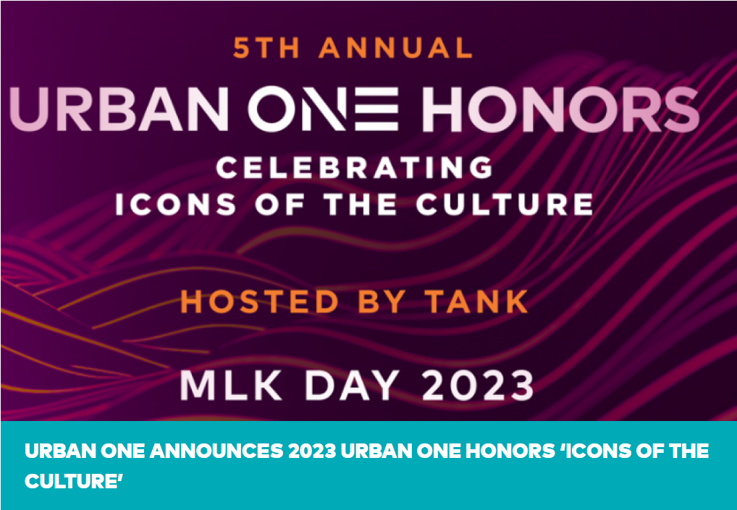
(November 29, 2022) As we wind down the year 2022, we are highly excited for 2023 to get here. Especially now that the anticipated Urban One Honors is right around the corner!

The 2023 Urban One Honors will honor the Icons of the Culture as it will air on Martin Luther King Jr. Day, January 16th.

The two-hour award ceremony will be hosted by R&B singer and actor Tank and will debut on TV One and CLEO TV.

Urban One will continue to celebrate the achievements of those who have made outstanding contributions to the arts, media, music, education, and our community.

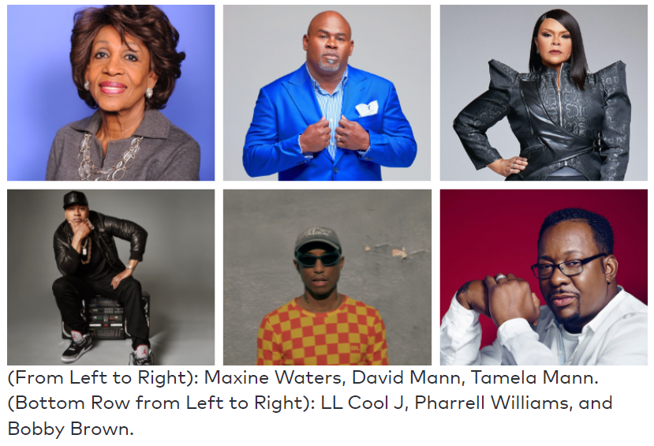

This year the legendary Maxine Waters will be honored with the Lifetime Achievement Honor. LL Cool J will be celebrated with the Entertainment Icon Honor. The King of R&B Bobby Brown will be honored with the Phoenix Honor award. The innovative Pharrell Williams is set to receive the Music Innovation Honor, while David and Tamela Mann will be given the Inspirational Impact Honor!

“Celebrating Icons of the Culture” serves as the topic for this year’s honoree class, which will highlight and celebrate a distinguished group of people who have made a lasting impact in the fields of entertainment, lifetime achievement, inspirational impact, music innovation, and the inaugural Phoenix Honor.

We also can’t wait to see special performances from Keke Wyatt as she will perform at the 5th Urban One Honors, while DJ Spinderella of Salt-N-Pepa, Monie Love, and Doug E. Fresh will commemorate Hip-Hop’s 50th anniversary.

Rev. Run of Run DMC, Run’s House, and Lamman Rucker TV One’s Bad Dad Rehab: The Next Session will both make special appearances.

LeToya Luckett, a GRAMMY Award-winning singer and actress, will host an exclusive backstage pass session with the show’s honorees, performers, and presenters.

We can’t WAIT to celebrate those that have put their blood, sweat, and tears into the culture!

Who are you excited to see at the 2023 Urban One Honor Awards? Sound off in the comments below!

