FOR IMMEDIATE RELEASE
DECEMBER 7, 2022

corook puts a queer spin on “stacy’s mom”

quirky alt-pop singer-songwriter shares “realistic” music video

watch “realistic” music video here | listen to “stacy’s mom” here

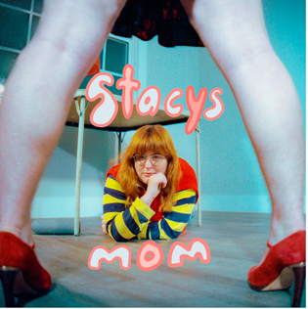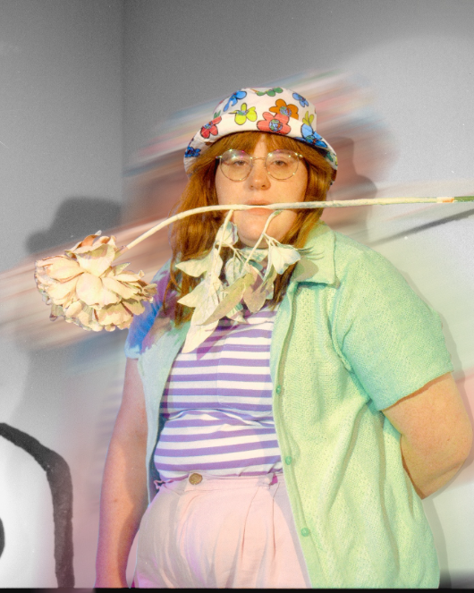
download artwork and press photo

“If specificity is the soul of narrative, then corook is one of the most naturally gifted storytellers in the game.”
– BILLBOARD

“corook is the next thing to bless your music downloads.”
– PEOPLE

Self-described “singer, songwriter, producer, multi-instrumentalist, and huge f*ckin dork” corook [pronounced ‘co-rook’] has shared the official music video for her latest single, “realistic,” which exclusively premiered on PEOPLE and is available now at YouTube HERE.

“‘Realistic’ is a love song about questioning my place in “true love”, as I haven’t seen it myself,” shares corook. “My parents are divorced and every love story I’ve ever heard feels sappy and exaggerated. I wanted this video to represent the questioning in the song by questioning reality itself. It flows in and out of drawings to real people. It is my commitment to finding true love in the truest way possible, somewhere in the grey area. Maybe I’m a skeptic or maybe I’m realistic.”

The earnest and quirky alt-pop artist has also released her incredible cover of Fountains of Wayne’s classic, “Stacy’s Mom” that she originally performed as part of Salt Lick Sessions. Delivered through corook’s refreshing and uniquely queer perspective, the innovative rendition is available now at all DSPs and streaming services HERE.

“I’ve known I was queer for as long as I can remember, and I came out when I was a senior in high school so I spent my entire childhood in the closet wondering if there was something wrong with me. I don’t think anyone can relate to the lyric ‘I know it might be wrong but I’m in love with Stacy’s mom” more than queer people. It was a no brainer to put my own spin on it. I hope it gives the LGTBQIA+ community a place to land inside of a song we already loved so much.”

Recently named one of The Advocate’s “7 Queer Artists For Your Fall Playlist,” the genre-busting, Nashville-based musician tackles deeply personal themes in her music and visuals through a humorous lens. This past spring, she blessed the world with her debut achoo! EP, which features surprising and insightful tracks including “idk god,” “degree,” “bad friend,” and “sims,” in addition to the fan favorite, “snakes”. Since release, corook has shared her viral adult lullaby, “it’s ok!,” the unrestrained single “BDSM,” super-hot “hell yeah,” heartfelt “your mom,” and the recently released ode to self-worth, “smoothie”. corook also got vulnerable in front of the camera, reflecting on their vulnerable mental health journey in the latest episode of Out Magazine’s “Love, Me” video series now streaming HERE.

corook – who recently travelled to Mexico City for a performance at Mexico’s Festival Corona Capital – has spent much of this past year on the road, including a US tour alongside NYC-based piano pop/rock trio Jukebox the Ghost as well as her debut festival performance at Bonnaroo Music & Arts Festival, featured in Rolling Stone’s Bonnaroo 2022 wrap-up. Earlier this year, she made her first-ever North American live run alongside K.Flay and opened for X Ambassadors at “A Night Benefitting Reproductive Rights” at The Troubadour. New dates will be announced soon. For updates, please visit www.corook.com.

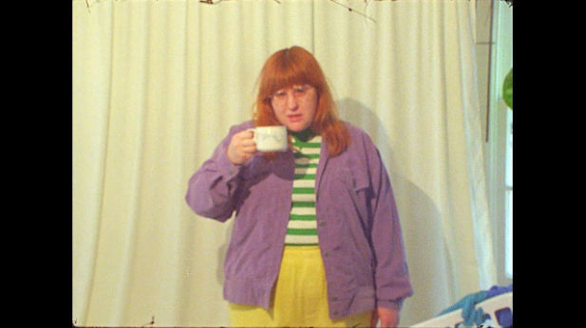
download hi res video screengrab here

corook by corook
corook aka Corinne Savage (yes that’s her real last name) is a singer, songwriter, producer, multi-instrumentalist and a huge fuckin dork. No but seriously. She can solve a Rubix cube in under a minute (depending on how she’s feeling that day.) This ~freckled chubby babe~ was born and raised just outside of downtown Pittsburgh, Pennsylvania, where they grew up listening to Drake, Gwen Stefani and Mac Miller (RIP). She went to a performing arts high school (yes, just like Victorious) where she came out as QUEERAF her senior year. She then went to Berklee College of Music (wow – Owen Wilson voice) and graduated with TWO degrees (barely.) corook currently resides in Nashville, Tennessee (howdy.) She spends most of her time writing and producing music for her artist project “corook” (boop!) locked away in her room, alone (she blames it on Coronavirus but she’s actually just anti-social.) She’s 27 and VERY cute.

connect with corook:
corook.com | instagram | tiktok | press assets

press contact:
andrew.george@atlanticrecords.com

