JOEL CORRY PUTS HIS SPIN ON TIËSTO AND TATE MCRAE’S
WORLDWIDE HIT SINGLE, “10:35”

LISTEN TO “10:35 (JOEL CORRY REMIX)”

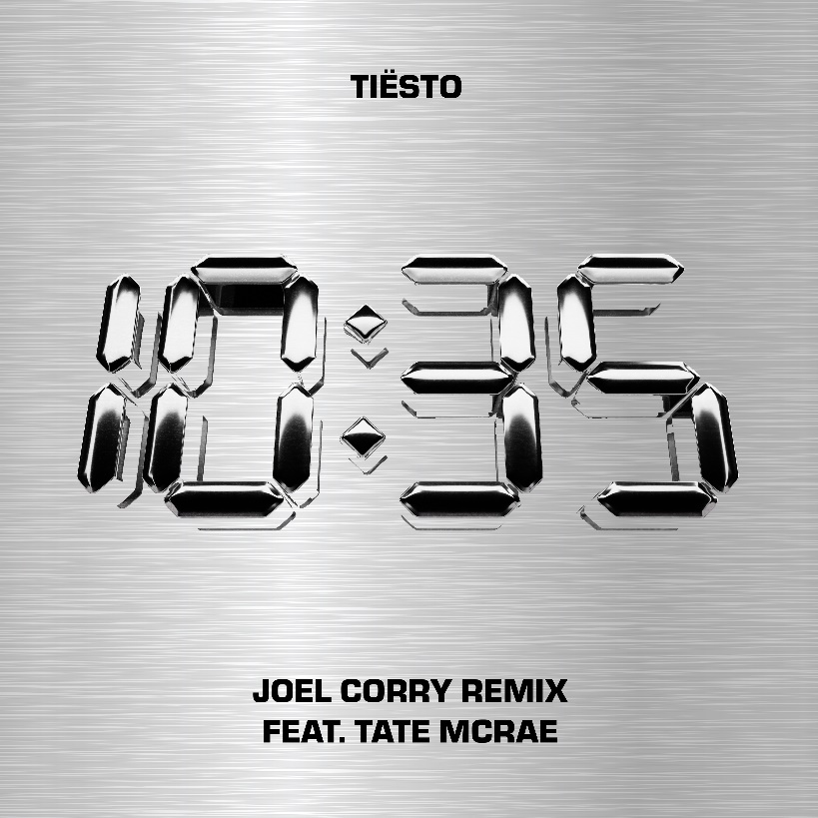
DOWNLOAD HERE

GRAMMY® Award-winning, RIAA platinum-certified international icon Tiësto and multi-platinum singer/songwriter Tate McRae have enlisted superstar DJ/producer Joel Corry for an exclusive new spin on “10:35,” the worldwide hit single co-created in partnership with Dubai’s new ultra-luxury resort Atlantis The Royal. The remix premieres today at all DSPs and streaming services. Listen HERE.

The already club ready single gets the Joel Corry treatment, taking it to new heights and sure to be heard on dancefloors all over the world.

The original version of “10:35” was joined by a strikingly conceptual music video now boasting over 10M views via YouTube following its broadcast premiere late last year. The track has streamed over 30M US streams to date and 137M globally across all platforms with 17M+ in the last week. The hit single is charting at Top 50 in 15+ markets on Spotify while simultaneously landing #2 on UK Radio, #3 German Radio, and hitting a new mid-week peak of #12 on the overall European airplay chart.

ABOUT JOEL CORRY:
With five platinum UK records, five BRIT Award nominations, and over a decade of club shows all over the world under his belt, Joel Corry is one of the most revered names in dance music. He made his breakthrough with 2019’s UK Top 10 single, “Sorry,” which also broke the all-time 24-hour Shazam record in the UK with over 41,000 recorded tags, paving the way for collaborations with the likes of David Guetta, Charli XCX, Jax Jones and Saweetie, as well as a further four Top 10 records including 2020’s UK #1 single and global smash, “Head & Heart” feat. MNEK. Over the last two years, Joel has played sold-out headline tours in both the US, the UK and Australia, performed at the MTV EMAs, held down two consecutive 16+ week residencies at Ibiza Rocks, as well as his first ever residency in Las Vegas. In 2022, Joel also made his Pride Of Britain Awards TV performance debut, played his biggest shows to date with Zedd in New York, played his debut show in Tokyo and much more.

ABOUT TIËSTO:
Tiësto is a GRAMMY® Award-winning, RIAA platinum-certified, international icon. The DJ and producer is the only artist to ever hold the titles of “The Greatest DJ of All Time” courtesy of Mixmag, and “#1 DJ” according to Rolling Stone. From his underground dance floor bangers to his high profile Las Vegas residency and worldwide crossover success, Tiësto created the blueprint that defines what it means to be a superstar in today’s dance music world. With over 36 million albums sold, 10+ billion cumulative streams, and a social platform with an audience now exceeding 30 million fans around the globe, he continues to revolutionize the dance music landscape. Tiësto’s first single upon signing with Atlantic Records, 2020’s “The Business,” has dominated airplay and charts worldwide since its September 2020 release, hitting #1 at US Dance radio while also garnering over 1.6 billion worldwide streams to date. A top 10 hit in 10 countries, as well as a Top 50 success on Spotify in 31 countries, “The Business” was honored with “Best Dance/Electronic Recording” nomination at the 64th Annual GRAMMY® Awards as well as 15 platinum certifications and eight gold certifications in countries around the world. “Don’t Be Shy” with Karol G followed in 2021, marking Karol G’s first-ever English language song and the first Latin Artist collaboration for Tiësto. The historic track currently boasts over 867 million streams, over 1.2 million TikTok creates, and video views exceeding 290 million. The third single from Tiësto’s upcoming album on Atlantic Records, “The Motto” with Ava Max, proved another blockbuster, reaching the top 5 on Billboard’s “Dance/Electronic Songs” chart while earning more than 929 million worldwide streams to date. This summer saw “Hot In It” with Charli XCX reach the top 10 on Billboard’s “Hot Dance/Electronic Song” chart, fueled in part by over 200 million views across TikTok and IG Reels, and over 122 million streams to date.

ABOUT TATE MCRAE:
Calgary native singer/songwriter/dancer Tate McRae has become the artist to watch with over 4.9 billion career streams, over 765 million video views, a #1 Top 40 hit, and multiple #1 dance hits. McRae’s 3x platinum, #1 smash, “you broke me first,” has amassed over 1.6 billion streams worldwide since its 2020 release. In addition to two acclaimed EPs – 2020’s ALL THE THINGS I NEVER SAID and 2021’s TOO YOUNG TO BE SAD – she has collaborated with various artists including Regard & Troye Sivan’s #1 dance hit, “You,” Khalid (“working”), blackbear (“u love u”), and Jeremy Zucker (“that way”).

Last year saw the release of McRae’s highly anticipated debut album, i used to think i could fly, which landed at #1 on Spotify’s “Global Top Albums Debut” chart while also charted among the top 10 in multiple countries upon release. Now with over 978 million streams to date, the album features the platinum-certified “she’s all i wanna be” and gold-certified “feel like shit,” along with collaborations with superstar writers and producers including Greg Kurstin, Finneas, Charlie Puth, Alexander 23, Blake Slatkin, Louis Bell and more. i used to think i could fly received praise from media outlets worldwide, with Billboard raving, “Tate McRae steps into stardom on her long-awaited debut album,” and GRAMMY.com writing, “Each track shows McRae is ready to be one of her generation's most raw-and-real superstars.”

Hailed as an electrifying live act, McRae has performed at various music festivals including Lollapalooza, Bonnaroo, Firefly, The Governor’s Ball, Austin City Limits, and more. The youngest musician featured on Forbes’ “30 Under 30” list for 2021, McRae recently appeared on Variety’s 2022 “Power of Young Hollywood” list and, for the second consecutive year, Billboard’s “21 Under 21” list. Among her other accolades, McRae been nominated for a 2021 People’s Choice Award, three 2022 iHeartRadio Music Awards, and a 2022 Billboard Music Award. She was named Apple’s “Up Next Artist” for 2021, one of YouTube’s “Artists on the Rise,” and MTV’s “Push Artist” in 2020, as well as included on Amazon and Pandora’s 2021 “Artist to Watch” and PEOPLE’s 2021 “Ones to Watch” lists. What’s more, Tate was named this year’s brand ambassador for both Maybelline and Essentia.

# # #

CONNECT WITH TIËSTO:
OFFICIAL | FACEBOOK | INSTAGRAM | SPOTIFY | TIKTOK | TWITTER | YOUTUBE

CONNECT WITH TATE MCRAE:
OFFICIAL | FACEBOOK | INSTAGRAM | SPOTIFY | TIKTOK | TWITTER | YOUTUBE

CONNECT WITH JOEL CORRY:
OFFICIAL | FACEBOOK | INSTAGRAM | SPOTIFY | TIKTOK | TWITTER | YOUTUBE

FOR MORE INFORMATION ON TIËSTO:
Paige Rosoff – Atlantic Records
Paige.Rosoff@atlanticrecords.com

FOR MORE INFORMATION ON TATE MCRAE:
Kirsten Mikkelson – RCA Records
kirsten.mikkelson@sonymusic.com

FOR MORE INFORMATION ON JOEL CORRY:
Gabrielle Reese – Atlantic Records
gabrielle.reese@atlanticrecords.com

