FOR IMMEDIATE RELEASE
JANUARY 27, 2023

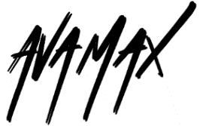

AVA MAX’S DIAMONDS & DANCEFLOORS ARRIVES TODAY

RIAA MULTI-PLATINUM CERTIFIED POP STAR’S HIGHLY ANTICIPATED
SOPHOMORE ALBUM IS OUT NOW

RELEASING ALONGSIDE “ONE OF US” OFFICIAL VISUALIZER – WATCH HERE

FEATURING STANDOUT SINGLES “MILLION DOLLAR BABY,” “COLD AS ICE,”
“ONE OF US,” “DANCING’S DONE,” “WEAPONS” AND “MAYBE YOU’RE THE PROBLEM”

SPECIAL HEADLINE SHOW TO CELEBRATE ALBUM RELEASE
AT MASONIC LODGE IN LOS ANGELES ON FEBRUARY 2
TICKETS SOLD OUT IN MINUTES

LISTEN TO DIAMONDS & DANCEFLOORS HERE
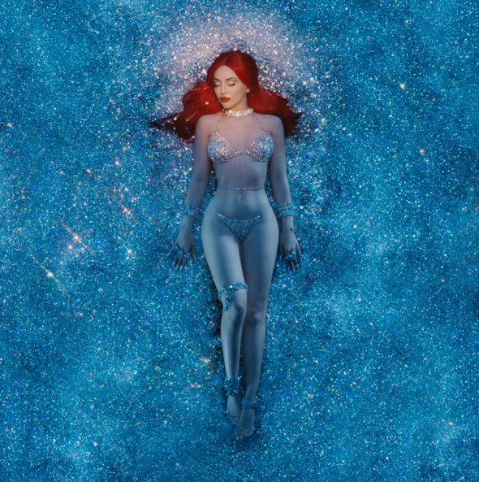
DOWNLOAD HI-RES ARTWORK

“She wanted to pair her soul-crushing lyrics with upbeat, dance-ready melodies… What came out was some of Max’s best work yet.” – ROLLING STONE

Vulture’s “28 Albums We Can’t Wait To Hear In 2023”
Rolling Stone’s “Recommends” January 2023
UPROXX’s “The Most Anticipated Albums of 2023”

RIAA multi-platinum certified global pop sensation Ava Max has unveiled her eagerly awaited sophomore album Diamonds & Dancefloors. The album releases alongside official visualizer for recent track “One Of Us” - Watch HERE.

Following RIAA Certified Platinum debut album Heaven & Hell, the disco-powered new album features standout single “Million Dollar Baby,” which garnered 10M streams and 8M music video views in just two weeks after release and has now amassed 108M global streams. Hailed by PAPER as “a euphoric euro dance number,” “Million Dollar Baby” is joined by an official music video, directed by Andrew Donoho (Khalid, Janelle Monae, Paul McCartney), currently boasting over 25M views – Watch HERE. The sophomore album also includes recent releases “Cold As Ice” and “One of Us,” 80s disco track “Dancing’s Done,” powerful “Weapons” and passionately self-assured “Maybe You’re The Problem.”

AVA MAX – DIAMONDS & DANCEFLOORS

1. Million Dollar Baby
2. Sleepwalker
3. Maybe You're The Problem
4. Ghost
5. Hold Up (Wait A Minute)
6. Weapons
7. Diamonds & Dancefloors
8. In The Dark
9. Turn Off The Lights
10. One Of Us
11. Get Outta My Heart
12. Cold As Ice
13. Last Night On Earth
14. Dancing’s Done

The album was written by singer-songwriter Ava alongside an elite cast of GRAMMY winning writers and producers, including Henry Walter (Miley Cyrus, Maroon 5), Mathew James Burns (Lady Gaga, Ariana Grande), Peter Rycroft (Little Mix, Becky Hill), Sean Douglas (Lizzo), Pablo Bowman (Jonas Brothers, Anne-Marie), Madison Love (Madison Beer, Camila Cabello), Michel “Lindgren” Schulz (John Legend, Dua Lipa), Melanie Fontana (BTS, John Legend) and Ryan Tedder (Beyonce, Leona Lewis, Adele).

To celebrate the release of Diamonds & Dancefloors, Ava recently announced a headline show taking place on February 2, 2023 at the famous Masonic Lodge at Hollywood Forever Cemetery in Los Angeles, with tickets selling out in minutes. For more information, please visit HERE.

Ava rang in 2023 with a stellar performance on CNN’s New Year's Eve Live and is ringing in album release with her recent appearance on The Kelly Clarkson Show and an exclusive story featured on Rolling Stone, which wrote, “Max’s vocals shine on ‘Ghost’ as she sings about ‘feeling haunted’ by her ex over sparkling synth lines. On the disco-drenched ‘Hold Up, Wait a Minute,’ Max questions her partner’s connection with a past love. And her most emotional song on the project, ‘One of Us,’ started as a ballad but transformed into an empowering anthem about coming to terms with the end of a relationship.”

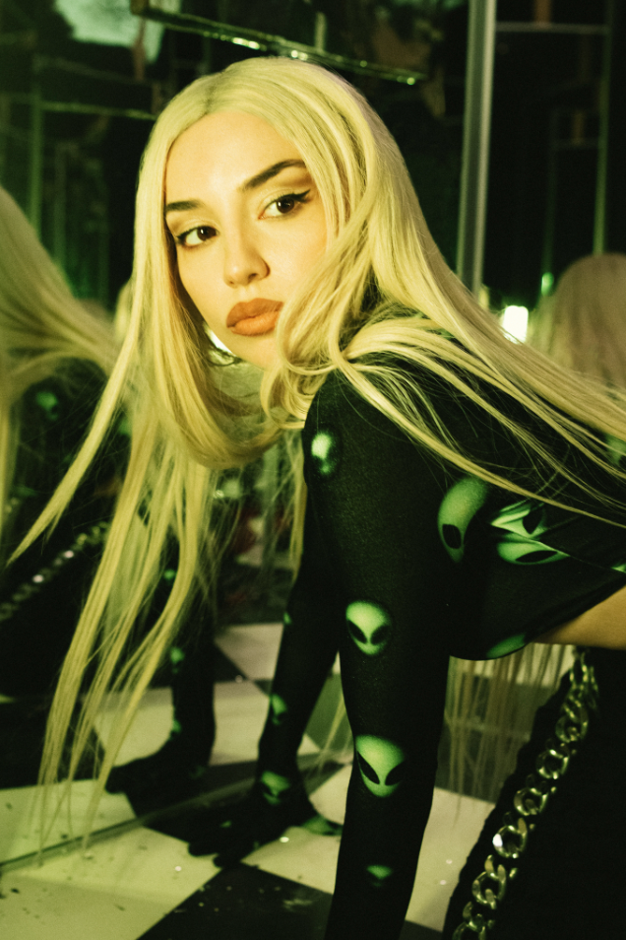
DOWNLOAD HI-RES PRESS PHOTO
CREDIT MARILYN HUE

WHAT CRITICS ARE SAYING ABOUT DIAMONDS & DANCEFLOORS

“…Diamonds & Dancefloors is shaping up to be a more introspective record as Max ruminates on the times she’s been hurt. But rather than wallow in self-pity, she picks herself up and heads straight to the dancefloor” – FORBES

“Ava Max is partying like it’s 2000 and 2004 on the thumping ‘Million Dollar Baby,’ a sleek, calisthenic pop song...” – THE NEW YORK TIMES

“With touches of Eighties synths and retro-futurism, the Albanian American pop star delivers electro-pop bangers that will make you dance and cry at the same time” – ROLLING STONE

"'Weapons' is Ava Max doing what she does best –– conjuring empowering, technicolor Europop that's camp and impeccably constructed" – PAPER MAGAZINE

“The summery anthem [Maybe You’re The Problem] builds off of the momentum that her mammoth hit ‘Sweet but Psycho’ established, and if this is what the rest of her highly-anticipated album sounds like, we’re in for a real treat” – CONSEQUENCE
“Maybe you're the problem, and maybe this is the most upbeat breakup song ever….this song was made for blasting at full volume and dancing with your girlfriends.” – V MAGAZINE

CONNECT WITH AVA MAX:
OFFICIAL I INSTAGRAM I TIKTOK | TWITTER I FACEBOOK | YOUTUBE

Press Contacts:
Kelly McWilliam / Kelly.McWilliam@atlanticrecords.com
Ashley Kalmanowitz / Ashley.Kalmanowitz@atlanticrecords.com

