FOR IMMEDIATE RELEASE
JANUARY 20, 2023

BANKROL HAYDEN EMBARKS ON LANDMARK NEW YEAR
WITH MELODIC NEW SINGLE + VISUAL
“CAN’T CHANGE FOR YOU (FEAT. charlieonnafriday & ARDEN JONES)”

TRACK HERALDS FORTHCOMING NEW MIXTAPE, 29,
COMING SOON

LISTEN HERE | WATCH HERE

ANNOUNCES THE 29 TOUR AS HIS FIRST EVER HEADLINE TOUR
KICKING OFF APRIL 15 IN SAN DIEGO, CA

TICKETS ON SALE NOW HERE

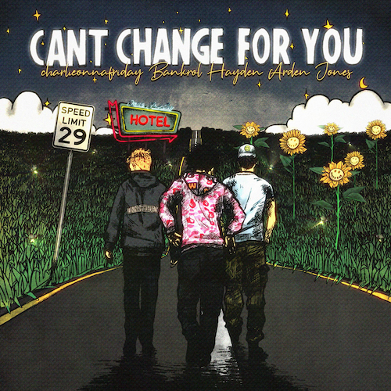
DOWNLOAD HI-RES ARTWORK

Rising hip-hop star Bankrol Hayden is embarking on what looks to be a landmark new year with his new single and visual, “Can’t Change For You (Feat. charlieonnafriday & Arden Jones).” The melodic track paired with their laconic vocal styles makes for a harmonic decision to remain the same this year. Directed by JakeTheShooter, the visual takes the trio back to high school, reigniting their irreversible mindset on love. Watch HERE

“Working on ‘Can’t Change For You’ with a lot of my favorite peers was special,“ says Bankrol Hayden. “Arden and charlieonnafriday are some of my favorite artists right now and I was excited to have them on this song. This record is about not being able to change who you are for someone you love. We all got to share our personal experience in our verses, and I know my fans will be able to resonate with that helpless but unavoidable feeling.”

“Can’t Change For You” provides a glimpse of new music from Bankrol Hayden’s much-anticipated new mixtape, 29, coming soon. The track follows last month’s premiere of his Christmas basketball anthem, “Courtside.” Produced by longtime collaborator Einer Bankz (Travis Scott, 21
Savage), the bespoke track was created specifically for EPSN and ABC’s “NBA on Christmas Day” campaign and was featured extensively over the holiday season throughout all NBA on ESPN coverage, spanning promos, in-game placement, social media, and more. Named as the featured artist for all “NBA on Christmas Day” coverage, Bankrol Hayden – accompanied by producer Einer Bankz – celebrated the premiere of “Courtside” with a special appearance and live performance on ESPN’s NBA Today. Watch HERE.

Bankrol Hayden will celebrate his recent successes and much more with a long-awaited North American tour – his first headline run to date. “The 29 Tour” begins April 15 at San Diego, CA’s Voodoo Room and then continues through a May 18 finale at Los Angeles, CA’s The Echo. For more information on Bankrol Hayden and to purchase tickets, www.bankrol.co.

BANKROL HAYDEN
THE 29 TOUR

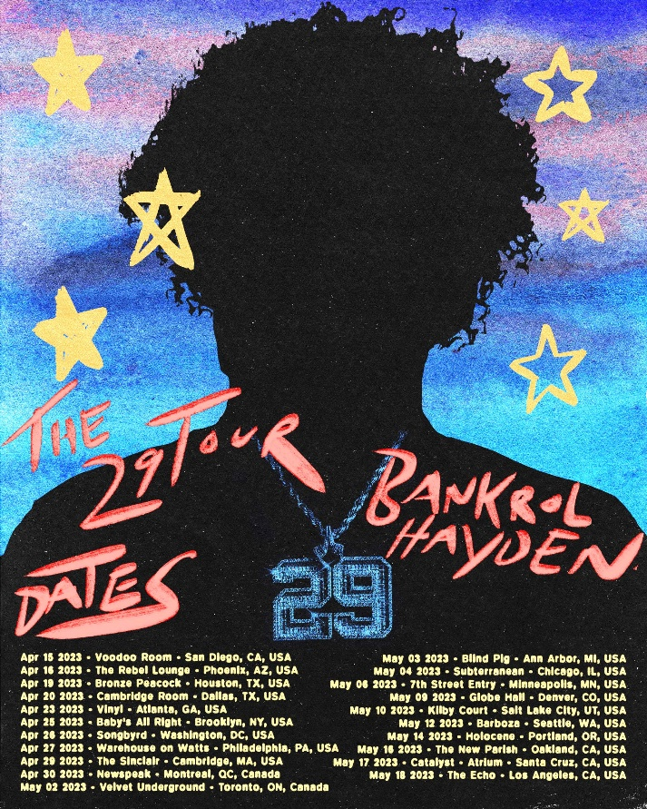
APRIL
15 – San Diego, CA – Voodoo Room
16 – Phoenix, AZ – The Rebel Lounge
19 – Houston, TX – Bronze Peacock
20 – Dallas, TX – Cambridge Room
23 – Atlanta, GA – Vinyl
25 – Brooklyn, NY – Baby’s All Right
26 – Washington, DC – Songbyrd
27 – Philadelphia, PA – Warehouse on Watts
29 – Cambridge, MA – The Sinclair
30 – Montreal, QC – Newspeak
MAY
2 – Toronto, ON – Velvet Underground
3 – Ann Arbor, MI – Blind Pig
4 – Chicago, IL – Subterranean
6 – Minneapolis, MN – 7th Street Entry
9 – Denver, CO – Globe Hall
10 – Salt Lake City, UT – Kilby Court
12 – Seattle, WA – Barboza
14 – Portland, OR – Holocene
16 – Oakland, CA – The New Parish
17 – Santa Cruz, CA – Catalyst (Atrium)
18 – Los Angeles, CA – The Echo

# # #

ABOUT BANKROL HAYDEN:
With over 1B streams to date to date, Bankrol Hayden is a true phenomenon, continuously earning fans around the globe with his positive brand of soulful, pop-forward hip-hop. The talented young artist first broke out in 2017 with a series of popular YouTube videos and SoundCloud favorites. Viral smashes as “B.A.N.K.R.O.L.,” “29,” and the RIAA gold certified “Brothers (Feat. Luh Kel)“ followed, the latter of which scored 30M Spotify streams and 6.5M YouTube plays in under six months. Bankrol Hayden made his Atlantic Records debut in 2020 with the hugely popular “Costa Rica,” quickly earning RIAA gold certification before following up with his powerful debut mixtape, Pain Is Temporary, highlighted by such emotionally charged tracks as “Whatchu On Today (Ft. Polo G),” “Drop A Tear (Ft. Lil Baby),” and “Rich Bitch,” all joined by official music videos streaming now at YouTube.

“Can’t Change For You” continues a run of radiant new music from Bankrol Hayden, including “Deep End (Feat. Lil Skies),” “Van Hayden,” “F*ck Love” the RIAA gold-certified “Costa Rica,” “Cabo,” “No Drama,” and 2021’s smash hit, “Come Through (Ft. Lil Tecca),” the latter of which boasted over 100M worldwide streams after making top playlists such as Spotify’s “Rap Caviar” and “Most Necessary,” Apple Music’s “#OnRepeat” and “The Plug,” Amazon’s “Fresh Hip-Hop,” and more.

Featured among YouTube’s “Artist on the Rise: Trending” series, Bankrol Hayden has also proven to be an electrifying live performer. Most recently highlights include Chicago’s Juice WRLD Day Festival and a series of summer festivals last year. He kicks off The 29 Tour in April—his first headline tour run to date. For more information and tour dates please visit www.bankrol.co.

ABOUT ARDEN JONES:
Currently boasting over 1.9M monthly Spotify listeners, Arden Jones set himself on an ambitious path in 2022 to release three new songs on the first Thursday of every month. 2022 saw Jones release nine three-track projects culminating with age tape 0 and to kick off 2023, Jones will be headlining a series of shows including stops in Los Angeles, San Francisco and Seattle. Known for an irresistible pop approach that bottles the sunshine of an endless California summer with elastic rhymes, radiant hooks, and euphoric, piano-laced beats, Jones has already earned over 160M worldwide streams for such hugely popular tracks as last year’s acclaimed vnclm_ x Atlantic Records debut single, “rollercoaster,” as well as the viral hit, “Parallel Parking.” Hailed by EARMILK for his “joviality and a starry-eyed innocence,” Jones – who has toured alongside fellow breakout pop stars Tai Verdes and Thomas Headon – recently toured as special guest on Chelsea Cutler’s “When I Close My Eyes Tour,” where he shared new music with his fans.
ABOUT CHARLIEONNAFRIDAY:
Seattle-born rising star charlieonnafriday has had a hand in the world of music from a very young age. Enrolled in piano and vocal lessons as a child, it was in only 8th grade that charlieonnafriday started taking music seriously when inspiration struck in a friend's basement studio. charlie took advantage of his time during the Covid-19 pandemic to hone his craft, releasing his breakout hit "After Hours" (40M+ streams) during his senior year of high school. Just one year later, charlie would release his debut album "ONNAFRIDAY" with Island Records, capturing the ears of many and garnering over 1.1 million followers on TikTok. Effortlessly combining a rhythmic flow with pop instincts, charlie draws his inspiration from all around him. charlie highlights his desire to live his life to the fullest, "capturing moments" along the way with his music.

CONNECT WITH BANKROL HAYDEN
OFFICIAL | FACEBOOK | INSTAGRAM | TIKTOK | TWITTER | YOUTUBE

PRESS CONTACT
FAIRLEY MCCASKILL | FAIRLEY.MCCASKILL@ATLANTICRECORDS.COM

# # #

